C# Call by Reference

C# provides a **ref** keyword to pass argument as reference-type. It passes reference of arguments to the function rather than copy of original value. The changes in passed values are permanent and **modify** the original variable value.

**public** **void** Show (**ref** **int** val)

        {

             val *= val; // Manipulating value

            Console.WriteLine("Value inside the show function "+val);

        }

     In Main

**int** val = 50;

program.Show(**ref** val);

# C# Out Parameter

C# provides **out** keyword to pass arguments as out-type. It is like reference-type, except that it does not require variable to initialize before passing. We must use **out** keyword to pass argument as out-type. It is useful when we want a function to return multiple values.

public int ManipulateValue(out int Value)

{

Value = 4;

Value *= 5;

return 5;

}

In Main

Console.WriteLine(example.ManipulateValue(out Number)); //same as ref

Nullable:

Null-Coalescing operator (??):

int x = y?? 0;

output: if y=null -> x=0

else: y=x

Null-Conditional operator (?):

* allows you to access members (properties, methods, indexers) of an object safely without having to explicitly check for nulls each time.
* It doesnot throw NullReferenceException

int? length = text?.Length; output : length = null

string? str=Console.ReadLine();//it can be null (Nullable)

Nullable<string> str=”s”;Console.WriteLine(str);

ToRead Float value from input: (No ToFloat function)

float f=Convert.ToSingle(Console.ReadLine());

**Conditional Attribute: Conditional("CONDITION1")**

You can use conditional attributes to include or exclude method invocations based on the presence of a preprocessor symbol. This can help in creating methods that are invoked only for specific builds like debugging or logging.

**Example:**

csharp

#define DEBUG

using System;

using System.Diagnostics;

class Program

{

static void Main()

{

PrintIfDebug("Hello, Debug!");

}

[Conditional("DEBUG")]

static void PrintIfDebug(string message)

{

Console.WriteLine(message);

}

}

The **PrintIfDebug** method will only execute if the **DEBUG** symbol is defined.

Upcasting:

to convert derived class object to base class object (upcasting)

Animal animal2 = new Dog();

Downcasting:

Animal animal1= new Dog();

Dog dog1 = (Dog)animal1;

as: (safe type conversion)

Dog dog = animal as Dog; *// Safely returns null if conversion isn't valid*

**is:** (return Boolean)

check whether it is of given type:

bool s= animal is Dog

typeOf:

to get the type of something (Object, variables, properties)

Type stringType = typeof(string);

Console.WriteLine(stringType.FullName); // Outputs: System.String

nameOf:

The **nameof** operator produces the name of a variable, type, or member as the string constant.

For debugging, traceability

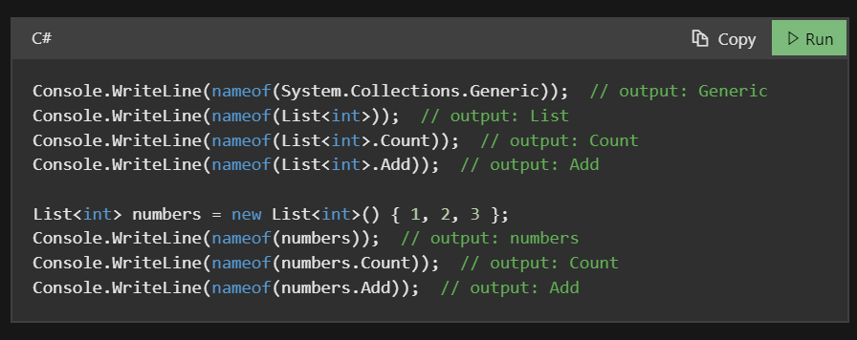

It is used in TestcaseSource in NUnit

**Structs are implicitly sealed therefore they can't be inherited but it can implement interfaces.**

C# Extension Methods

C# allows us to create and **add new methods to existing class** without creating a new child class.

The existing class does not require recompiling the code. Static class.

C# extension methods are the special type of the static methods that can be called as instance methods.

* An extension method should be a **static method.**
* It must have **this keyword** associate with class name.
* The class name should be the first parameter in the parameter list.

<https://www.javatpoint.com/csharp-extension-methods>

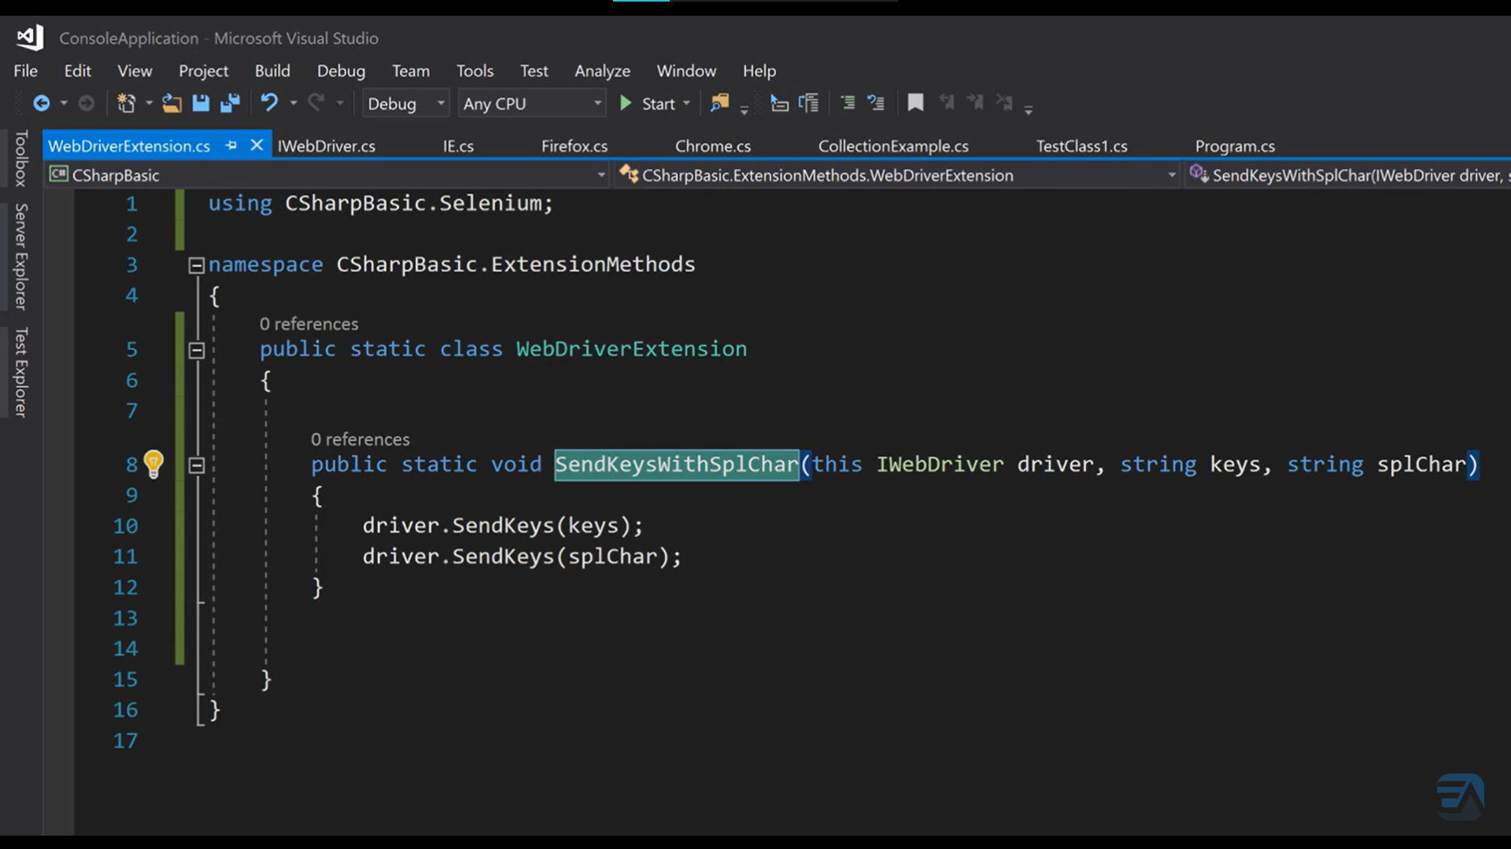

C# Partial Classes

Partial classes help split the methods into two or more source(.cs) files. All the partial classes will be combined when the whole program is compiled.

It can break the functionality of a single class into many files. When the application is compiled, these files are then reassembled into a single class file. The partial keyword is used to build a partial class.

Partial class: (same signature)

* All the parts that contain the class definition must use the partial keyword.
* All the parts of the partial class must have the same access modifier
* If any of the parts are declared as abstract, then the entire type is considered as abstract or if any of the parts are declared as sealed, then the entire type is considered as sealed or if any of the parts inherit a class, then the entire type inherits that class**.**
* it is possible with Partial classes that the different parts of the partial class can specify different base interfaces and the final type should and must implement all the interface methods.

C# Partial Method

Partial method is a special type of method which is declared and defined in two separate partial classes.

Declaration part represents signature and presents in a partial class.

The definition part provides implementation of the method and resides in separate partial class.

The concept of partial method is helpful when we have declaration and definition of method in two separate files.

If definition (implementation) of method is not provided, compiler removes the signature at compile time.

There are some **rules and restrictions** apply to the partial method.

* The signature of partial method must be same in both partial classes.
* Partial method declaration and implementation should not be at the same time.
* The partial method must return void.
* A partial method must and should be declared within a partial class or partial struct. A non-partial class or struct cannot include partial methods.
* No access modifiers are allowed like virtual, override, sealed, new or extern.
* Partial methods are implicitly private and can have static and unsafe modifiers.

The Partial modifier is not available on delegates and Enumeration declarations.

Partial 🡪 class, struct, interfaces.

(var) Implicitly Typed Local Variable

The **var** keyword can be used in following context.

* To create local variables inside a method block.
* In loop construct to initialize variable (foreach).
* In using statement to store resource reference.

The **var** keyword has following restrictions.

* It should use to declare and initialize local variable in the same statement. Ex. var a = (a=220);
* It cannot be used to declare class variables.
* It cannot be used to initialize multiple implicitly typed variables in the same statement.
* var d=1.2; (allowed)

<https://www.javatpoint.com/csharp-object-and-collection-initializer>

[C# Named and Optional Arguments - javatpoint](https://www.javatpoint.com/csharp-named-and-optional-arguments)

Operator Overloading

 Overloaded operators are functions with special names the keyword **operator** followed by the symbol for the operator being defined.

public static Box operator+ (Box b, Box c) {

Box box = new Box();

box.length = b.length + c.length;

box.breadth = b.breadth + c.breadth;

box.height = b.height + c.height;

return box;

}

Destructor: (Finalizer)

C# destructor cannot have parameters. Moreover, modifiers can't be applied on destructors.

    ~Employee()

        {

            Console. WriteLine("Destructor Invoked");

        }

Indexers and Destructors can’t be static.

**typeof**(Dog).IsSubclassOf(**typeof**(Animal)) //to check whether it is derived type

IsSealed,IsAbstract, IsSerializable, IsInterface, IsPublic etc

### Static methods only access static data members, they cannot access non-static data members in the class.

You can’t create static, readonly variables inside static methods, but you can use static class member created outside the method.

We can create local, const variables inside static methods.

Common functionality, Occurs only once (executes constructor only once), memory save, which does not associate with object ex: Utility, Helper classes

### Points to remember for C# static class:

* C# static class contains only static members and static methods, static constructor.
* C# static class cannot be instantiated.
* C# static class is sealed.
* C# static class cannot contain instance constructors.

[C# Static Class, Methods, Constructors, Fields](https://www.tutorialsteacher.com/csharp/csharp-static)

# C# static constructor

* C# static constructor is used to initialize static fields.
* It can also be used to perform any action that is to be performed only once.
* It is invoked automatically before first instance is created or any static member is referenced. Static constructor will be invoked only once i.e. at the time of class loading.
* There can be only one static constructor in a class
* C# static constructor cannot have any access modifier or parameter and invoke implicitly.
* Static Constructor cannot be inherited and overloaded.
* Parameterless constructor

Ex: static ClassName(){}

Static method is called when it is explicitly called by the user

1. Static methods can be overloaded but cannot be overridden.
2. Static methods can contain local static variables.
3. Static methods cannot access or call non-static variables unless they are explicitly passed as parameters.
4. We can’t use var for static members

A static constructor in C# is called automatically by the .NET runtime, and it is triggered under certain conditions. The exact timing can be summarized as follows: (automatic trigger, Thread safety)

1. **Before Any Static Members Are Accessed**: The static constructor is called before any of the static members of the class are accessed. This includes static fields, properties, methods, or events.
2. **Before Any Instances of the Class Are Created**: Although a static class cannot be instantiated, for non-static classes with static constructors, the static constructor is invoked before the first instance of that class is created.

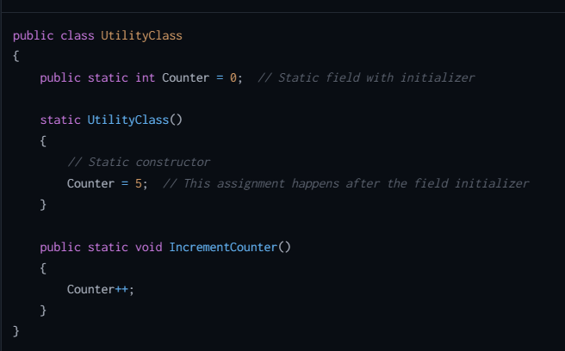

First initialization of counter to 0 happens then constructor executes at the time of class loading. Static method is executed when it is called

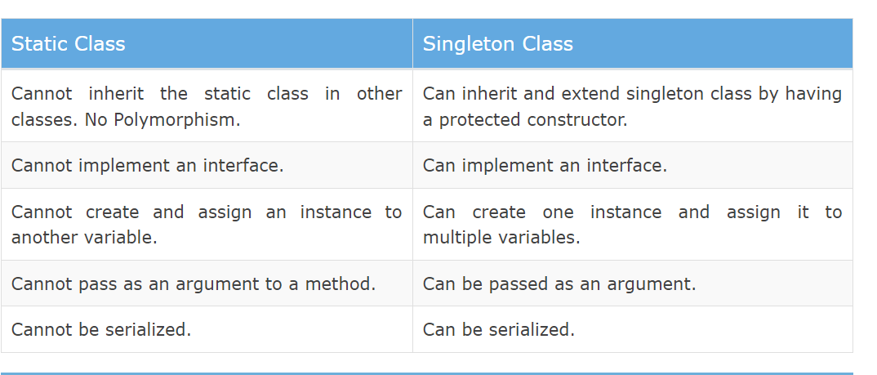

**Restrictions on Properties:**

* **A property cannot be passed via ref or out parameter to a method.**
* **You cannot overload a property (we can’t use multiple get and set methods in one property), can be overrided**
* **A property should not alter the state of the underlying variable when the get accessor is called.**

**Only get means it should initialize value only in constructor;**

**Init: can be defined value in constructor and through Object initializers**

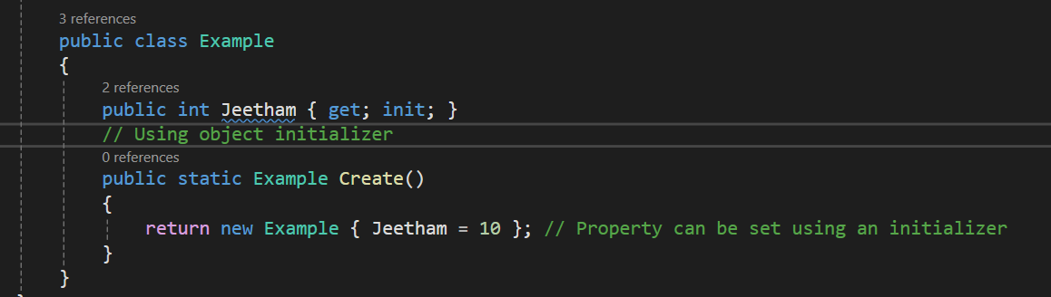

Boxing:

* The process of converting a [Value Type](https://www.geeksforgeeks.org/c-data-types-2/) variable (char, int etc.) to a [Reference Type](https://www.geeksforgeeks.org/c-data-types-2/) variable (object) is called Boxing.
* Boxing is an implicit conversion process in which object type (super type) is used.
* Ex: int num=9;

Object obj=num;

Unboxing:

* The process of converting a [Reference Type](https://www.geeksforgeeks.org/c-data-types-2/) variable into a [Value Type](https://www.geeksforgeeks.org/c-data-types-2/) variable is known as Unboxing.
* It is an explicit conversion process.
* Ex: Object obj =9;

int num=(int)obj;

Data Types:

public record Person(string FirstName, string LastName, int Age);

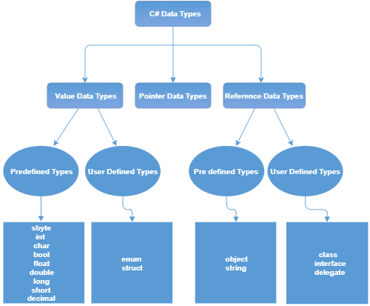

**Nullable**

**dynamic**

**recordArray**

**A**

**Array**

&🡪address  
*🡪Indirection

* **The Value Data Types** will directly store the variable value in memory and it will also accept both signed and unsigned literals. The derived class for these data types are **System.ValueType**.

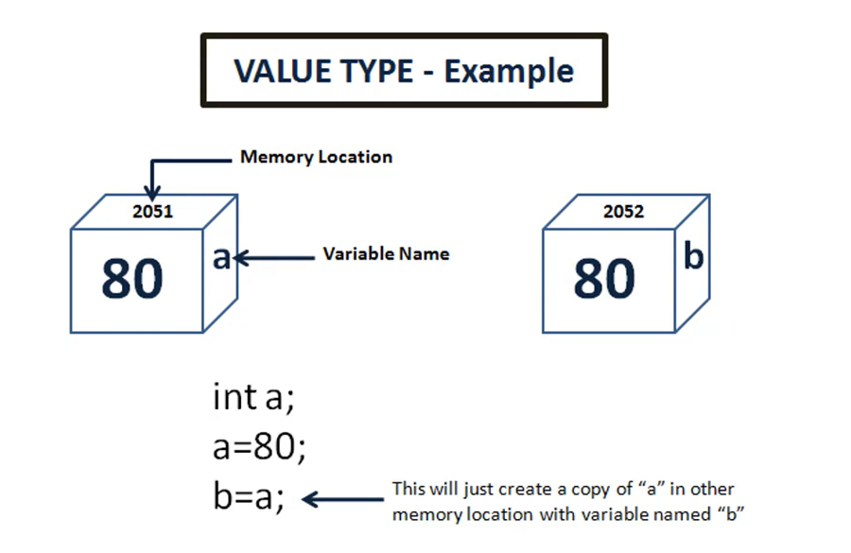 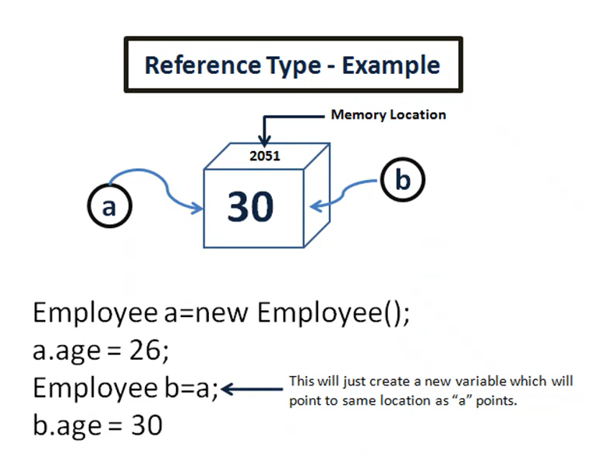

* **The Reference Data Types** will contain a memory address of variable value because the reference types won’t store the variable value directly in memory.
* **The Pointer Data Types** will contain a memory address of the variable value.
* [Value Types vs Reference Types in C#](https://www.c-sharpcorner.com/article/value-types-vs-reference-types-in-c-sharp/)

**You use the following operators to work with pointers:**

* Unary & (address-of) operator: to get the address of a variable
* Unary * (pointer indirection) operator: to obtain the variable pointed by a pointer
* The -> (member access) and [] (element access or index) operators
* Arithmetic operators +, -, ++, and --
* Comparison operators ==, !=, <, >, <=, and >=

[C# Strings - javatpoint](https://www.javatpoint.com/c-sharp-strings)

[C# Array Class - javatpoint](https://www.javatpoint.com/c-sharp-array-class)

[Defect Management Process in Software Testing (Bug Report) (guru99.com)](https://www.guru99.com/defect-management-process.html)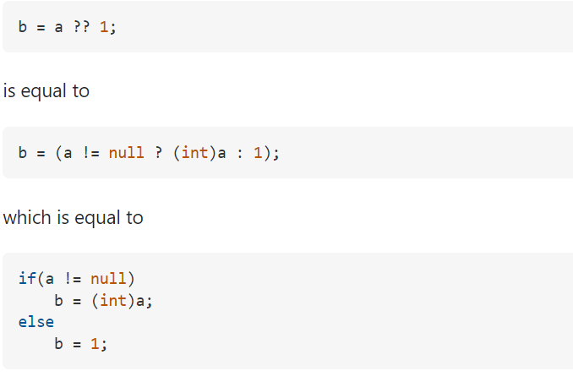

char -> int -> long -> float -> double

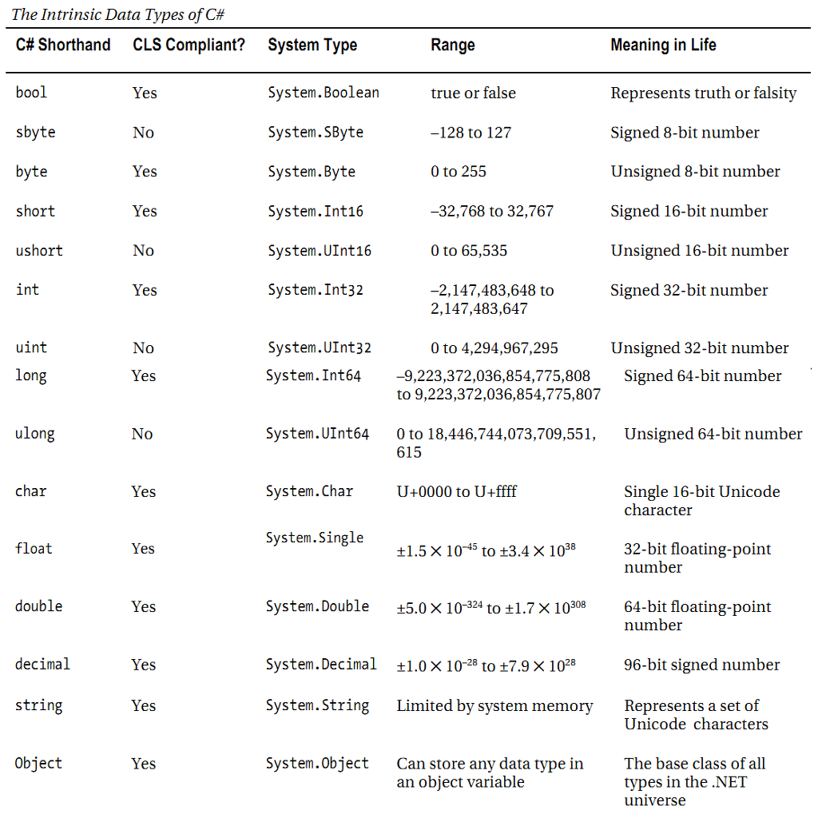

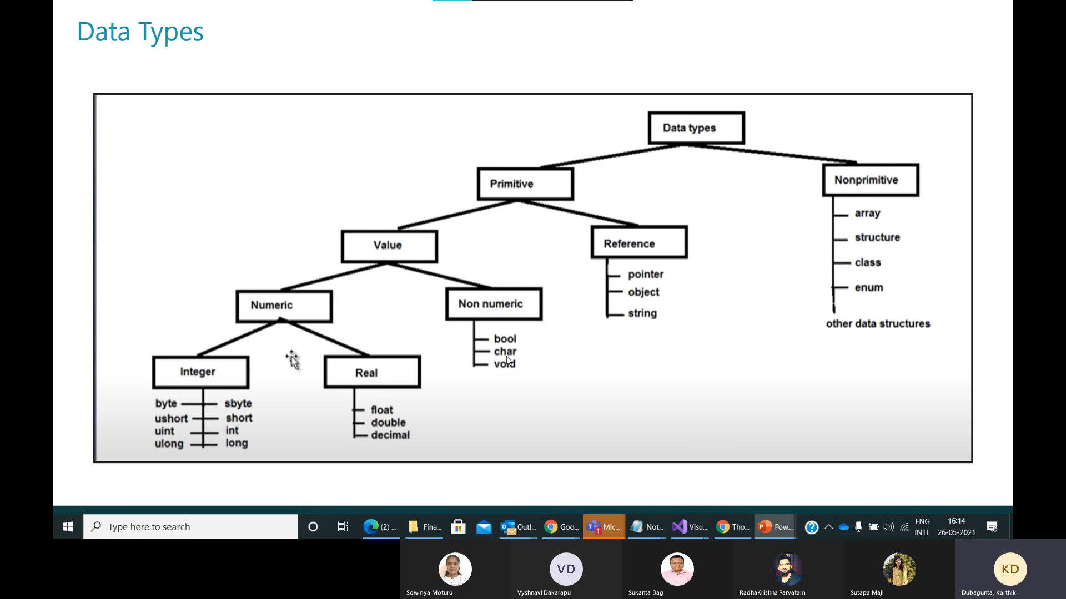

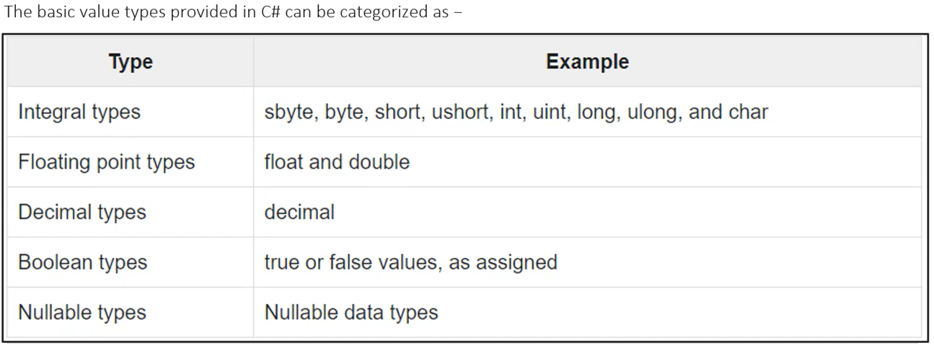

Types of Variables:

* 1. Local variables
  2. Instance variables
  3. Static variables (global variables)
  4. Constant variables ex: const double pi=3.14
  5. Read-Only variables [readonly keyword - C# Reference | Microsoft Learn](https://learn.microsoft.com/en-us/dotnet/csharp/language-reference/keywords/readonly)
* readonly indicates that assignment to the field can only occur as part of the declaration or in a constructor in the same class.
* A readonly field can be assigned and reassigned multiple times within the field declaration and constructor. Ex: readonly int n=0; (modifier)
* Because value types directly contain their data, a field that is a readonly value type is immutable.
* Because reference types contain a reference to their data, a field that is a readonly reference type must always refer to the same object. That object isn't immutable.
* For Reference type, the readonly modifier prevents the field from being replaced by a different instance of the reference type.

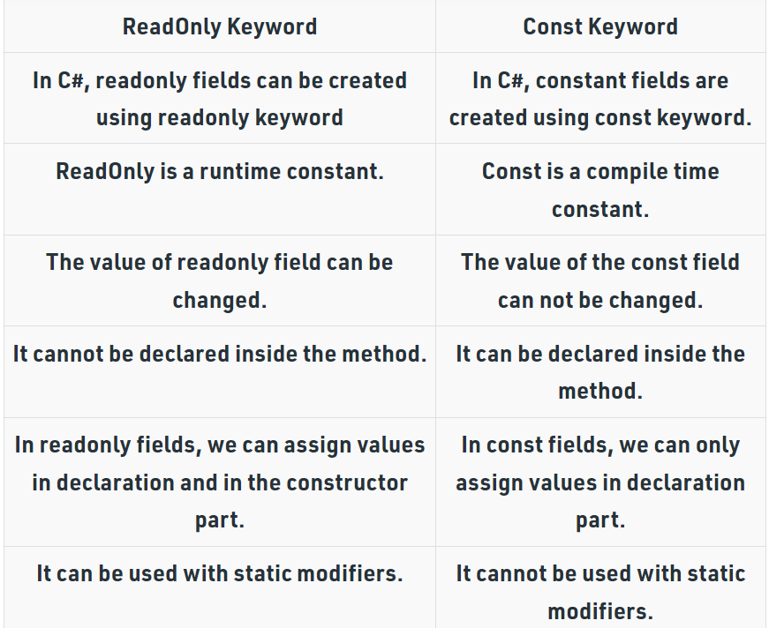

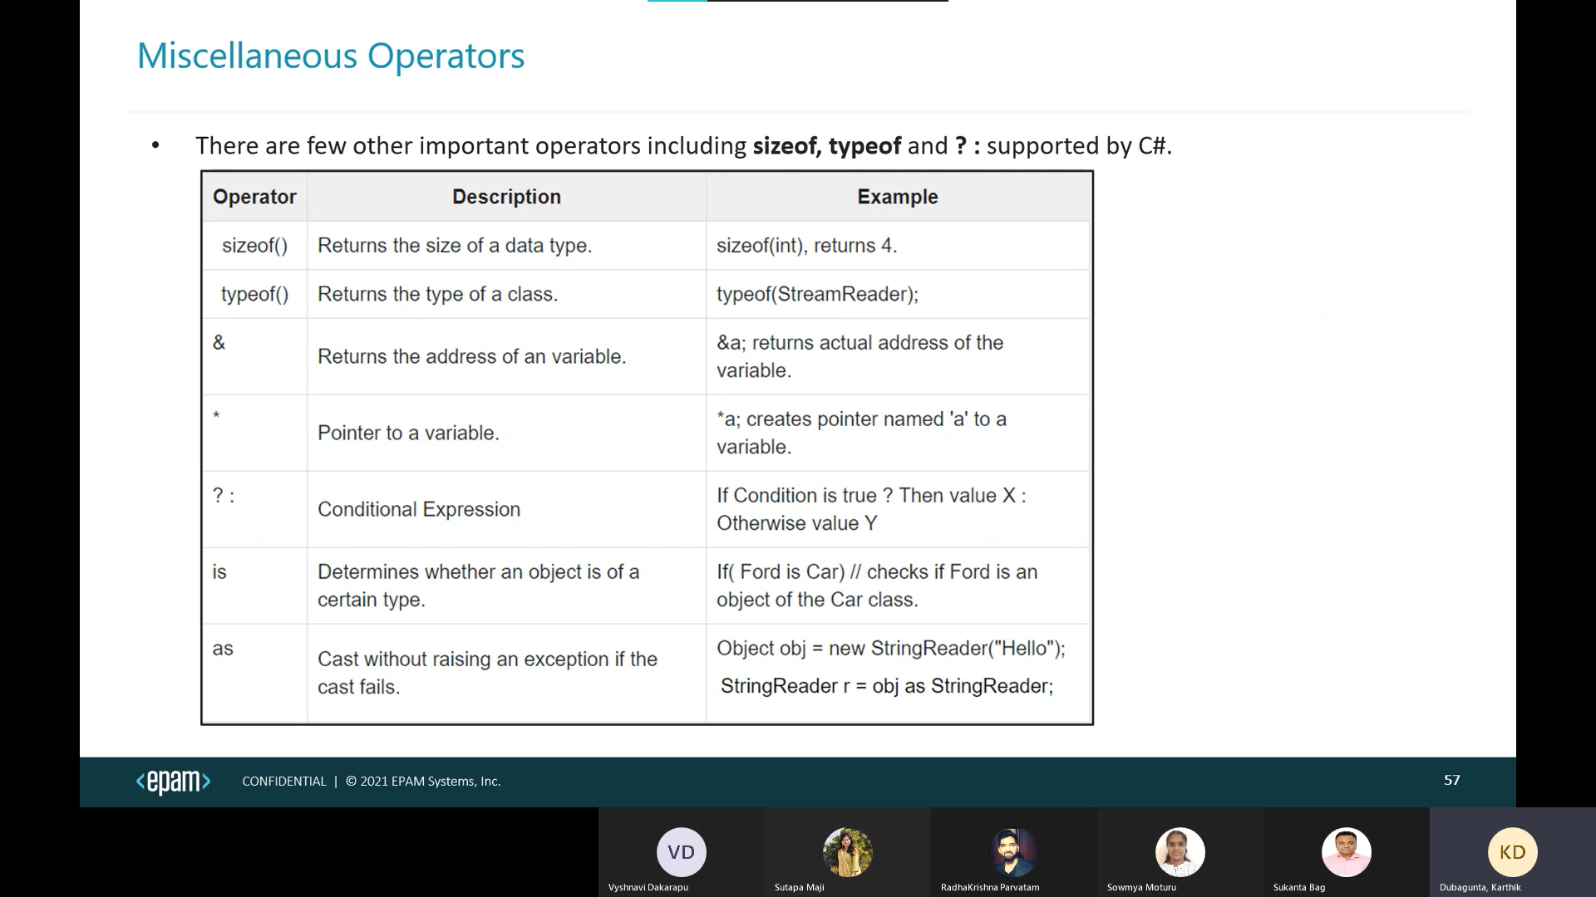

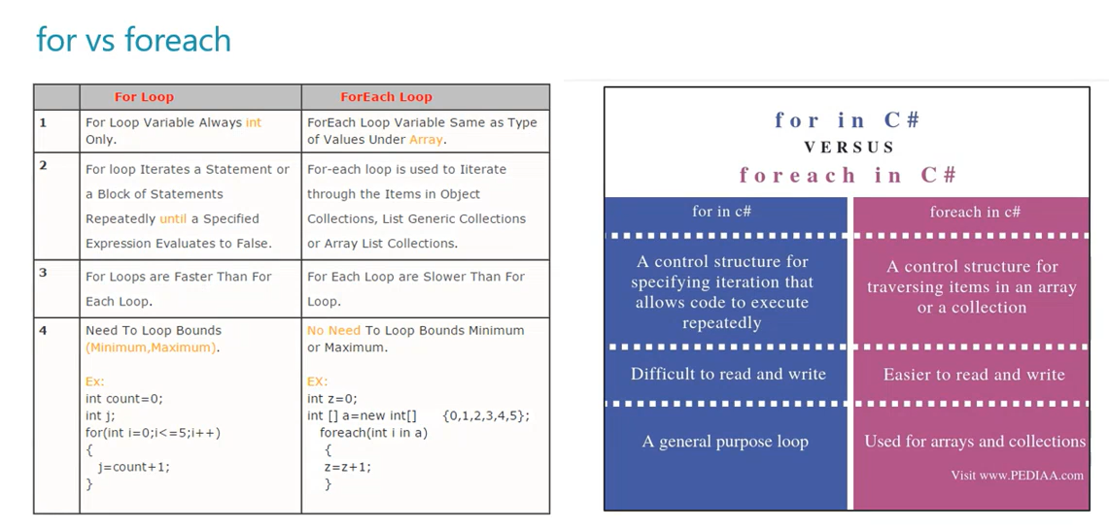

For can go backwards

Object class:

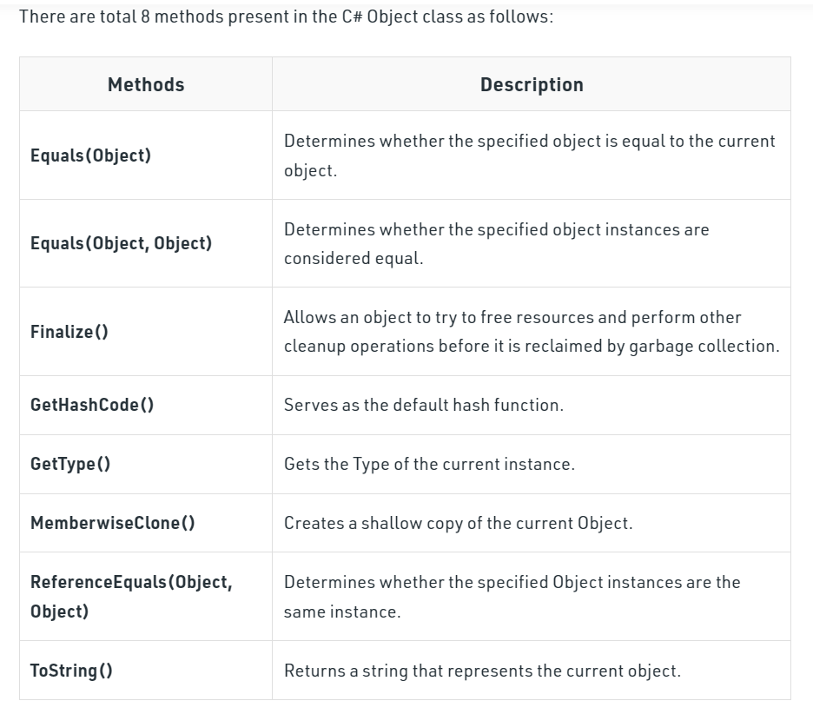

Access Specifiers:

[What are the default access modifiers in C#? - Stack Overflow](https://stackoverflow.com/questions/2521459/what-are-the-default-access-modifiers-in-c/3175697#3175697)

* By default, all members are private in C#
* We can’t declare private for Types.
* We can’t declare protected, protected internal, private for class. We can only use internal, public. By default, internal for class.

**Assembly (Project)**

1. Private 🡪 within class (default)
2. Public 🡪 everywhere
3. Protected 🡪 subclasses (same or different project)
4. Internal 🡪 within same Project
5. Protected internal 🡪 within same Project or derived types of another project.
6. Private Protected 🡪 within same class and derived classes of same project.

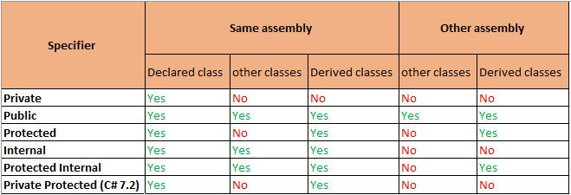

Namespaces:

* Namespaces in C# are used to organize too many classes so that it can be easy to handle the application. (We can import, organize, related classes, reuse the class, change class functionality)
* In C#, global namespace is the root namespace. The global:System will always refer to the namespace "System" of .Net Framework.
* To access the class of a namespace, we need to use namespacename.classname.
* We use using keyword to import that namespace.

Ex: we use System.Console where System is the namespace and Console is the class.

C# Properties can be read-only (only get) or write-only (only set).

 Structs are used for lightweight objects such as Color, Rectangle, Point etc.

Structs in C# are value type than reference type. It is useful if you have data that is not intended to be modified after creation of struct.

**Enum:**

* Enum is used to store a set of named constants such as season, days, month, size etc.
* Enum constants has default values which starts from 0 and incremented to one by one.
* Enum does not contain constructor and methods. To add functionality to an enumeration type, create an extension method.

1. (int)season ---- 4
2. Season----Winter
3. Enum.GetNames(typeOf(Season)), GetValues() sames as GetNames.

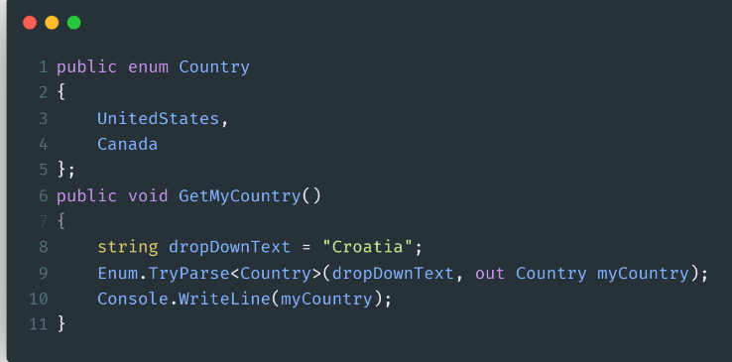

Iterators:

* This feature was introduced in ***C# 2.0***.
* An iterator can be used to step through collections such as lists and arrays.
* It uses the **yield return** statement to return the element from the collection at a time.
* it always remembers the current location of the iterator, so when the next iteration takes place, it will return the next element of the given collection.
* If you want to stop the iteration you will use the **yield break** statement.
* The return type of this method is IEnumerable, IEnumerable<T>, IEnumerator, or IEnumerator<T>. (GetEnumerator).
* You cannot use iterator in an events instance constructor, static constructor, or static finalizer.
* An iterator method does not contain in, ref, or [out](https://www.geeksforgeeks.org/out-parameter-with-examples-in-c-sharp/) parameters.
* Iterator can be used as a method, or as a property.
* Iterator method is also known as get accessor.

using System;

using System.Collections.Generic;

class GFG {

public static IEnumerable<string> GetMyList()

{

// Creating and adding elements in list

List<string> my_list = new List<string> () {

"Cat", "Goat", "Dog", "Cow”};

foreach (var items in my_list)

{

yield return items;

}

}

static public void Main ()

{

IEnumerable<string> my_slist = GetMyList();

foreach(var i in my_slist)

{

Console.WriteLine(i);

}

}

}

In IEnumerator First we need to MoveNext() and Current to get first element.

String, String Builder are present in c#

No StringBuffer, throws in dotnet. Equals compares **values**, while == compares **object references**

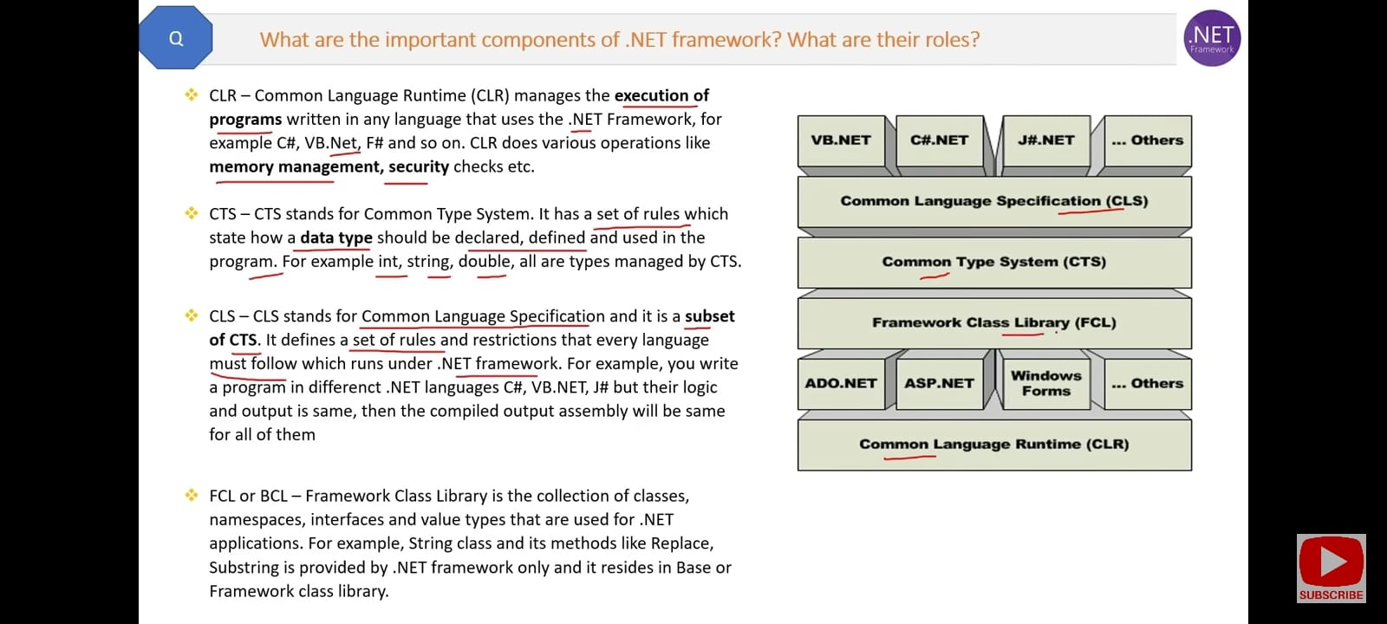

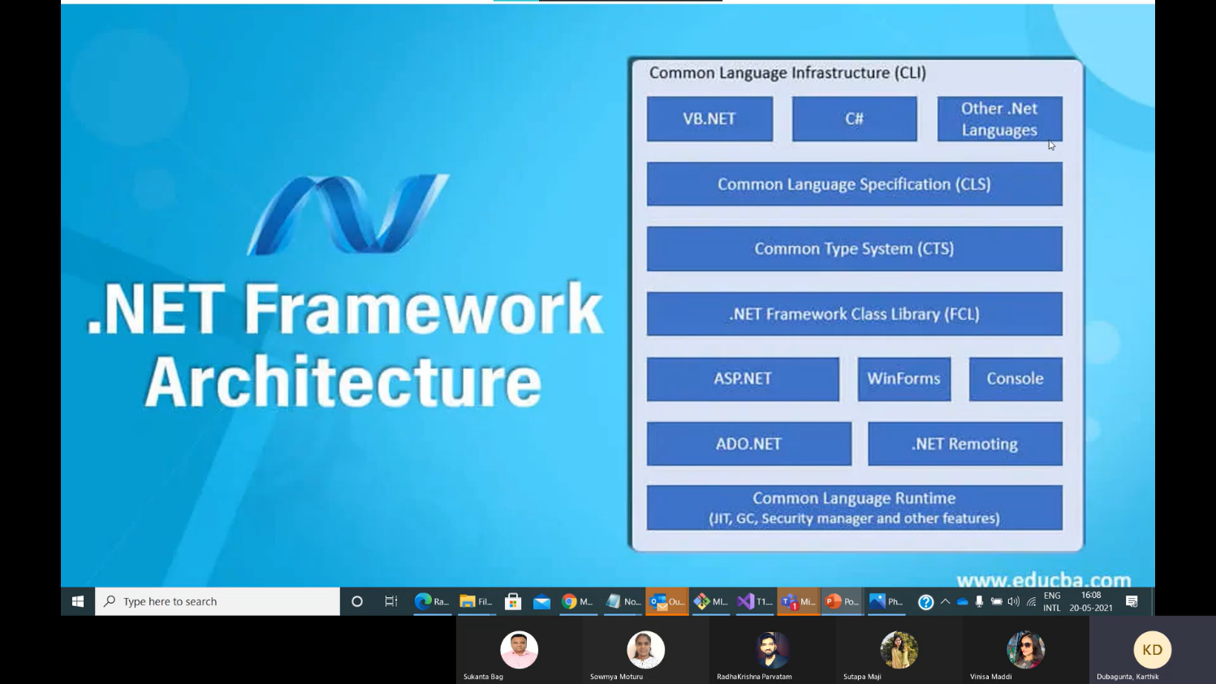

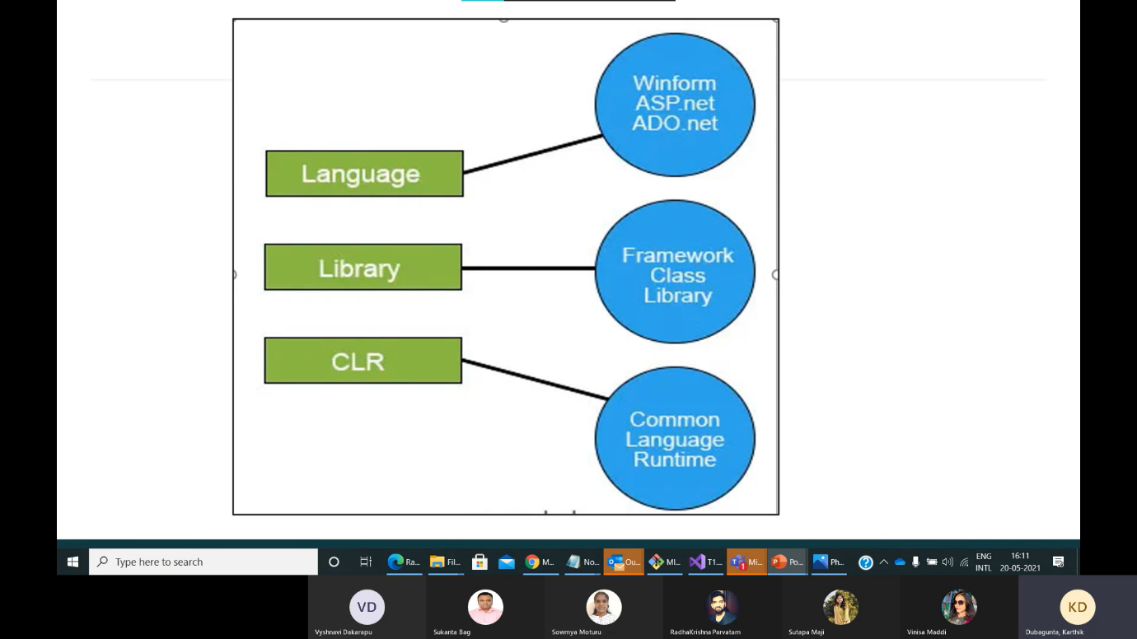 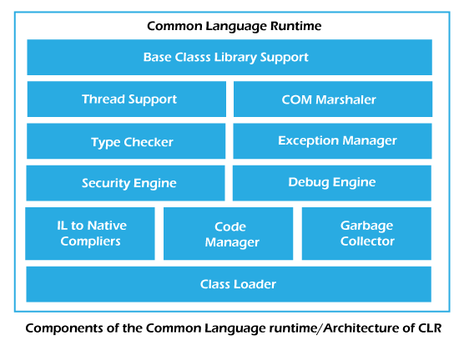

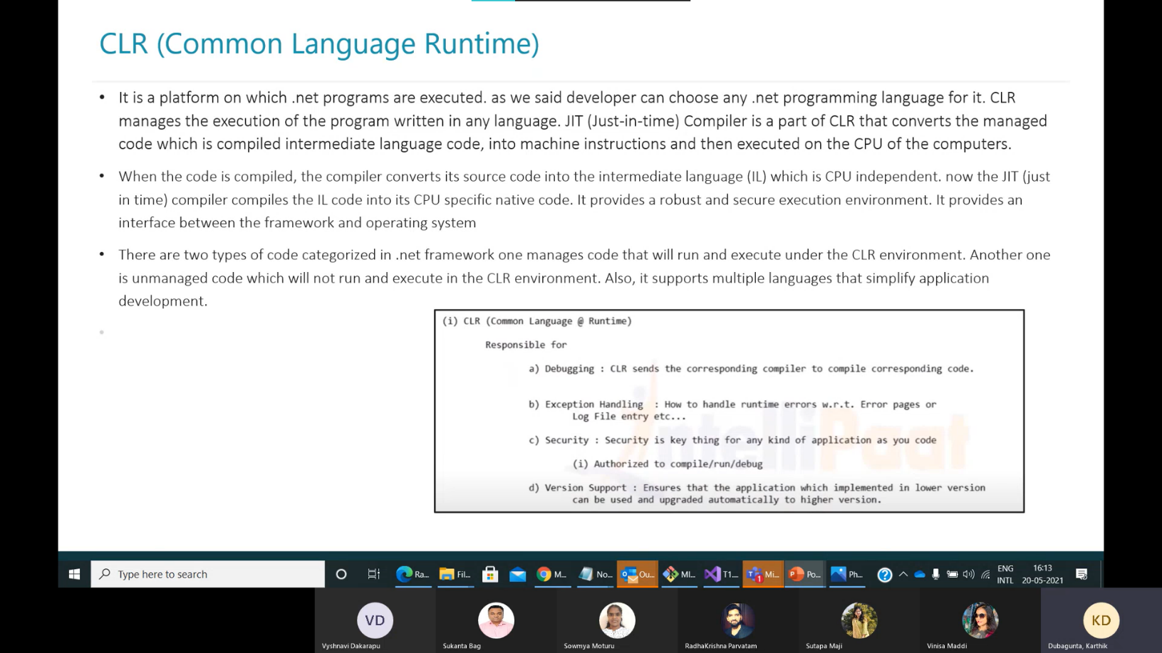

## **There are the following three types of JIT Compilers in Microsoft .Net Framework.**

**1)Pre-JIT**:

Pre-JIT Compiler compiles the whole source code into native code in a single cycle, done at the time of deployment of the application itself.

2) **Econo-JIT**:

Econo-JIT Compiler compiles only specific methods that are called at runtime. These compiled methods are removed once their processing is finished and not required in further execution.

3)**Normal-JIT**:

Normal-JIT Compiler compiles only specific methods that are called at runtime. These methods are compiled once and are stored in the cache. When the same methods are called again, the compiled code from cache will be used for execution.

dll 🡪 dynamic linked library

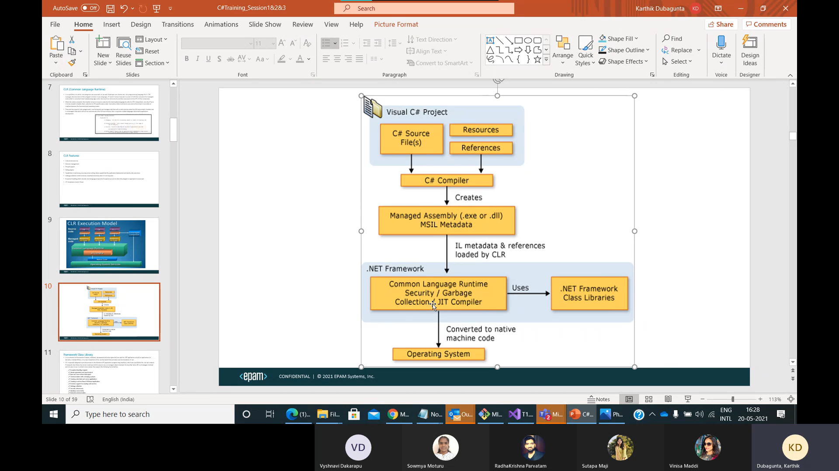

[C# Version History (tutorialsteacher.com)](https://www.tutorialsteacher.com/csharp/csharp-version-history)

The C# programming language was designed by [Anders Hejlsberg](https://en.wikipedia.org/wiki/Anders_Hejlsberg) from [Microsoft](https://en.wikipedia.org/wiki/Microsoft) in 2000 and was later approved as an [international standard](https://en.wikipedia.org/wiki/International_standard) by [Ecma](https://en.wikipedia.org/wiki/Ecma_International) (ECMA-334) in 2002

C# 11 is latest version

First parent constructor is called and then child constructor is invoked.

Child object can access the variables and methods of parent class.

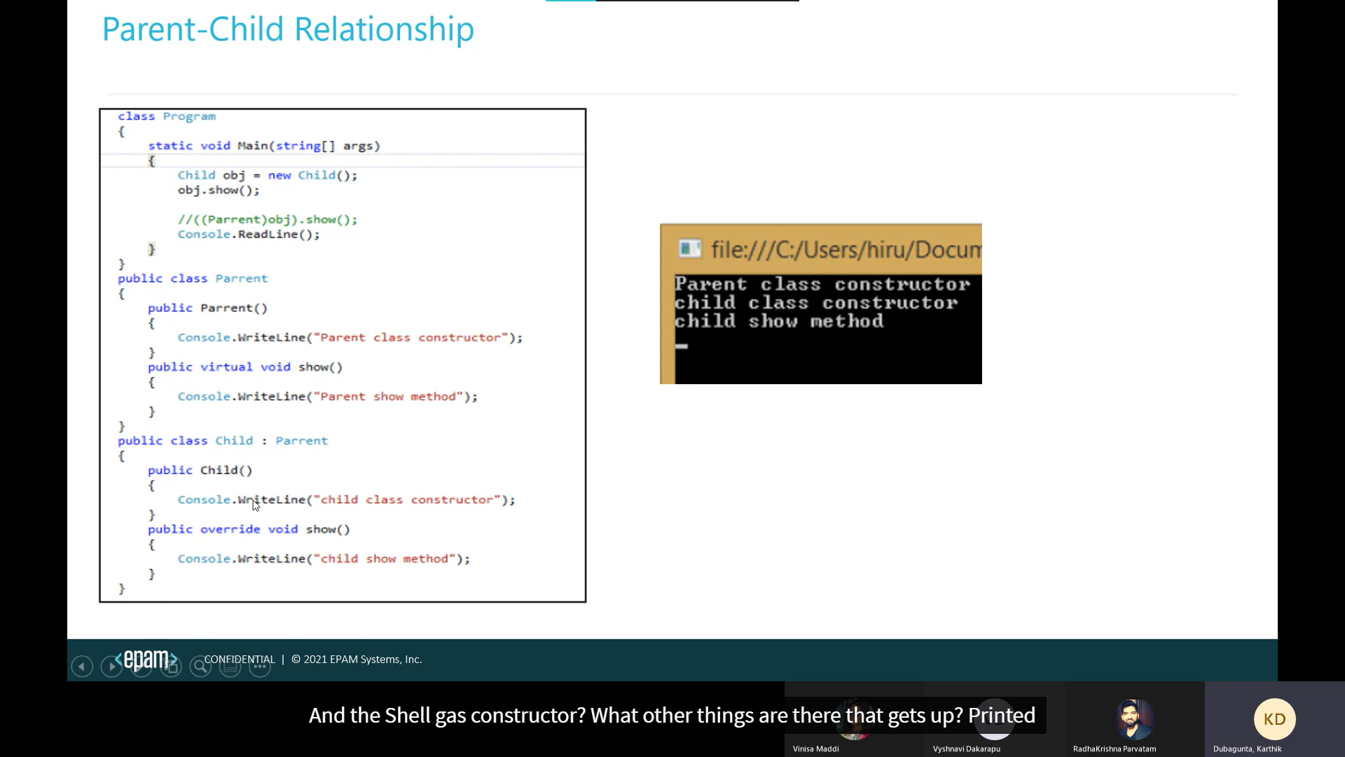

New modifier: (method hiding, shadowing)

When “new” used as a declaration modifier, the new keyword explicitly hides a member that is inherited from a base class.

When you hide an inherited member, the derived version of the member replaces the base class version.

The "new" keyword is used to hide a method, property, indexer, or event of the base class into the derived class.

Method hiding in C# is a concept where a method in a derived class has the same name as a method in the base class, but the method in the derived class is declared using the **new** keyword. This tells the compiler that the method is intended to hide the base class method, rather than override it. Method hiding is also known as "shadowing." (Reference method is called)

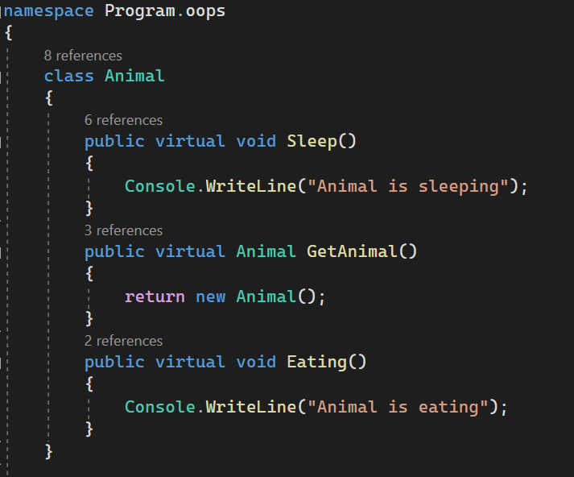 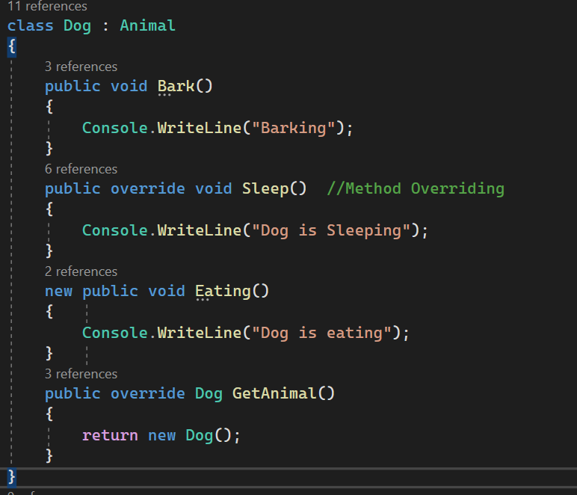

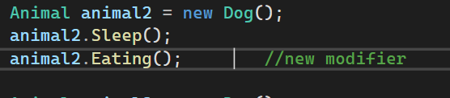

New is hiding eating method in derived class and it effects only in upcasting.

Output:  
Dog is sleeping Animal is eating

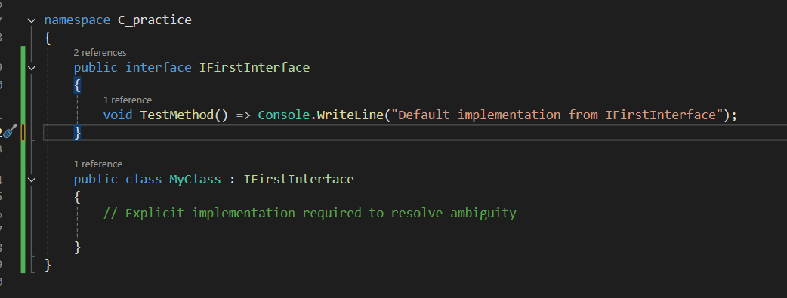  
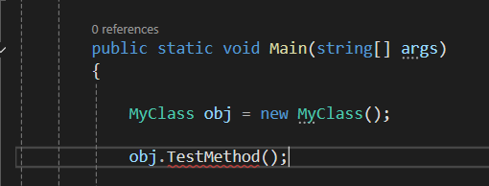

**Explicit Implementation Requirement**: When a class implements multiple interfaces that have conflicting default implementations for the same method, the class must provide an explicit implementation of the method. This resolves ambiguity by forcing the developer to specify which method implementation should be used, or to define a new one.

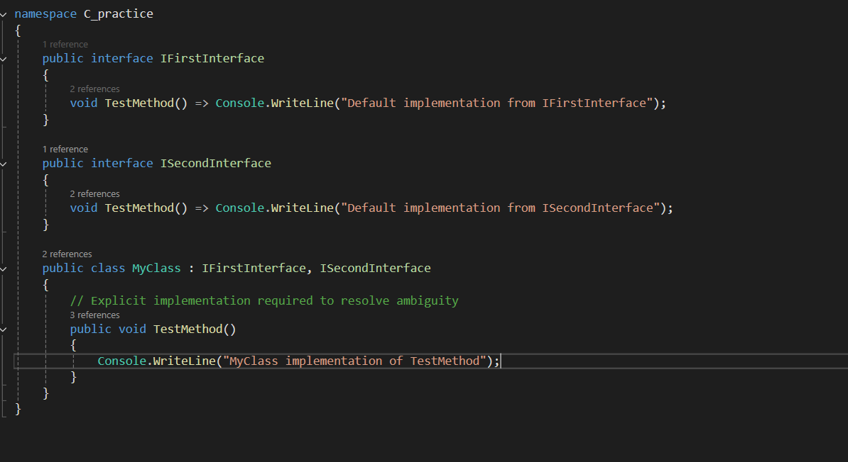

Array rank🡺 no of dimensions

Collections:

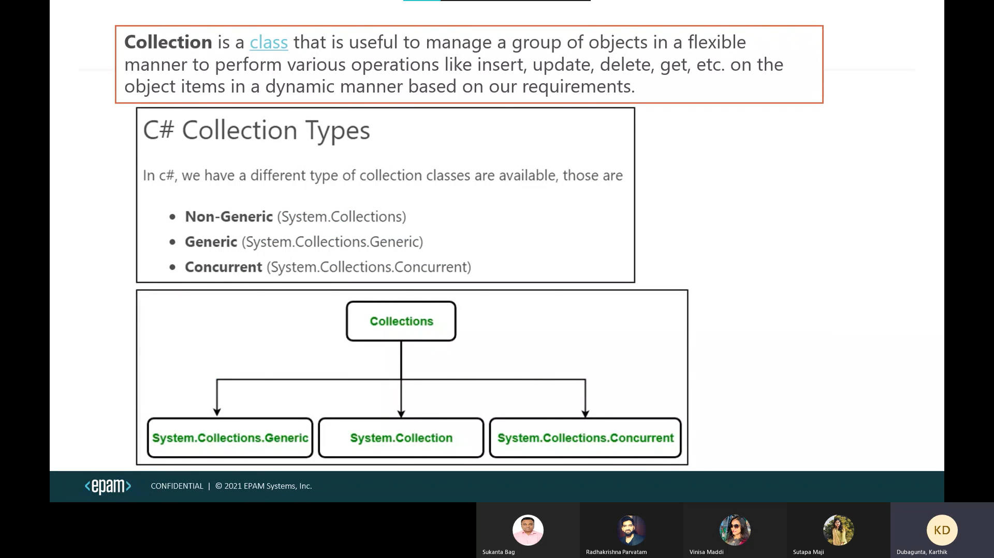

Non-Generic Collections:

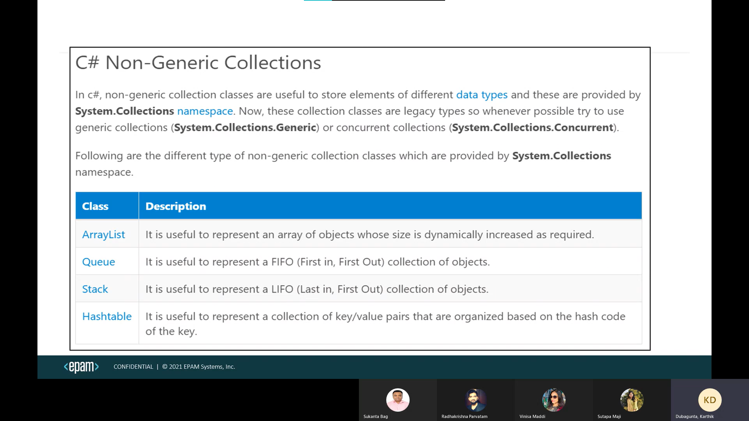

SortedList

* The ArrayList, Queue, stack collection accepts null as a valid value. It also allows duplicate elements.
* Using multidimensional arrays as elements in an ArrayList collection is not supported.
* The**ArrayList could become jagged and could be considered not to be multidimensional any longer.**
* In Hashtable, the key cannot be null, but value can be. It uses hash code to store key and values. key objects must be immutable in the Hashtable.
* In Hashtable, key must be unique. Duplicate keys are not allowed.

ArrayList arrayList = new ArrayList();

arrayList.Add(1);

arrayList.Add(2);

arrayList.Add("pip");

arrayList.Add("io");

arrayList.Sort(); --- System.InvalidOperationException

ArrayList arr = new ArrayList(){“Zeh”, “zeh”};

arr.Sort() // output: zeh, Zeh   
Here it will ignore cases, Lower case is prioritized first and follows ascii

Thread Safety: (public static)

* The collection classes in the System.Collections namespace include ArrayList and Hashtable. These classes provide some thread safety through the Synchronized property, which returns a thread-safe wrapper around the collection.
* System.Collections.Generic classes don't provide any thread synchronization
* Concurrent collections are thread safe.

Generics advantages:

* Generics provide type-safety, so we can hold a single type of object in generics.
* It provides a compile-time checker so it doesn’t show an error at runtime.
* There is no necessity to typecast an object.
* Generics provide type safety without the overhead of multiple implementations.
* Generics eliminates boxing and unboxing.
* reusability

Generic Collections:

* In Dictionary (no order), SortedList (sorted order) the key cannot be null, but value can be. key must be unique
* SortedList uses one list for the keys and another list for the associated values.
* List can accept null as a valid value for reference types and allows duplicate elements.
* Dictionary🡪hashing SortedList🡪list
* Hashset allows one null value and does not allow duplicates. (No order)
* The LinkedList<T> class does not support chaining, splitting, cycles, or other features that can leave the list in an inconsistent state.
* It allows null values and duplicates.
* The only multithreaded scenario supported by LinkedList<T> is multithreaded read operations.
* If the LinkedList<T> is empty, the First and Last properties contain null.

Generics

* SortedDictionary
* SortedSet

Class should implement IComparable interface because of “this” keyword list.Sort()

public int CompareTo(Object obj)

{

return this.Id.CompareTo(obj.Id);

}

New comparer class should be created to implement IComparer interface

public int Compare(Object obj1, Object obj2)

{

return obj1.Name.CompareTo(obj2.Name);

}

list.Sort(new Comparer class name())

Linked list is doubly linked list

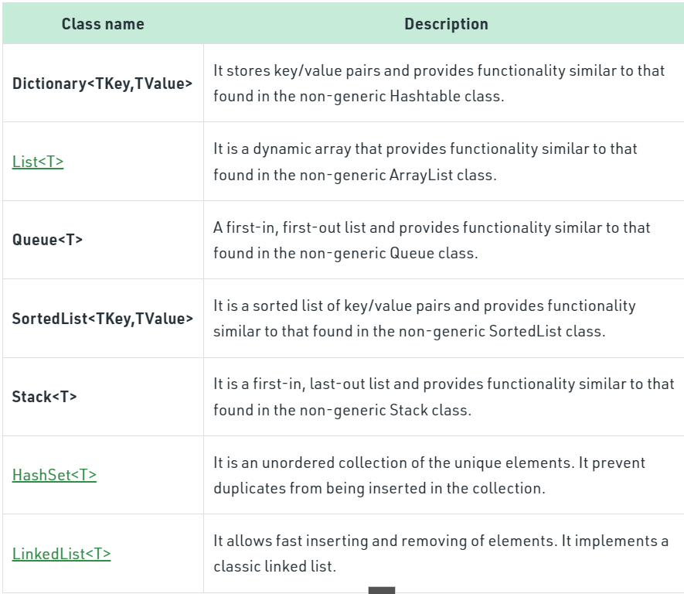

SortedSet, SortedDictionary

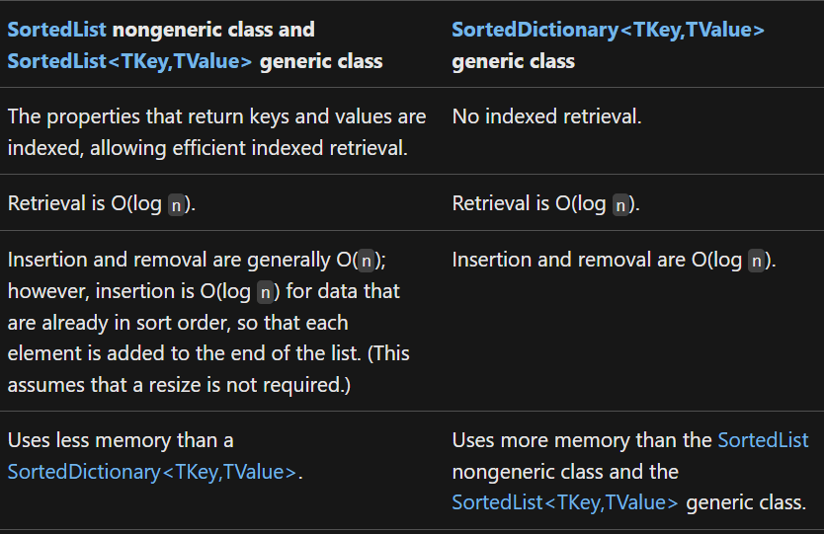

*sortedList uses List whereas sorted dictionaries binary search tree(AVL RED black tree) for sorting*

Concurrent Collections:

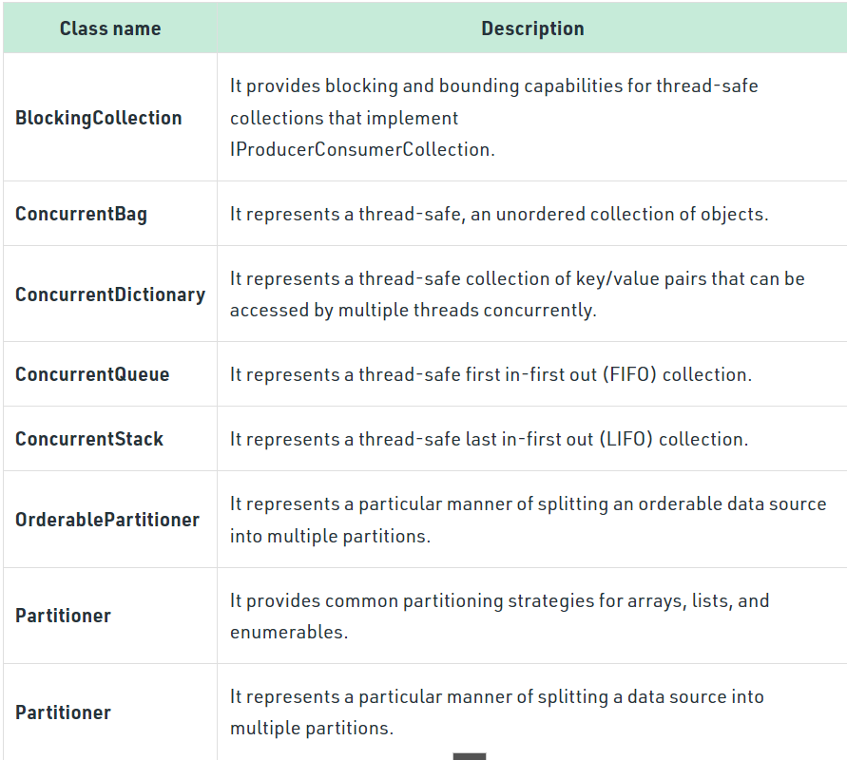

* clone - create something new based on something that exists.(always deep copy)
* copying - copy from something that exists to something else (that also already exists) (shallow or deep)

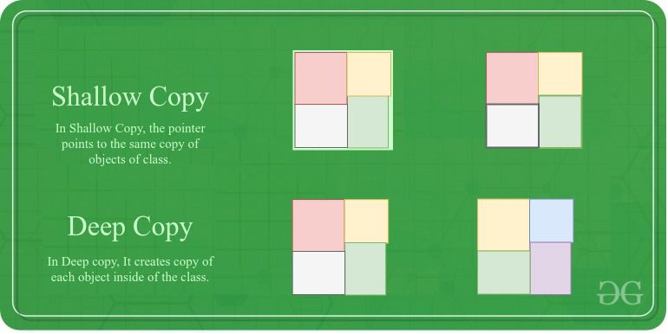 

**1. List<T>**

The default capacity of a **List<T>** is **0**. However, upon adding the first element, the capacity is increased to **4**. As more elements are added and the capacity is reached, the list's capacity is automatically doubled.

**2. Dictionary<TKey, TValue>**

The default capacity of a **Dictionary<TKey, TValue>** is **0**. However, upon adding the first element, the capacity is increased to a prime number, typically **3**. The capacity continues to increase to larger prime numbers as more elements are added and the current capacity is reached.

**3. HashSet<T>**

The default capacity of a **HashSet<T>** is **0**. Similar to **Dictionary<TKey, TValue>**, upon adding the first element, the capacity is increased to a prime number, typically **3**. The capacity increases to larger prime numbers as needed.

**4. Queue<T> and Stack<T>**

Both **Queue<T>** and **Stack<T>** have a default capacity of **4** when instantiated without a specified capacity. Their capacities also increase automatically as more elements are added, typically doubling when the current capacity is reached.

Exception Handling:

Exceptions two types:

1. System Exceptions (Arthimetic Exception etc)
2. Application Exceptions (explicitly throwing our own Exceptions)

The checked keyword is used to explicitly check overflow and conversion of integral type values at compile time. And throws overflow Exception.

 whereas, in an unchecked context, arithmetic overflow is ignored, and result is truncated.

Some common Exceptions

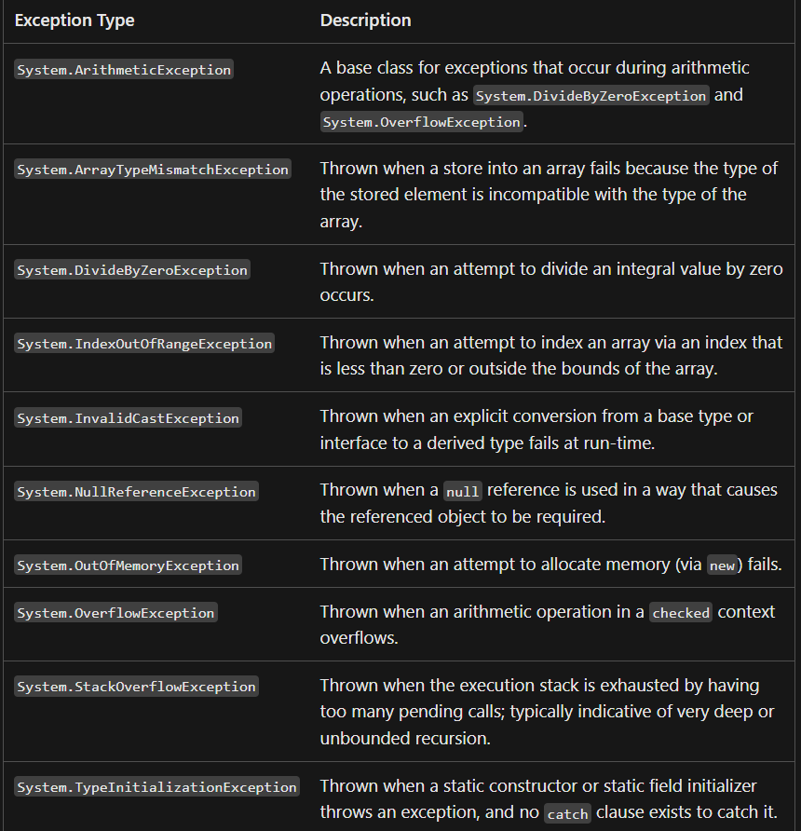

* try catch finally using throw
* using designed to give you an easy way to wrap a try/finally around an object that needs to be disposed. (Removing from the memory or closing)
* using can’t handle the Exceptions, we replace with try catch finally blocks to handle Exceptions.
* A variable declared by the using statement or declaration is readonly. You cannot reassign it or pass it as a ref or out parameter.
* When you declare several instances in one using statement, they are disposed in reverse order of declaration.
* The **using** statement is used to automatically manage the disposal of resources that implement the **IDisposable** interface.

public class OddNumberException : Exception

{

public OddNumberException(string message) : base(message)

{

}

}

csc **helloworld.cs**  🡺 to compile your code.

**helloworld 🡺** to run the file

[Class Diagram in Visual Studio 2019 | Class Designer Getting Started - YouTube](https://www.youtube.com/watch?v=syYyQ7LlcPc)

LINQ:

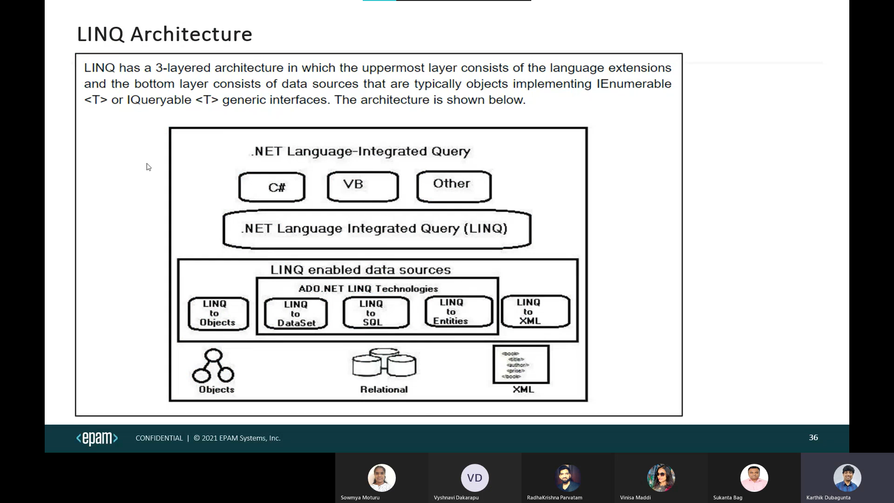

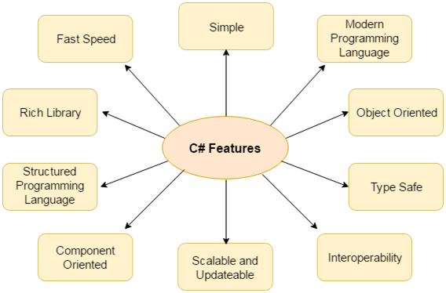

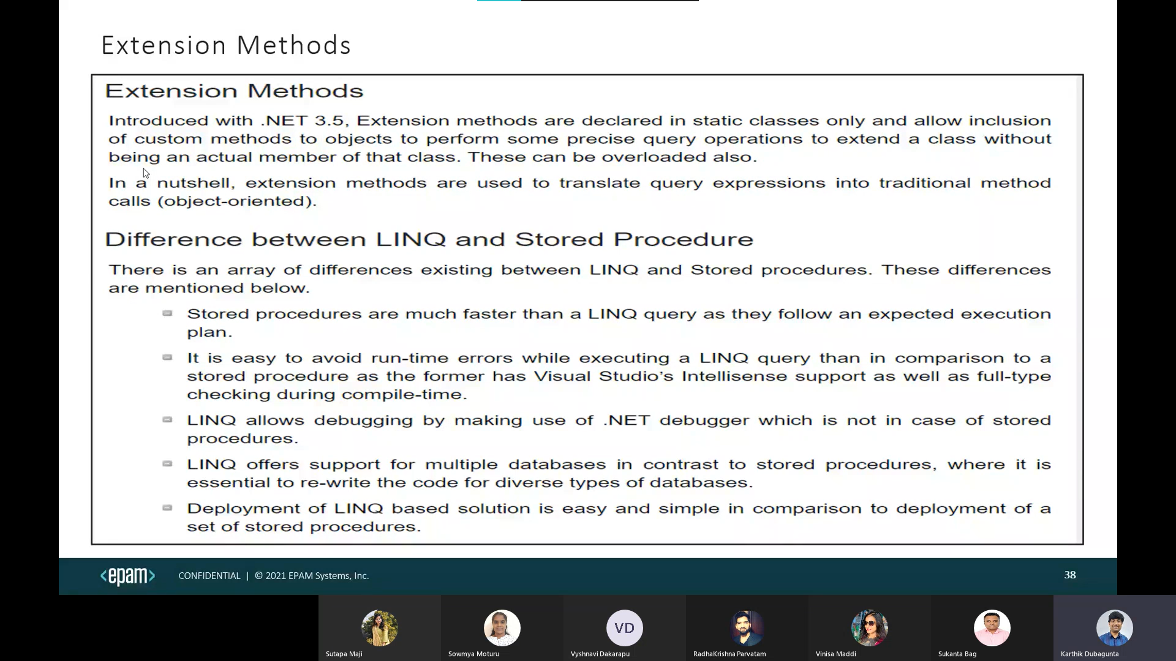

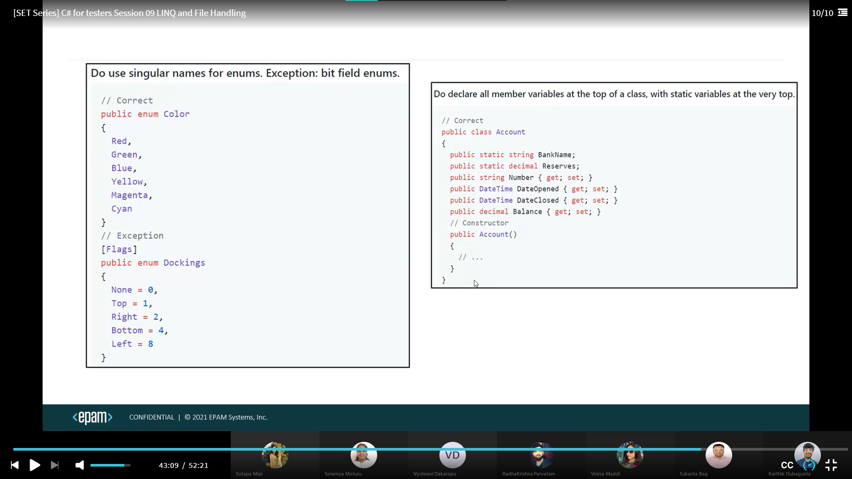

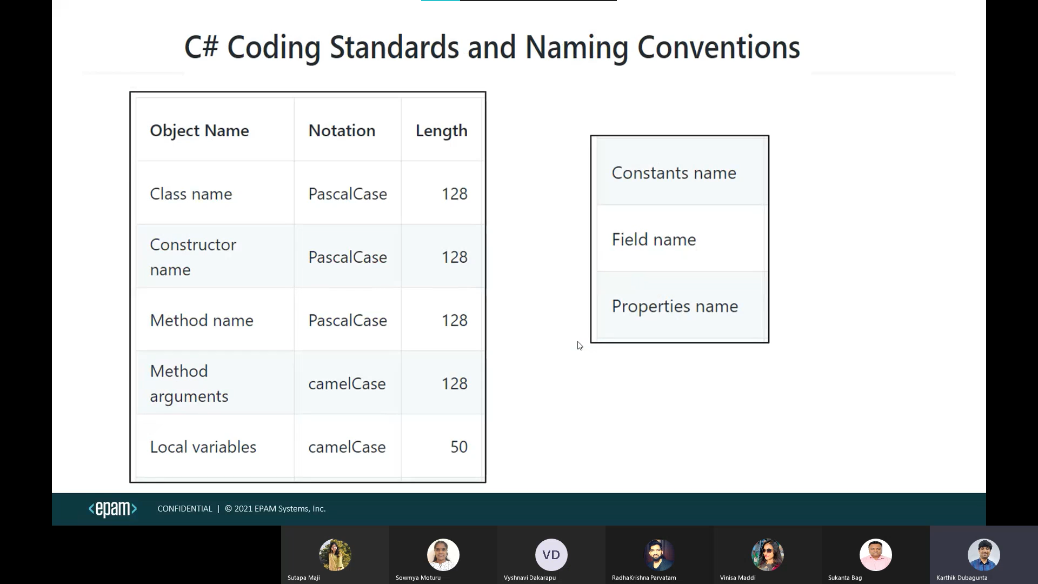

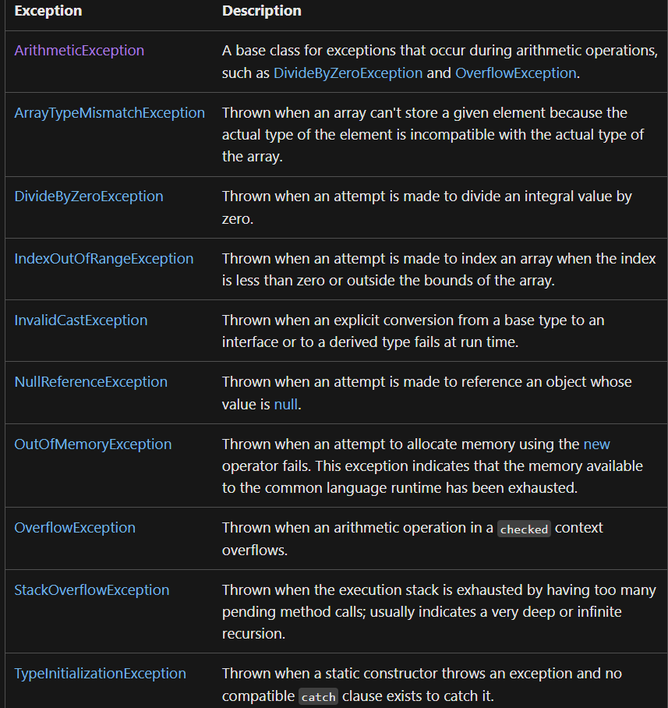

Indexers:

An indexer allows an instance of a class or struct to be indexed as an array. If the user will define an indexer for a class, then the class will behave like a virtual array.

**Syntax:**

[access_modifier] [return_type] this [argument_list]

{

get

{

// get block code

}

set

{

// set block code

}

}

**Important Points About Indexers:**

* There are two types of Indexers i.e. One Dimensional and Multi-Dimensional Indexers.
* Indexers can be overloaded.
* Indexers are also known as the *Smart Arrays* or *Parameterized Property* in C#.
* Indexer can’t be a static member as it is an instance member of the class.

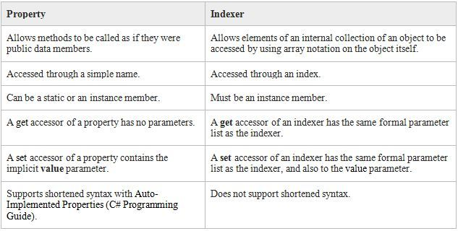

Supports expression bodied members for get only indexers.

|  |  |
| --- | --- |
| Indexers are created using this keyword | Properties don't require this keyword |
| Indexers can be overloaded | Properties can't be overloaded |
| Indexers are identified by signatures | Properties are identified by their names. |

Properties are first class citizens in C#.

A field defines a storage location

However, unlike fields, properties are implemented with accessors that define the statements executed when a property is accessed or assigned.

Properties are helpful in validation in setter ,Encapsulation and synchronization than fields.

Tuples:

* System.ValueTuple types are value types. System.Tuple types are reference types.
* System.ValueTuple types are mutable. System.Tuple types are immutable.
* Data members of System.ValueTuple types are fields. Data members of System.Tuple types are properties

(int a, byte b) left = (5, 10);

(long a, int b) right = (5, 10);

Console.WriteLine(left == right); // output: True

Console.WriteLine(left != right); // output: False

var t1 = (A: 5, B: 10); //independent of field names

var t2 = (B: 5, A: 10);

Console.WriteLine(t1 == t2); // output: True

Console.WriteLine(t1 != t2); // output: False

* multiple return types
* combination of collections
* hold database record temporarily.
* It is of reference type not of value type.
* It is limited to eight elements. Means you cannot store more than eight elements without nested tuple.
* These are only accessed by using *Item<elementNumber> property*

Linq:

[LINQ Tutorial - Javatpoint](https://www.javatpoint.com/linq)

Generics type Constraints:

Constraints inform the compiler about the capabilities a type argument must have.

Without any constraints, the type of argument could be any type. The compiler can only assume the members of System.Object.

New()🡪The type argument must have a public parameterless constructor.

[Constraints on type parameters - C# Programming Guide | Microsoft Learn](https://learn.microsoft.com/en-us/dotnet/csharp/programming-guide/generics/constraints-on-type-parameters)

[new constraint - C# Reference | Microsoft Learn](https://learn.microsoft.com/en-us/dotnet/csharp/language-reference/keywords/new-constraint)

**BinaryFormatter.Deserialize(stream)**

**BinaryFormatter.Serialize(stream, reference)**

Events in C# are a way for a class to provide notifications when something of interest occurs. The concept is based on the Observer design pattern, where the class that emits the event is known as the Publisher, and the classes that receive the event are called Subscribers.

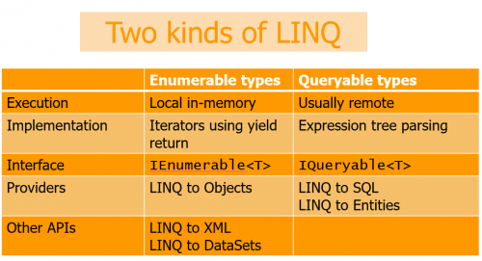

Iquerable is the child Of IEnumerable

Iquerable contains ElementType, Expression, (query)Provider without setters in system.Linq

IEnumerable contains GetEnumerator() method in System.Collections namespace.

IEnumerator Contains current with get, MoveNext(), Reset() methods System.Collections namespace

Range:  used to generate the sequence of integers upto count.

TakeWhile: will take values until condition fails, once failed it no longer takes values

SkipWhile: will skip values until condition fails, once failed it no longer skip values

[Exploring .NET 6's MinBy() and MaxBy() Extension Methods](https://www.c-sharpcorner.com/article/exploring-net-6s-minby-and-maxby-extension-methods/)

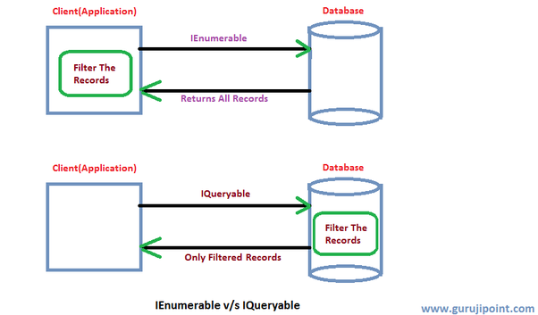

ICloneable contains clone() method.

IDisposable contains dispose() method which frees,release,reset unmanaged code

IEqualityComparer<T> contains Equals() and GetHashCode() methods in system.Collections.Generic namespace.

IEquatable<T> contains Equals() method in system namespace.

IComparable<T> contains CompareTo(obj) method in System namespace.

IComparer <T> contains Compare(obj1,obj2) method in System.Collections.Generics namespace.

TODictionary vs ToLookup

* **Uniqueness**: **ToDictionary** requires unique keys and fails with duplicates; **ToLookup** handles duplicates gracefully.
* **Mutability**: **Dictionary** objects are mutable, while **Lookup** objects are not.
* **Execution Timing**: **ToDictionary** executes immediately, while **ToLookup** employs deferred execution for element retrieval.

Concat vs Union (both preserves order)

Concat: don’t remove duplicates

Union: remove duplicates, set based

use casting when you are dealing with related types or when you are sure about the compatibility of types, and use Convert methods when dealing with different or unrelated types, especially with user input or external data sources.

1. **Deferred Execution or Lazy Operators:**These Query Operators are used for Deferred Execution. For example – Select, SelectMany, Where, Take, Skip, etc. belong to the Deferred or Lazy Operators Category.
2. **Immediate Execution or Greedy Operators:**These Query Operators are used for Immediate Execution. For example – Count, Average, Min, Max, First, Last, ToArray, ToList, etc., belong to the Immediate or Greedy Operators category.

| **Feature** | **Group By** | **Group Join** |
| --- | --- | --- |
| Purpose | Groups elements within a single collection based on a specified key. | Correlates the elements of two collections based on matching keys and groups results. |

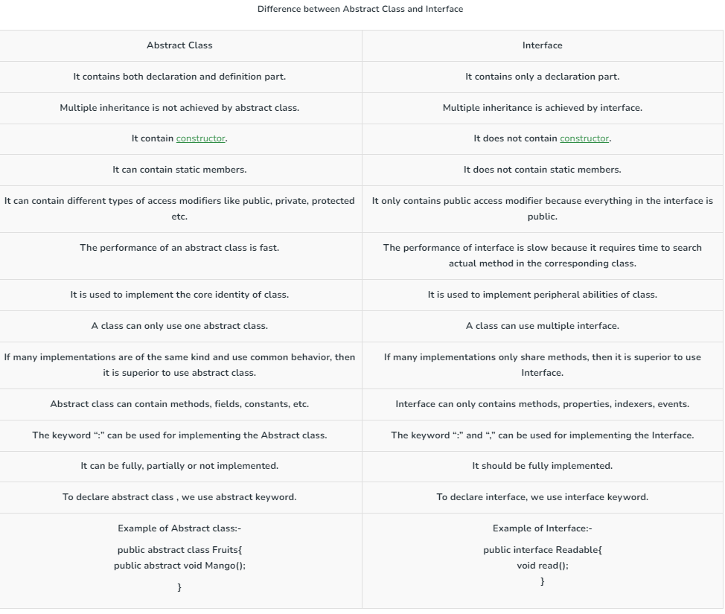

array accepts null value only when it is string type otherwise it does not accepts null value.

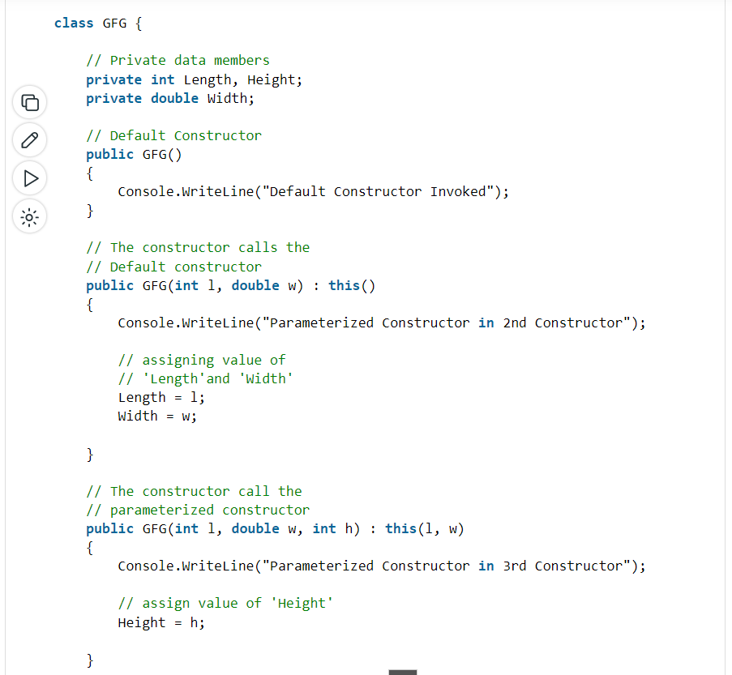

**Explicit Implementation Requirement**: When a class implements multiple interfaces that have conflicting default implementations for the same method, the class must provide an explicit implementation of the method

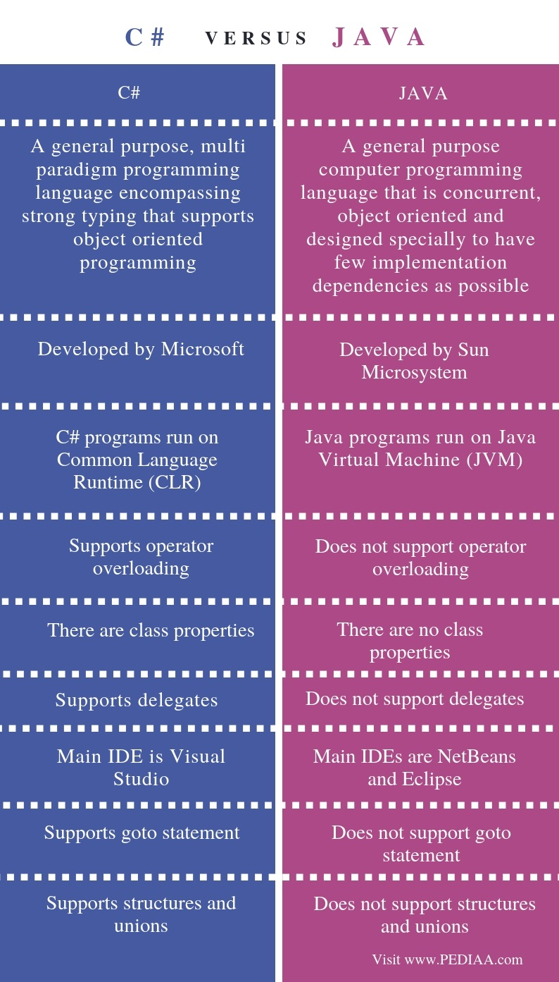 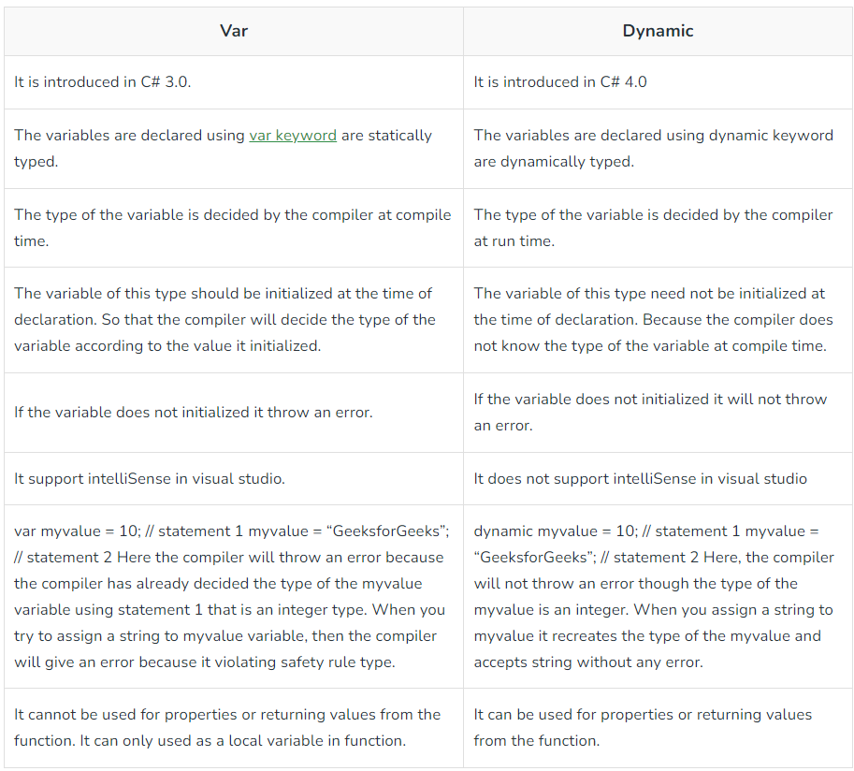

[Nested ClassesSin C# - GeeksforGeeks](https://www.geeksforgeeks.org/nested-classes-in-c-sharp/)

[What is Anonymous Types in C#? - GeeksforGeeks](https://www.geeksforgeeks.org/c-sharp-anonymous-types/)

**These are the methods of system.console**

* [Read**Key**()](https://msdn.microsoft.com/en-us/library/471w8d85(v=vs.110).aspx) (returns a **character or** ConsoleKeyInfo): reads only one single character from the standard input stream or command line. Usually used when you're giving options to the user in the console to select from, such as select A, B or C. Another prominent example, Press Y or n to continue.
* [Read**Line**()](https://msdn.microsoft.com/en-us/library/system.console.readline(v=vs.110).aspx) (returns a **string**): or Console.Readline() reads a single line from the standard input stream or the command line. As an example, it can be used to ask the user enter their name or age. It reads all the character till we press **enter**.
* [Read()](https://msdn.microsoft.com/en-us/library/system.console.read(v=vs.110).aspx) (reads and returns an **int**): or Console.Read() reads only one single character from the standard input stream. Similar to ReadKey except that it returns an integer. It returns the next character from the input stream, or returns (-1) if there is no more character to be read.
* Char is converted to int(Ascii)

(There are more system.console methods like write() and writeline() as well which are used to write in command line, behaving similarly as read() and readline() methods)

Object pooling offers the following pros for C# programmers:

* Object pooling can help improve performance by reusing objects that have already been instantiated, instead of creating new ones.
* It can also help reduce memory usage, since objects that are no longer needed can be returned to the pool rather than being left to be garbage collected by the runtime.
* Additionally, object pooling can make code more readable and maintainable by keeping track of objects in a central location.

Object pooling also has the following cons in C# software development: (design Pattern)

* One potential downside of object pooling is that it can introduce complexity to your code.
* Additionally, if not used correctly, object pooling can lead to decreased performance or memory leaks.

Delegate are declared inside class or outside class , inside or outside namespace.

Delegates types are sealed.

Generics in C# types are defined during runtime where in java they are type erasures they are defined in compiletime.

Log4Net:

<https://youtu.be/0Z8ai7K-_1g>

* log4net is optimized for speed.
* log4net is based on a named logger hierarchy.
* log4net is thread-safe.
* Logging behavior can be set at runtime using a configuration file. Configuration files are in XML format.
* log4net is designed to handle exceptions from the start.
* log4net categorizes logging into levels: DEBUG, INFO, WARN, ERROR and FATAL.
* The format of the log output can be easily changed by implementing a new layout class.
* The target of the log output as well as the writing strategy can be altered by writing a new appender class.
* log4net supports multiple output appenders per logger.
* ALL < DEBUG < INFO < WARN < ERROR < FATAL < OFF

|  |  |
| --- | --- |
| **Level** | **Comments** |
| DEBUG | Log messages that are useful to debug an application |
| INFO | Log messages that highlights the progress of the application at coarse-grained level |
| WARN | Log messages that are potentially harmful situations |
| ERROR | Logs error events that might still allow the application to continue running |
| FATAL | Logs very severe error events that will presumably lead the application to abort |

[PatternLayout Class](https://logging.apache.org/log4net/log4net-1.2.13/release/sdk/log4net.Layout.PatternLayout.html)

Nunit:

Custom attribute class should inherit by TestActionAttribute, Attribute

* MaxTime(n)
* This attribute does not cancel the test if the time is exceeded. It merely waits for the test to complete and then compares the elapsed time to the specified maximum. If you want to cancel long-running tests.
* The **Timeout Attribute** is used to specify a timeout value in milliseconds for a test case. If the test case runs longer than the time specified it is immediately cancelled and reported as a failure, with a message indicating that the timeout was exceeded.
* Collections of datapoints may be provided by use of the **DatapointSourceAttribute.** The **DatapointSource** attribute is used to provide data for **Theories.**

# LevelOfParallelism: the maximum number of worker threads executing tests in the assembly.

* Ordered tests are started in ascending order of the order argument .

Values by default -Combinatorial approach

Combinatorial, pairwise, sequential.

[TestCaseSource(typeof(AnotherClassWithTestFixtures),nameof(AnotherClassWithTestFixtures.DivideCases))]

Typeof only for IEnumerator (yield return).

<https://learn.microsoft.com/en-us/dotnet/core/testing/selective-unit-tests?pivots=mstest>

dotnet test --filter TestCategory=Positive

[OneTimeSetUp] works as you expect. It executes once, before all your tests and all your tests will use the same product.

[Setup] operations are performed just before each test method is called.

Assert.Multiple(() => {

Assert.That(result.RealPart, Is.EqualTo(5.2)); Assert.That(result.ImaginaryPart, Is.EqualTo(3.9));

});

For Debugging in Visual Studio:

* ctrl+click or F12
* Retry--> first time not execute because of delay, api testing.
* .net core in visual studio.
* select var right click debug and change value while debugging
* quick watch in debug

Jenkins:

[CI with Jenkins training | EPAM Video Portal](https://videoportal.epam.com/video/8JYK0zod)

We can traverse both forward and backward in DOM, i.e we can move from parent to child element and also from child to the parent element with xpath. However for css, we can only traverse from parent to child and not vice-versa.

Selenium: JasonHuggins 2004

It uses the process of serialization (convert Object’s data to JSON Format) and de-serialization(convert JSON format to object) just like REST web services.

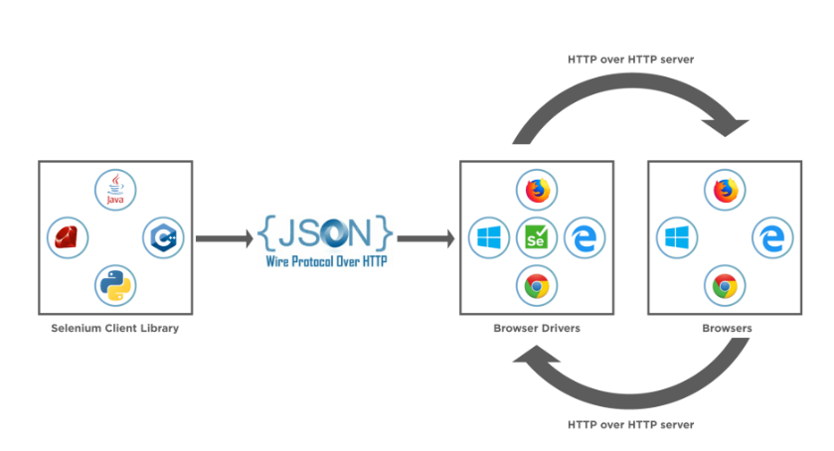

**IME (Input Method Engine)**

[What is Selenium WebDriver Architecture? How Does it works? (toolsqa.com)](https://www.toolsqa.com/selenium-webdriver/selenium-webdriver-architecture/)

[Exception Handling in Selenium Webdriver (Types)](https://www.guru99.com/exception-handling-selenium.html)

[Understanding Stale Element Reference Exception in Selenium - GeeksforGeeks](https://www.geeksforgeeks.org/understanding-stale-element-reference-exception-in-selenium/)

WebDriverException typically occurs when the WebDriver tries to perform actions or operations immediately after closing the driver session.

HTMLUnit Driver implementation is fastest -headless mode – execution is not visible to us. (running without GUI)

Either Selenium IDE can be opened as a pop-up window or inside bar

Window Handles:

[Selenium C# Tutorial: Handling Multiple Browser Windows (lambdatest.com)](https://www.lambdatest.com/blog/selenium-c-tutorial-handling-multiple-browser-windows/#:~:text=Commands%20Used%20For%20Window%20Handling%20In%20Selenium%20C%23,open%20instances%20of%20the%20browser%20under%20test.%20)

Once the[Selenium WebDriver](https://www.lambdatest.com/blog/selenium-webdriver-tutorial-with-examples/) instance is instantiated, a unique alphanumeric id is assigned to the window. This is called window handle and is used to identify browser windows. Since the id is unique, it is used by the Selenium WebDriver to switch between different windows (or tabs).

Close ()🡺 close only current instance of the driver.

Quit ()🡺 Closes all instances of the driver.

**Dispose()** is a method implemented from the IDisposable interface common in .NET environments. It's used for releasing unmanaged resources, cleaning up, and calling **Quit()** internally on the WebDriver instance.

Cases to use Quit ():

1. Multiple tabs are open.
2. Error occurred like driver already in use.

WebDriver Commands:

1. Url
2. Title
3. PageSource
4. CurrentWindowHandle
5. WindowHandles
6. Close, Quit, dispose.
7. FindElement, FindElements
8. Manage (. Cookies, Window, Timeouts(), logs)
9. SwitchTo (NewWindow(), Window(), Frame(), Alert(), ParentFrame(), ActiveElement(), DefaultContent())
10. Navigate

Web Element Commands:

1. TagName
2. Text
3. Enabled
4. Selected
5. Location
6. Size
7. Displayed
8. Clear
9. SendKeys
10. Submit
11. Click
12. string GetAttribute(string attributeName);
13. string GetDomAttribute(string attributeName);
14. string GetDomProperty(string propertyName);
15. string GetCssValue(string propertyName);
16. ISearchContext GetShadowRoot();

Most people don't know the difference between an element attribute and an element property, so the traditional getAttribute method returns either the attribute or the property depending on which the you probably want. It does a good job of this. When moving to a w3c standard, though, we can't define a "best guess at what user wants" endpoint, so there is an attribute endpoint and a property endpoint. For backwards compatibility, we kept the original behavior for getAttribute and it is now implemented by sending a large chunk of JavaScript to the browser. The new methods are named slightly differently in different languages, but essentially getDomAttribute & getDomProperty which always return the exact value for property and attribute.

GetShadowRoot()🡺ShadowDOM is used to separate certain HTML structure, JS and CSS from the actual application DOM.

Encapsulated one

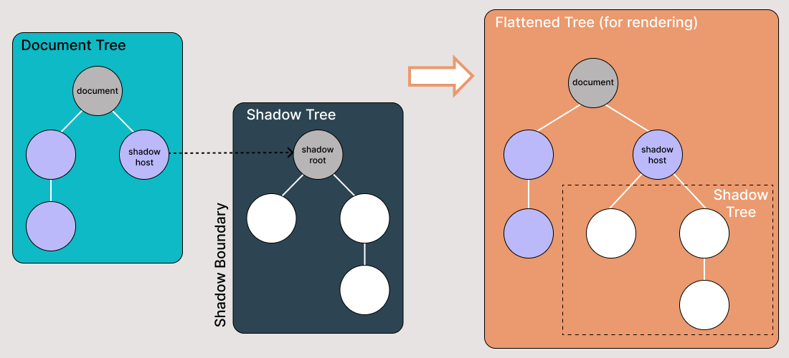

| **Method** | **Description** | **Use Case** |
| --- | --- | --- |
| **GetAttribute** | Retrieves the value of a web element's attribute as it is represented in the DOM after the page has been parsed and after any JavaScript has potentially modified the DOM. | Use when you need the current state of an attribute, possibly after dynamic changes by JavaScript. |
| **GetDomAttribute** | Retrieves the value of a web element's attribute exactly as it appears in the HTML source code, without any modifications made by JavaScript. | Use when you need the original value of an attribute as provided in the HTML source. |

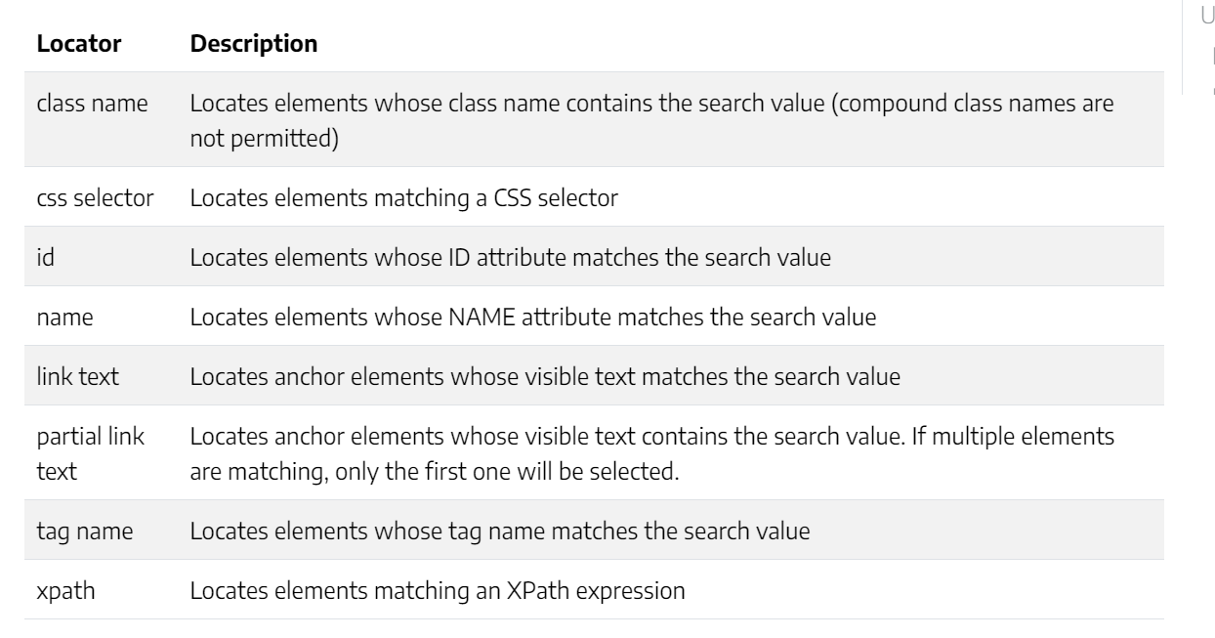

Navigation Commands:

1. GoToUrl()
2. Back()
3. Forward()
4. Refresh()
5. Equals(), GetType(), ToString().

IReadOnlyCollection: It Contains only count property with get. (thread safe) multiple readers are allowed.

Using System.Collections.Generic.

ReadOnlyCollection:

Using System.Collections.ObjectModel;

The fact that ReadOnlyCollection is immutable means that the collection cannot be modified, i.e. no objects can be added or removed from the collection. This does not mean that the objects it contains immutable.

Count, list[i], contains(), CopyTo(), GetEnumerator(), IndexOf().

Add, Insert, Remove, RemoveAt, Clear 🡺 Throws NotSupportedException.

Implements IList, IList<T>, IReadOnlyList<T>

**GetCssValue() vs GetAttribute():**

* Inside style attribute properties are printed through GetCssValue()

<input type = "text" id = "firstName">

* getAttribute("type") = "text"
* getCssValue("type") = ""

Upload File:

IWebElement fileInput = driver.FindElement(By.Id("file-upload")); *// change selector*

fileInput.SendKeys("C:\\Path\\To\\Your\\File.txt")

DownloadFile;

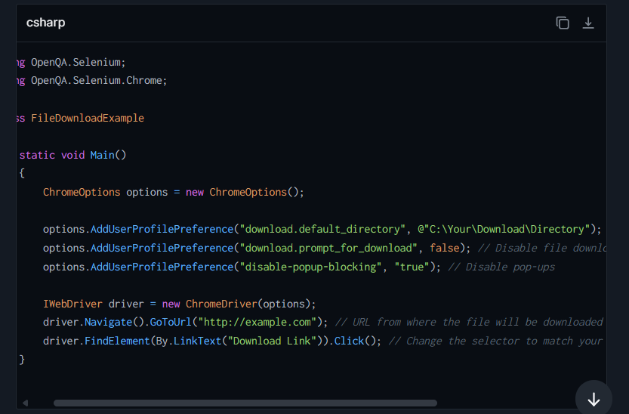

Implicit Waits:

1. Implicit Wait
2. PageLoad
3. Asynchronous JavaScript
4. Thread.Sleep()

***Default value of implicit wait is 0 seconds***. Implicit wait has a default polling time of 250 milliseconds.

**Explicit Waits:** They are Smart waits which waits for the time till the condition specified *in wait* ***.until*** *(* YourCondition*) method becomes*true. Polling Time=500ms

Fluent Waits:

The ***polling time (or polling interval)*** is the time interval in which Selenium starts searching again after the last failed try. Again Repeats the Steps.

* Fluent Wait is used to define the maximum amount of time to wait for a condition, as well as the frequency

Custom Waits:

Webdriver Wait: It is bounded to webDriver

Default Wait: Default wait is more generic wait in the sense that it is not bound to WebDriver. This wait can be used to pass in any object to wait on.

SwitchTo()🡺 Handling Windows, Alerts, Frames.

ActiveElement, ParentFrame, DefaultContent, Frame, Window

**ActiveElement** - Switches focus to element that has focus at the moment. If there’s no element with focus, this method will switch to body element of the page.

**Alert** - Switches focus to currently active dialog box.

**DefaultContent** - Switches focus to the first frame on the page or main document if page contains iframes.

**Frame** - Switches focus to frame by given index.

**ParentFrame** - Switches focus to parent frame of currently selected frame.

**Window** - Switches focus to the window with specified name.

1. webDriver.Close() - Close the browser window that the driver has focus of
2. webDriver.Quit() - Calls Dispose()
3. webDriver.Dispose() - Closes all browser windows and safely ends the session.

Best Practices of Locating Elements in Selenium:

* Choose the right Selenium locator to recognize a web element in Selenium.
* Avoid using dynamic attribute values to locate different elements in the Selenium locator.
* Use ID and name attributes when your web page contains a unique set instead of XPath for a speedy process.
* When using locators, ensure that the locator points directly to the needed element.
* Avoid anything that causes breakage in the script, such as using auto-generated elements since we generate element attribute properties at a run time in a dynamic web environment.
* When using CSS or XPath locators, avoid using those generated by the Chrome Dev Tools. This leads to code breakage, maintenance, and reliability issues.
* Always keep your locators short of identifying them easily.

Alerts:

1. Simple Alerts
2. Confirmation Alerts
3. Prompt Alerts.

Actions:

KeyDown:

The keyDown() method is used for pressing and holding a key. The keys that we are referencing here are the Shift, Ctrl, and Alt keys.

The keyUp() method is used to release the key that is already pressed using the keyDown() method.

JavaScriptExecutor is used when Selenium Webdriver fails to click on any element due to some issue.

* JavaScriptExecutor provides two methods “executescript” & “executeAsyncScript” to handle.
* Executed the JavaScript using Selenium Web driver.
* Illustrated how to click on an element through JavaScriptExecutor, if selenium fails to click on element due to some issue.
* Generated the ‘Alert’ window using JavaScriptExecutor.
* Navigated to the different page using JavaScriptExecutor.
* Scrolled down the window using JavaScriptExecutor.
* Fetched URL, title, and domain name using JavaScriptExecutor.
* <https://blog.qasource.com/software-development-and-qa-tips/how-to-resolve-element-click-intercepted-exception-in-selenium>

Relative Locators:

* **Below():** Web element located below for the specified element.
* **LeftOf() :** Target web element which is present to the left of specified element.
* **RightOf():** Target web element which is presented to the right of a specified element.
* **Above():** Web element located above for the specified element.
* **Near() :** Target web element which is away(approx. 50 pixels) from the specified element.

**StaleElementReferenceException:** This Selenium exception occurs happens when the web element is detached from the current DOM.

[What's new in Selenium 4: Key Features | BrowserStack](https://www.browserstack.com/guide/selenium-4-features)

PageFactory: reduce Boilercode, lazy instialization of elements, readability, encapsulation

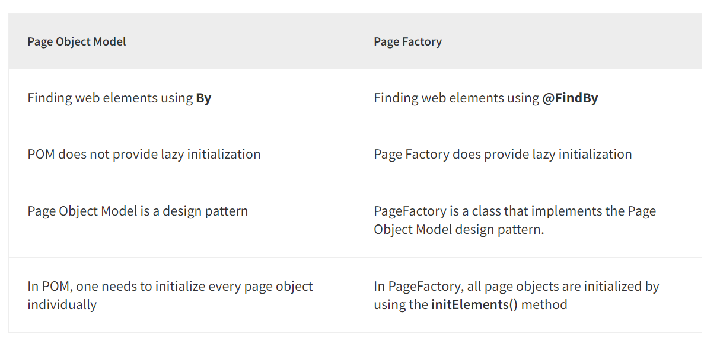

Selenium Grid:

* The ***Selenium Grid*** is a testing tool which allows us to run our tests on different machines against different browsers. It executes tests Parallelly.
* The new Selenium Grid comes with Docker support and we can deploy on Kubernetes.

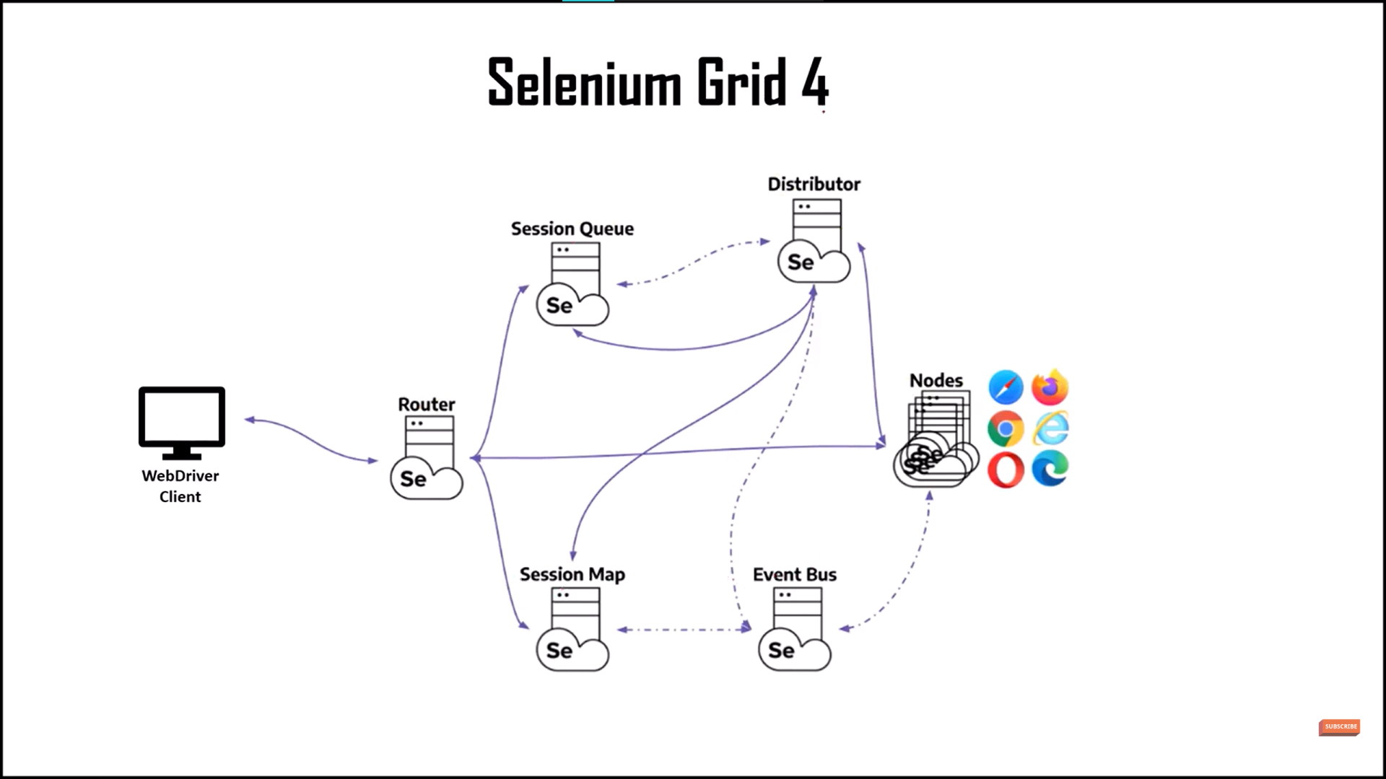

driver=new RemoteWebDriver (new Uri(http://localhost:4444),options);

C:\Users\Vishnu_Kolluri\Selenium_Grid

Selenium Grid Components:

1. **Router** = It is the Entry point of Selenium Grid. From WebDriver client it takes requests and pass to session or node. If we have request in existing session, it will directly pass request to node.
2. **Session map** = It is used for data storage, it contains information of sessionId, NodeId.
3. **Session Queue** = (FIFO) store session request
   1. Request timeout
   2. Session Retry
4. **Distributor** = It sees session Queue if there are any pending requests and pass to node and it registers the node.
   * 1. It creates requested session at the node.
     2. and keeps the information of node and capabilities in the Selenium Map.
5. **Event bus** = node sends registration event to the Event bus.
   * 1. Internal Communicator in the grid
     2. distributor reads the Event bus to check node is reachable otherwise it throws node unreachable Exception.
6. **Node** = server or machines, where multiple instances or browsers are running, and our test scripts are executed.
7. In Selenium Grid, the hub is a central server that manages the network of test machines and directs test requests to individual nodes for execution

Selenium Grid Modes:

1. **Standalone Mode:**  (5 or less node)

* + java -jar selenium-server-4.8.0 standalone

2. **Hub and Node Mode**: (6 to 100 nodes)

Same Machine:

* + java -jar selenium-server-4.9.0.jar hub
  + java -jar selenium-server-4.8.0.jar node --port 7777

Different Machine:

* + java -jar selenium-server-4.8.0 node --hub http://localhost:4444

3. **Distributed Mode:** (more than 100 nodes)

* In this mode each component should be registered at different VMs

<https://youtu.be/J6EdJ6wBZPQ>

[FindsBy(How=How.Id, Using = "g2599-name")]

[CacheLookup]

PageFactory.InitElements(driver, obj);

Xpath axes, CSS selectors

 //div[@class=’Mammal’]/ancestor::div

//*[contains(text(),'ABC')]

|  |  |
| --- | --- |
| **AxisName** | **Result** |
| ancestor | Selects all ancestors (parent, grandparent, etc.) of the current node |
| ancestor-or-self | Selects all ancestors (parent, grandparent, etc.) of the current node and the current node itself |
| attribute | Selects all attributes of the current node |
| child | Selects all children of the current node |
| descendant | Selects all descendants (children, grandchildren, etc.) of the current node |
| descendant-or-self | Selects all descendants (children, grandchildren, etc.) of the current node and the current node itself |
| following | Selects everything in the document after the closing tag of the current node |
| following-sibling | Selects all siblings after the current node |
| namespace | Selects all namespace nodes of the current node |
| parent | Selects the parent of the current node |
| preceding | Selects all nodes that appear before the current node in the document, except ancestors, attribute nodes and namespace nodes |
| preceding-sibling | Selects all siblings before the current node |
| self | Selects the current node |

[CSS Selectors Cheat Sheet](https://www.freecodecamp.org/news/css-selectors-cheat-sheet/)

Advantages of selenium:

* 1. OpenSource
  2. Handles dynamic pages
  3. Automate Web Testing, reduce time for testing
  4. Cross browser testing
  5. Strong Support team
  6. Language Support
  7. Head and Headless mode testing
  8. Integrate with other tools

Playwright:

Advantages of Playwright over selenium:

* 1. Autowaits
  2. Used for Modern Web Applications which rely on Javascript
  3. High Speed and performance
  4. More inbuilt methods : screenshots, recording video, generating pdfs etc
  5. Better handling of browser contexts
  6. Simplified Apis – easy who already knows JS
  7. Can do API testing also

Disadvantages:

* 1. Captcha, barcodes
  2. Payment
  3. Can’t do desktop, Mobile testing
  4. Learning should be needed
  5. Lack of logging, reporting

Playwright is an open-source test automation framework for web applications. It was developed by Microsoft and released to the public on January 2020

Playwright, browser,browsercontext (browser session), page  
 public static async Task Main()  
 {  
 using var playwright = await Playwright.CreateAsync();  
 await using var browser = await playwright.Chromium.LaunchAsync(new{Headless= false});

var browserContext = browser.NewContextAsync()  
 var page = await browserContext.NewPageAsync();  
  
 await page.GotoAsync("https://www.microsoft.com");  
 // other actions...  
 }

Browsers: Chromium, Firefox, WebKits

**Specflow: (Tricentis)**

**Reqnroll**

**Topics: (gherkin, bindings, execution)**

## Step Definition Methods Rules

* Must be in a public class, marked with the [Binding] attribute.
* Must be a public method.
* Can be either a static or an instance method. If it is an instance method, the containing class will be instantiated once for every scenario.
* Cannot have out or ref parameters.
* Should return void or Task.
* SpecFlow supports a very simple dependency framework that is able to instantiate and inject class instances

[Create calculator project — documentation (specflow.org)](https://docs.specflow.org/projects/getting-started/en/latest/GettingStarted/Step2.html)

[Gherkin Reference — documentation (specflow.org)](https://docs.specflow.org/projects/specflow/en/latest/Gherkin/Gherkin-Reference.html) 26.2.0

[Step Definitions — documentation (specflow.org)](https://docs.specflow.org/projects/specflow/en/latest/Bindings/Step-Definitions.html)

[Sharing Data between Bindings — documentation (specflow.org)](https://docs.specflow.org/projects/specflow/en/latest/Bindings/Sharing-Data-between-Bindings.html)

[Hooks — documentation (specflow.org)](https://docs.specflow.org/projects/specflow/en/latest/Bindings/Hooks.html)

[Scoped Step Definitions — documentation (specflow.org)](https://docs.specflow.org/projects/specflow/en/latest/Bindings/Scoped-Step-Definitions.html)

[Command Line Usage — SpecFlow+ Runner documentation](https://docs.specflow.org/projects/specflow-runner/en/latest/Usage/SpecFlowPlus-Runner-Command-Line.html)

[ScenarioContext — documentation](https://docs.specflow.org/projects/specflow/en/latest/Bindings/ScenarioContext.html)

[SpecFlow.Assist Helpers — documentation](https://docs.specflow.org/projects/specflow/en/latest/Bindings/SpecFlow-Assist-Helpers.html)

[Welcome to SpecFlow+ LivingDoc’s documentation! — SpecFlow+ LivingDoc documentation](https://docs.specflow.org/projects/specflow-livingdoc/en/latest/)

Context Injection:

POCO, Dependency injection (constructor)

* A Background allows you to add some context to the scenarios that follow it. It can contain one or more Given steps, which are run before *each* scenario, but after any [Before hooks](https://docs.specflow.org/projects/specflow/en/latest/Bindings/Hooks.html).
* A Scenario Outline must contain an Examples
* The automation that connects the Gherkin specifications to source code is called a *binding*.
* By default the hooks of the same type (e.g. two [BeforeScenario] hook) are executed in an unpredictable order.
* When running tests in multiple threads with SpecFlow+ Runner, Before and After hooks such as BeforeTestRun and AfterTestRun are executed once for each thread.
* ScenarioContext helps you store values in a dictionary between steps.
* Feature Context dict<string,int>

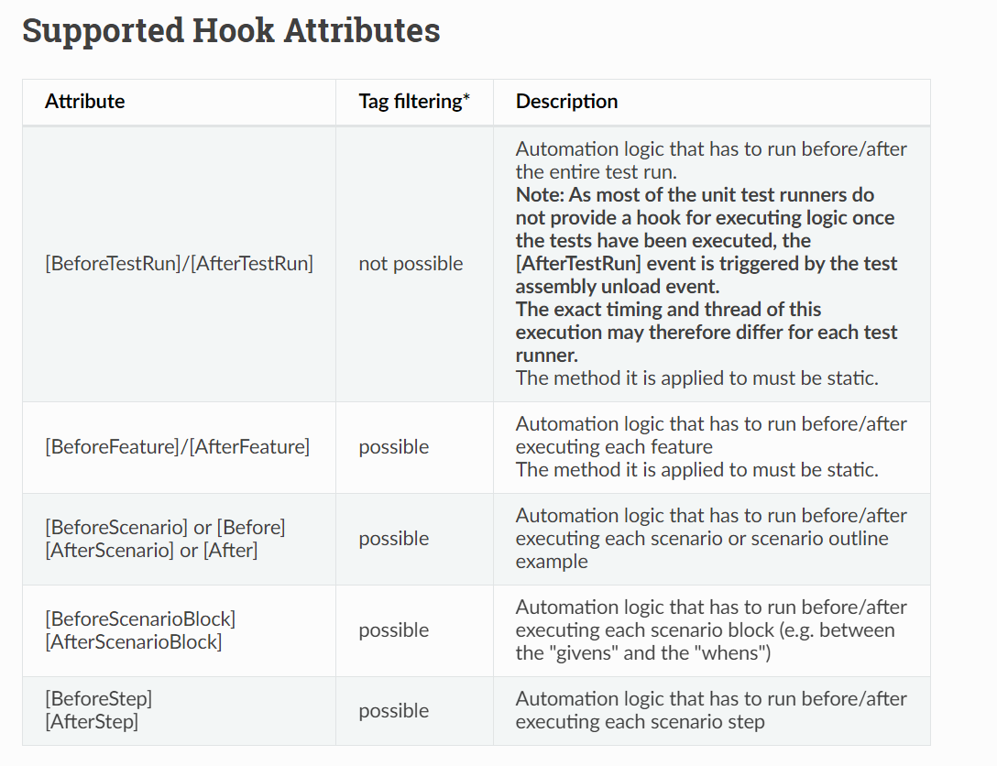

{

**"stepAssemblies"**: [

{

**"assembly"**: "MySharedBindings"

}

]

}

<specFlow>

<stepAssemblies>

<stepAssembly assembly="MySharedBindings" />

</stepAssemblies>

</specFlow>

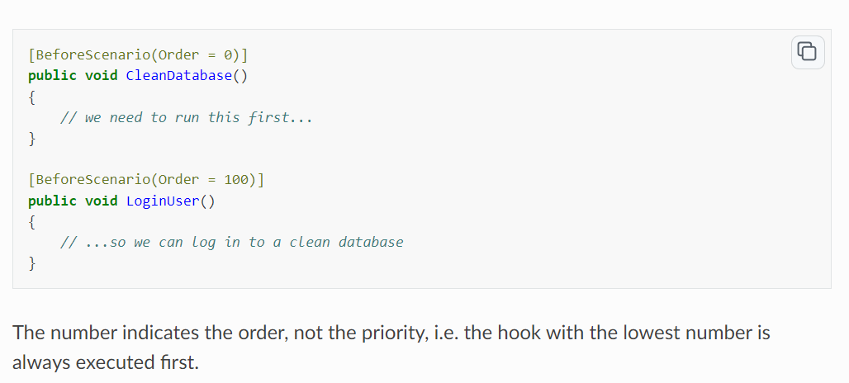

[Scope(Tag = "mytag", Feature = "feature title", Scenario = "scenario title")]

Feature: Calculator

* SpecRun.exe run Default.srprofile --basefolder c:\MyProjectFolder --outputfolder output --report MyReport.html

SpecFlow+ LivingDoc (closed-source): This is a**set of tools that renders your Gherkin Feature Files** in an easily readable format with syntax highlighting and allows you to quickly share and collaborate on Gherkin Feature Files with stakeholders that are not familiar with developer tools

[BeforeScenario(Order = 100)]

Scenario Outline: Add two numbers

Given I have entered <a> into the calculator

And I have entered <b> into the calculator

When I press add

Then the result should be <result> on the screen

@source:CalculatorExamples.xlsx

Examples:

| case | a | b | result |

[External Data Plugin — documentation (specflow.org)](https://docs.specflow.org/projects/specflow/en/latest/Guides/externaldata.html)

@ignore

@source

@DataSource, @DisableDataSource

@DataFormat=format This tag only needs to be used if the format cannot be identified from the file extension.

@DataField=change the Column name (c=p)

@DataSet = Sheetname

FeatureContext methods : FeatureInfo, Count, TestError

ScenarioContext methods: Count

* 1. Pending() - throws PendingStepException (not implemented step)
  2. ScenarioInfo – Info about scenario (Title, Description, Tags, Arguments)
  3. TestError – error (returns exception)
  4. CurrentScenarioBlock – type of the block (Given, When, Then)
  5. StepContext - to access the currently executed step

Nunit behind Specflow in Onetime setup it will call test runner, and uses Test Attribute, TestcaseAttribute, DescriptionAtttributes, CategoryAttribute and uses TechTalk.specflow library

IObjectContainer in SpecFlow is a built-in dependency injection container that is used to manage objects and dependencies within the scenario execution. It is part of the BoDi (a lightweight dependency injection framework) which is embedded in SpecFlow and is designed to maintain the state across different bindings and step definitions during the complete lifecycle of a scenario.

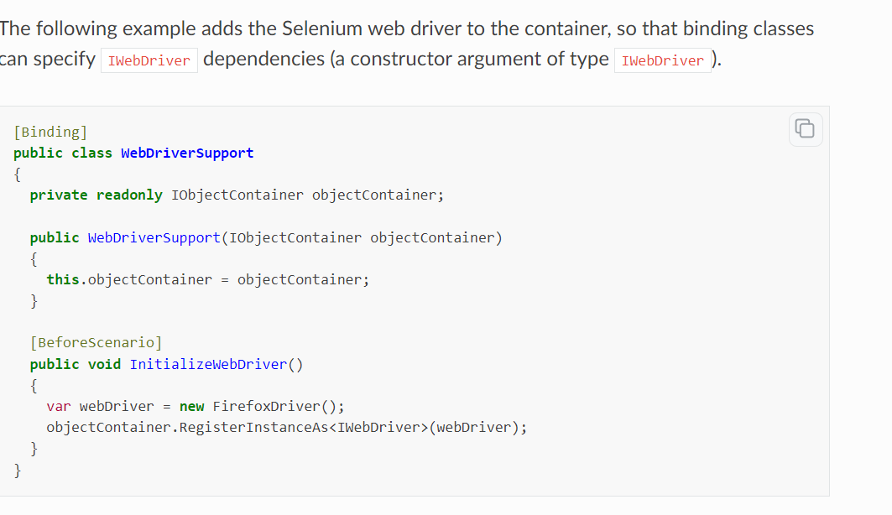

Resolve dependency

**Rest API:**

Endpoint: is a URL which represents the resource.

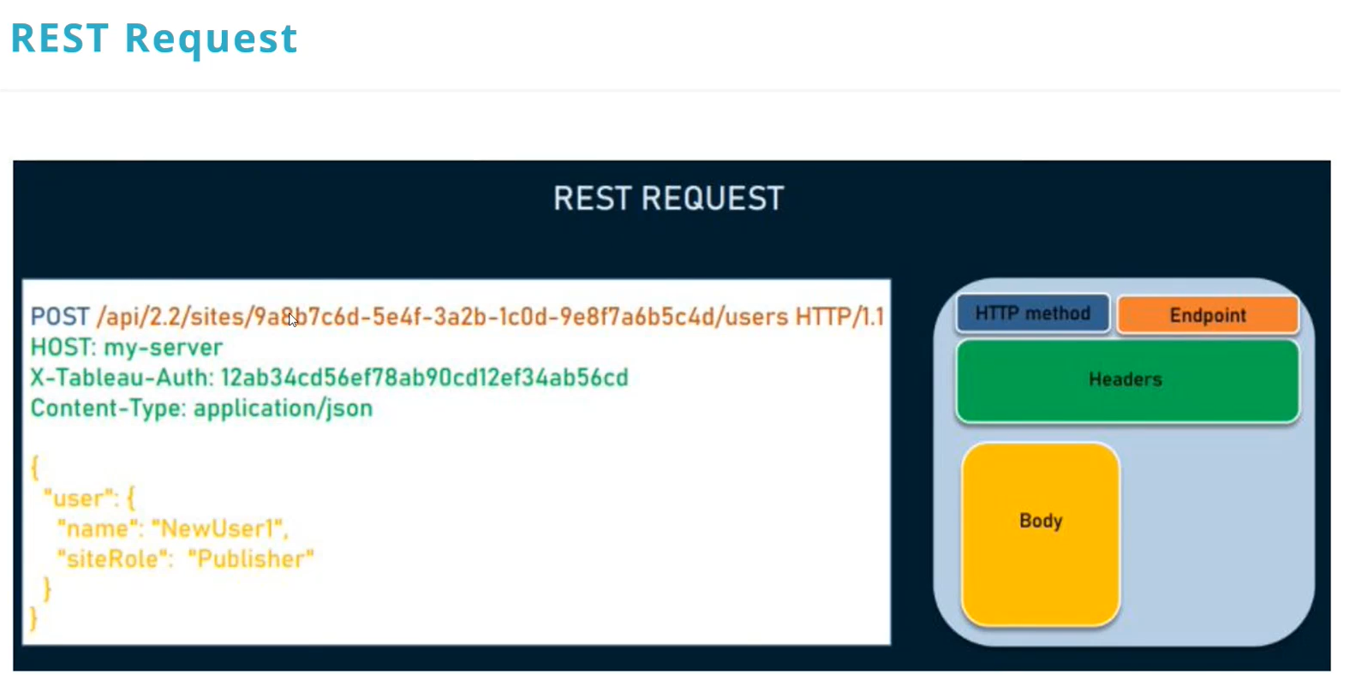

[Monolithic vs Microservices architecture - GeeksforGeeks](https://www.geeksforgeeks.org/monolithic-vs-microservices-architecture/)

Presentation layer, application layer, business logic layer, data access layer

A monolithic architecture is a traditional approach to designing software where an entire application is built as a single, indivisible unit. In this architecture, all the different components of the application, such as the user interface, business logic, and data access layer, are tightly integrated and deployed together.

SOA (service-oriented architecture) (reusable) is an architectural approach in which applications make use of services available in the network.

In this architecture, services are provided to form applications, through a network call over the internet.

 It uses common communication standards to speed up and streamline the service integrations in applications. Each service in SOA is a complete business function. The services are published in such a way that it makes it easy for the developers to assemble their apps using those services

If all the functionalities of a project exist in a single codebase, then that application is known as a monolithic application.

Microservices are the small services that work together. Entire functionality divides.

Service oriented:

A Service-Oriented Architecture or SOA is a design pattern which is designed to build distributed systems that deliver services to other applications through the protocol.

[SOA - Service Oriented Architecture - javatpoint](https://www.javatpoint.com/service-oriented-architecture)

WSDL stands for Web Services Description Language. It is an XML-based definition language mainly used for describing the functionality of SOAP-based web services==soap

SOAP:

* Clients uses stubs / proxies.
* Client uses Stub creates a SOAP request.
* SOAP request is sent to Web Service skeleton.
* Web Service skeleton invokes the Web Service.
* Web Service uses Skeleton prepares SOAP response.
* SOAP response is interpreted by Stub.

**Breakdown of the SOAP Request:**

* **Envelope**: The root element of the SOAP message. It defines the XML document as a SOAP message.
* **Header (Optional)**: Contains any optional attributes of the message used in processing the message, either at an intermediary point or at the ultimate endpoint. It can contain application-specific information like authentication credentials.
* **Body**: Contains the actual SOAP message intended for the ultimate endpoint of the message. All mandatory information must be included in the body.

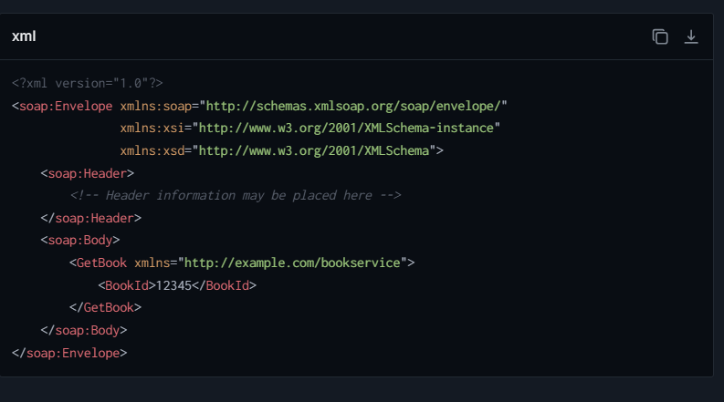

Idempotent: This means that no matter how many times you perform the operation, the state of the server remains the same after the initial request.

* POST is NOT idempotent.
* GET, PUT, DELETE, HEAD, OPTIONS and TRACE are idempotent.

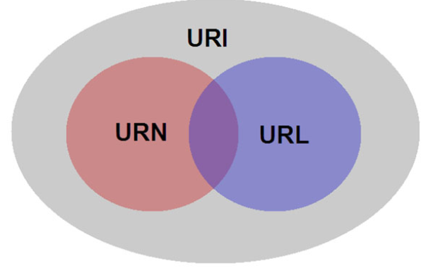

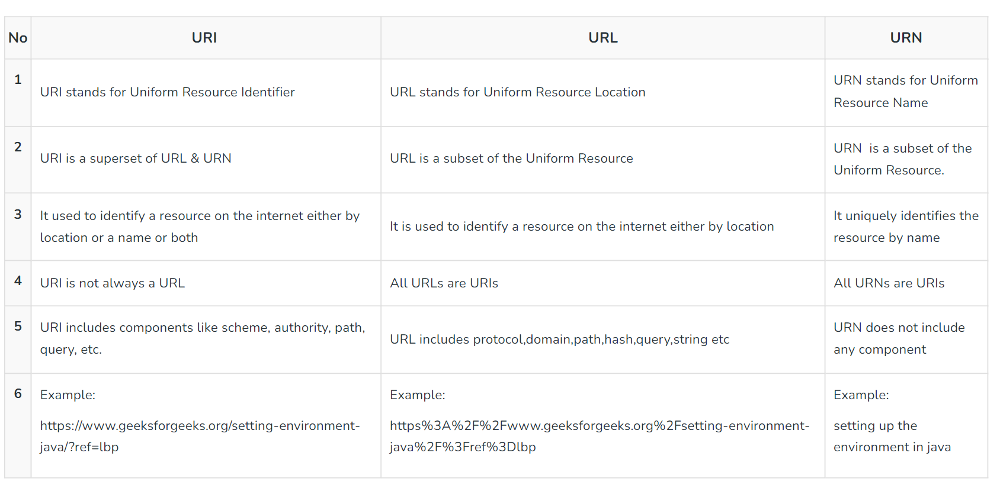

URN: urn:isbn:0451450523 URI:  ./page.html URL: https://www.google.com/search?q=example

Head: It’s used to retrieve the headers of a resource, without the resource itself.

 Options: It’s used to determine the supported methods of a server or resource.

Trace: TRACE is like sending a message in a bottle and seeing the path it takes to reach its destination. It is used for debugging purposes.

CONNECT is the tunnel builder of HTTP methods. It’s typically used by proxy servers to establish a direct link to a target over an HTTP connection.

WADL stands for Web Application Description Language, which is a machine-readable language consisting of XML descriptions, which is based on [HTTP](https://www.geeksforgeeks.org/http-full-form/) web services==Rest. (XML based)

402—payment required.

405- Method not allowed, 415 – unsupported Media type

[List of HTTP status codes - Wikipedia](https://en.wikipedia.org/wiki/List_of_HTTP_status_codes)

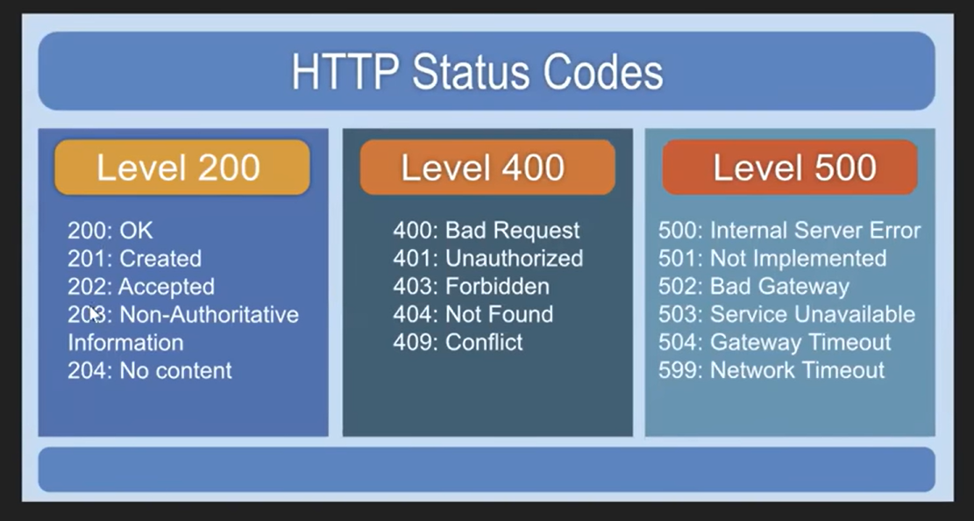

|  |  |
| --- | --- |
| **CATEGORY** | **DESCRIPTION** |
| 1xx: Informational | Communicates transfer protocol-level information. |
| 2xx: Success | Indicates that the REST web-service successfully carried out whatever action the client requested |
| 3xx: Redirection | Indicates that the client must take some additional action to complete their request. |
| 4xx: Client Error | This category of error status codes points the finger at clients. |
| 5xx: Server Error | The server takes responsibility for these error status codes. |

* **Basic Authentication** is the simpler method, sending encoded credentials with each HTTP request, leaving it vulnerable to eavesdropping unless used over HTTPS.
* **Digest Authentication** provides a more secure alternative by sending a hash of the user's credentials, rather than the credentials themselves. It incorporates additional features like nonce values to prevent replay attacks, making it more secure against potential credential theft. However, it is also more complex to implement and manage than Basic Authentication.
* [Authenticators | RestSharp](https://restsharp.dev/docs/advanced/authenticators)

1. HttpBasicAuthenticator
2. OAuth1Authenticator
   1. ForRequestToken(ConsumerKey, ConsumerSecret)
   2. ForAccessToken(ConsumerKey, ConsumerSecret, Accesstoken, AcessSecret)
      1. 0-legged Auth – consumersecret : null
   3. ForClientAuthentication(ConsumerKey, ConsumerSecret, username, password) (XAuth)
3. OAuth2
   1. OAuth2AuthorizationRequestHeaderAuthenticator(token, “Bearer”)
   2. OAuth2UriQueryParameterAuthenticator
4. JwtAuthenticator
5. Custom Authenticator : IAuthenticator

client.Authenticator = new OAuth2UriQueryParameterAuthenticator(accessToken);

Dependency Injection: Its like creating objects in another class and passing it to required class

Class can’t inherit the concrete

Rest API – may or may not follow REST principles

Restful Api = strictly follows REST principles (statelessness, uniform interface, cacheability, layered system, client server architecture, code on demand)

**API Gateway:**

It acts as a centralized entry point for managing and routing requests from clients to the appropriate backend services or microservices within a system

Features:

Request Validation, Authentication, Authorization, Monitoring, Logging, caching, Request routing, Load balancing (distributes inputs to desired server), Rate Limiting (no. of requests user can make in time frame)

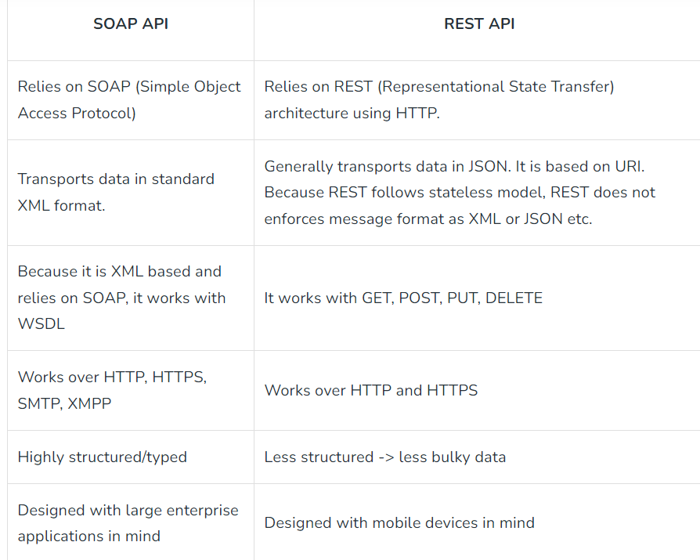

Xml, Highly structured, all protocols

Rest constraints:

1. **Uniform interface.** Specific resources should be described by [**Uniform Resource Identifier**](https://www.baeldung.com/java-url-vs-uri) (URI).
2. **Client-server architecture**.
3. **Statelessness.** A RESTful API should be stateless It refers to the practice of designing the server to treat each request as an independent transaction, unrelated to any previous request. This means the server does not store any state about the client session on the server between requests. Therefore, every single request should provide complete data to process it. Thus, it leads to greater availability of the API.
4. **Cacheability.** The server’s response should provide information on whether it should be cached and for what time or not. [**Caching**](https://www.baeldung.com/spring-cache-tutorial) the data that updates rarely improves performance and eliminates redundant client-server interactions. When possible, resources should be cacheable on the client or server side.
5. **Layered system.** A REST API can consist of multiple layers, eg., business logic, presentation, data access. Moreover, layers shouldn’t directly impact others. Further, the client shouldn’t know if it’s connected directly to the end server or intermediary. Therefore, we can easily scale the system or provide additional layers such as gateways, proxies, load balancers.
6. **Code on demand**. This one is an optional constraint. The server can return a part of the code itself instead of the data in JSON format. The point is to provide specific operations on the data that the client can use directly. Although, it’s not a common practice

A Restful system consists of a:

* client who requests for the resources.
* server who has the resources.

**Components of a REST API**

A typical REST API consists of the following parts:

* URL
* Request Method
* Request Headers
* Request body
* Response Code
* Response Headers
* Response body

Tools:

1. Curl
2. Swagger
3. Soap UI
4. Api tester
5. HTTP request app
6. Pyresttest

OAuth 2.0 defines a protocol, i.e., specifies how tokens are transferred, JWT defines a token format.

**1. Session:**

It is the overall amount of time spent on an activity. (Server side) more secure.

**2. Cookie:**  
A cookie is a small text file that is saved on the user’s computer. The maximum file size for a cookie is 4KB. (Client side)

* **Session Cookies:** These cookies are active till the browser that triggers the cookie is open. When we close the browser this session cookie gets deleted
* **Persistent Cookies:** These cookies are written permanently on the user machine and it lasts for months or years

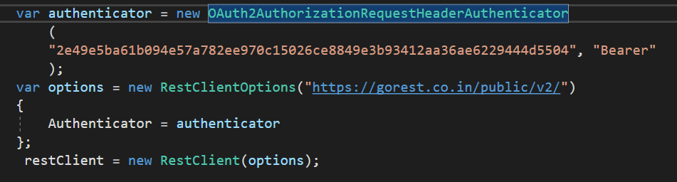

Payload issues (validation)

Deserialization Issues.

Authorization issues.

Advantages :

* Earlier validation of correctness in response and data.
* Earlier test maintenance.
* Better speed and coverage of testing.
* GUI independent testing.
* Reduced testing cost.
* Language independent test.
* Helpful in testing core functionality.

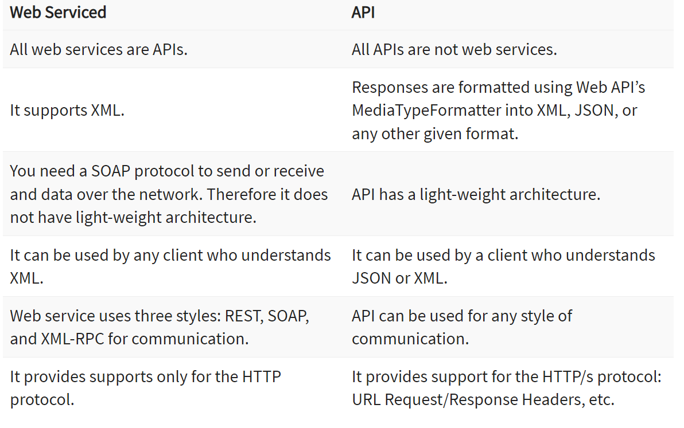

Xml, Http,

**Test Doubles:** A Test Double is an object that can stand-in for a real object in a test, like how a stunt double stands in for an actor in a movie.

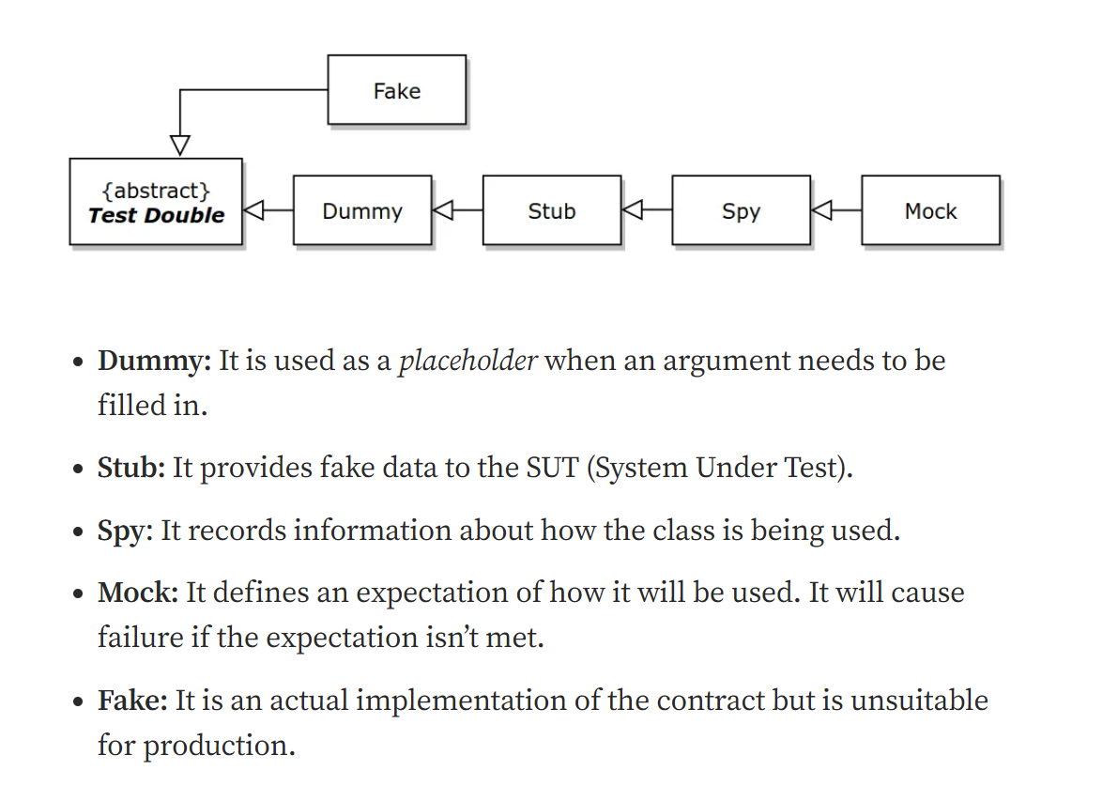

Manipulate req data

| **Aspect** | **Dummy API** | **Mock API** |
| --- | --- | --- |
| **Purpose** | Used to fill parameter lists where an object is required but no actual object behavior is needed. | Used to simulate the behaviors of complex, real objects in a controlled manner to test functionality. |
| **Functionality** | Minimal or no functionality; often returns **null** or simple default values. | Can be programmed to return various outputs depending on input, simulating complex logic and interactions. |
| **Usage in Testing** | Typically used in unit testing to pass through APIs as placeholders. | Used extensively in unit testing to assert interactions and to ensure components behave correctly under specified conditions with mocked responses. |

* **Dummy APIs** are simplistic and are essentially used where the code requires an object interface but nothing more. They are placeholders with no programmed behavior.
* **Mock APIs** are designed to replicate the behaviour of real APIs, allowing developers to mimic and interact with API dependencies accurately during testing. This enables the testing of components in isolation from their real counterparts.
* suppose Module A requires information from Module B but Module B is not yet developed. For Module B data we use stub
* Suppose Module B is developed but Module A is not developed Here we use driver

Input data (stub)

Module B

=

Module A

RestSharp:

Internally uses httpclient

URL segment parameter replaces placeholder values in the request URL:

Swagger is a set of open-source tools built around the OpenAPI Specification that can help you design, build, document, and consume RESTful web services.

Fiddler: Fiddler is a free web debugging proxy tool that allows you to inspect, monitor, and modify all HTTP(S) traffic between your computer and the Internet.

RestClient:

* client.AddDefaultParameter("foo", "bar");

Rest Request:

1. AddHeader(string name, string value);
2. AddHeader<T>(string name, T value); // value will be converted to string
3. AddOrUpdateHeader(string name, string value); // replaces the header if it already exists
4. request.AddQueryParameter("foo", "bar/fox", false); -false: encode optional
5. request.AddObject(params);
6. var request = new RestRequest("health/{entity}/status")
   * 1. .AddUrlSegment("entity", "s2");
7. request.AddCookie("foo", "bar");
8. const json = "{ data: { foo: \"bar\" } }";
   * 1. request.AddStringBody(json, ContentType.Json);
9. AddJsonBody, AddXmlBody

// Adds a file from disk

1. AddFile(parameterName, filePath, contentType);

// Adds an array of bytes

1. AddFile(parameterName, bytes, fileName, contentType);

// Adds a stream returned by the getFile function

1. AddFile(parameterName, getFile, fileName, contentType);
2. restRequest.AddCookie("name", "value", "path", "domain");

* Cookie myCookie = new Cookie("cookieName", "cookieValue", "/", "example.com");
* request.CookieContainer = new CookieContainer();
* request.CookieContainer.Add(myCookie);

Remove Cookies: don’t have direct method for removing cookies

var cookies = client.CookieContainer.GetCookies(uri);

var newCookieContainer = new CookieContainer();

foreach (Cookie cookie in cookies)

{

if (cookie.Name != "session_id")

{

newCookieContainer.Add(cookie);

}

}

Sessions are generally managed by cookies. A server typically sends a session cookie with a unique ID that identifies the session.

Execute requests:

public async Task<RestResponse> ExecuteAsync(

RestRequest request,

CancellationToken cancellationToken = default

)

1. Task<RestResponse> ExecuteGetAsync(RestRequest request, CancellationToken cancellationToken)
2. Task<RestResponse> ExecutePostAsync(RestRequest request, CancellationToken cancellationToken)
3. Task<RestResponse> ExecutePutAsync(RestRequest request, CancellationToken cancellationToken)
4. Task<RestResponse> ExecuteDeleteAsync(RestRequest request, CancellationToken cancellationToken)
5. Task<RestResponse> ExecuteHeadAsync(RestRequest request, CancellationToken cancellationToken)
6. Task<RestResponse> ExecuteOptionsAsync(RestRequest request, CancellationToken cancellationToken)
7. Task<RestResponse<T>> ExecuteAsync<T>(RestRequest request, CancellationToken cancellationToken)
8. Task<RestResponse<T>> ExecuteGetAsync<T>(RestRequest request, CancellationToken cancellationToken)
9. Task<RestResponse<T>> ExecutePostAsync<T>(RestRequest request, CancellationToken cancellationToken)
10. Task<RestResponse<T>> ExecutePutAsync<T>(RestRequest request, CancellationToken cancellationToken)
11. Task<RestResponse<T>> ExecuteDeleteAsync<T>(RestRequest request, CancellationToken cancellationToken)
12. Task<RestResponse<T>> ExecuteHeadAsync<T>(RestRequest request, CancellationToken cancellationToken)
13. Task<RestResponse<T>> ExecuteOptionsAsync<T>(RestRequest request, CancellationToken cancellationToken)

If you just need a deserialized response,

1. Task<T> GetAsync<T>(RestRequest request, CancellationToken cancellationToken)
2. Task<T> PostAsync<T>(RestRequest request, CancellationToken cancellationToken)
3. Task<T> PutAsync<T>(RestRequest request, CancellationToken cancellationToken)
4. Task<T> PatchAsync<T>(RestRequest request, CancellationToken cancellationToken)
5. Task<T> DeleteAsync<T>(RestRequest request, CancellationToken cancellationToken)
6. Task<T> HeadAsync<T>(RestRequest request, CancellationToken cancellationToken)
7. Task<T> OptionsAsync<T>(RestRequest request, CancellationToken cancellationToken)

[Handling responses | RestSharp](https://restsharp.dev/docs/usage/response)

[Configuration | RestSharp](https://restsharp.dev/docs/advanced/configuration)

* OAuth2UriQueryParameterAuthenticator
* OAuth2AuthorizationRequestHeaderAuthenticator
* IAuthenticator – custom authenticator
* JWT (JSON Web Tokens) authentication is a mechanism through which a server can authenticate users and services via a token-based approach
* OAuth1 is an authorization protocol that enables applications to securely access resources on behalf of a user.
* JWT is a token format and can be used to transfer information securely. It is commonly used for single-sign-on (SSO) because of its ability to carry user information.
* OAuth2 is a more comprehensive authorization framework that allows third-party services to exchange web resources on behalf of a user. JWTs can be used within OAuth2 as a type of token
* **OnBeforeRequest** is typically used for high-level modifications and final touches to the **RestRequest** object before sending it.
* **OnBeforeHttpRequest** offers a chance to adjust the underlying **HttpWebRequest**, granting more granular control over the HTTP transmission itself.

Execute doesnot throw errors

Interceptors are a powerful feature of RestSharp that allows you to modify requests and responses before they are sent or received.

Rest Client

1. BeforeRequest(RestRequest request, CancellationToken cancellationToken)
2. AfterRequest(RestResponse response, CancellationToken cancellationToken)
3. BeforeHttpRequest(HttpRequestMessage requestMessage, CancellationToken cancellationToken)
4. AfterHttpResponse(HttpResponseMessage responseMessage, CancellationToken cancellationToken)
5. BeforeDeserialization(RestResponse response, CancellationToken cancellationToken)

All those functions must return a ValueTask instance.

* As interceptors provide a better way to interject the request and response execution flow, request properties OnBeforeRequest, OnBeforeDeserialization and OnAfterRequest are marked obsolete and will be removed in future versions.

[Error handling | RestSharp](https://restsharp.dev/docs/advanced/error-handling)

RestClientOptions

| **Property** | **Behavior** |
| --- | --- |
| FailOnDeserializationError | Changes the default behavior when failed deserialization results in a successful response with an empty Data property of the response  Setting this property to true will tell RestSharp to consider failed deserialization as an error and set the Response Status to Error accordingly. |
| ThrowOnDeserializationError | Changes the default behavior when failed deserialization results in empty Data property of the response.  Setting this property to true will tell RestSharp to throw when deserialization fails. |
| ThrowOnAnyError | Setting this property to true changes the default behavior and forces RestSharp to throw if any errors occur when making a request or during deserialization. |

**Git:**

Undoing Changes:  
Working Directory: git checkout --filename / git checkout . / git clean -xfd / git clean -f  
Staging Area (indexing): git reset -- file.txt  
Local Branch: git reset HEAD^^ (HEAD~2) / git commit --amend -m "Message"  
Remote Repo: git revert <sha1>

To add existing repo to gitlab

* cd existing_repo
* git remote add origin https://gitlab.com/Vishnukolluri/mini_project_test.git
* git branch -M main
* git push -uf origin main

Git Reset:  
git reset --soft: Commit to Index(Staging Area)  
git reset --hard: Delete the changes from Commit area  
git reset --mixed: Commit to File System

* Git reset -->move the tip of a branch to a different commit. This can be used to remove commits from the current branch. It moves the branch backwards by commits.
* Git Revert-->undoes a commit by creating a new commit. This is a safe way to undo changes, as it has no chance of re-writing the commit history.

**Git blame :** It operates on single file. It is used to trace changes made in the file.  annotates each line in a file with information about the last commit that modified the line.

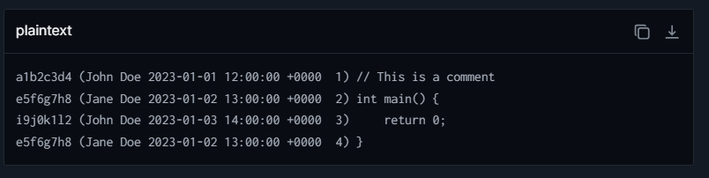

[How to Use git-blame? - GeeksforGeeks](https://www.geeksforgeeks.org/how-to-use-git-blame/)

**Manual Testing:**

Sanity testing is a subset of regression testing. It focuses on verifying whether one or two functionalities or commands are working as expected after making minor changes to the software.

Retesting – related to bug, Sanity testing – related to newly added module

[Performance testing](https://testgrid.io/solutions/performance-testing) tests a software/application’s responsiveness, speed, scalability, and stability under normal or peak load conditions.

Load testing determines the system behavior when multiple users use it at the same time.

Stress testing is a type of performance testing that evaluates the robustness and error handling capabilities of a system under extreme conditions.

Spike testing is another performance testing technique to assess how a system will perform with a sudden spike in traffic. This test checks whether the system will function correctly when change is made in size or volume of the system and resources and scaled up and down.

**Endurance testing**

Another form of stress testing, endurance testing, is a test to check for the system’s performance under a significant load but over an extended period. This testing helps identify any potential issues related to memory leaks, resource exhaustion, performance degradation, or other stability problems that may occur over time.

Accessibility testing tests whether the application or system is accessible to disabled people.

* **Monkey Testing** verifies the application's ability to handle unexpected, random inputs internally, focusing on operational stability.
* **Fuzz Testing**, on the other hand, systematically tests the software's capacity to handle malformed or malicious inputs from external sources, focusing on uncovering security vulnerabilities.
* **Exploratory Testing:** A hands-on approach where testers actively engage with the software to explore its functionality without predefined plans or test cases.
* **Adhoc Testing:** A testing phase where the tester randomly tests the application without following any specific document or plan to find defects.
* **Monkey Testing:** A type of testing where inputs are randomly generated to check how the system behaves under unexpected or erratic conditions.
* **Gorilla Testing:** Intensive testing of a particular module or unit repeatedly to ensure its robustness and reliability.

| **Aspect** | **Test Strategy (first done)** | **Test Plan** |
| --- | --- | --- |
| Definition | High-level document that outlines the testing approach. | Detailed document describing the testing scope, objectives, resources, schedule, and deliverables. |
| Objective | To provide a general testing guideline across projects. | To define specific testing activities for a particular project. |

**Dependency Injection :**

It is used for loose coupling

Dependency Injection (DI) is a design pattern used to implement [**IoC (Inversion of Control)**](https://dotnettutorials.net/lesson/introduction-to-inversion-of-control/). It allows the creation of dependent objects outside of the class and provides those objects to a class that depends on it.

1. **Client Class:** The Client Class (dependent class) is a class that depends on the Service Class. That means the Client Class wants to use the Services (Methods) of the Service Class.
2. **Service Class:** The Service Class (dependency) is a class that provides the actual services to the client class.
3. **Injector Class:** The Injector Class is a class that injects the Service Class object into the Client Class. (main class)

[Dependency Injection Design Pattern in C# - Dot Net Tutorials](https://dotnettutorials.net/lesson/dependency-injection-design-pattern-csharp/)

Different ways to achieve:

* 1. Constructor injection
  2. Property injection
  3. Method injection

[Dependency Injection in C#](https://www.c-sharpcorner.com/blogs/dependency-injection-di-c-sharp)

Design pattern: provides implementation, design principle: not provide implementation, guidelines

The main objective of Inversion of Control (IoC) in C# is to remove the dependencies (remove tight coupling) between the objects of an application which makes the application more decoupled and maintainable.

Real time example of DI: Iorder- getorder method, Ipayment -Payment method

, togetOrder, we need to do payment

**SOLID Principles:**

**1. Single Responsibility Principle**

A class should have single responsibility or single job (have only one reason to change)

EX: banking system class (deposit, withdraw, one class ) (Print balance another class)

Ex: 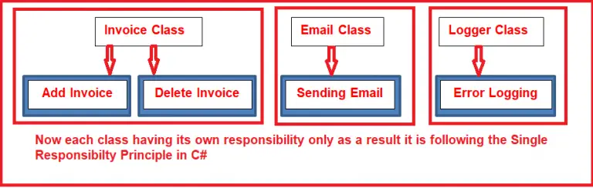

**2. Open/Closed Principle**

“**Software entities (classes, modules, functions, etc.) should be open for extension, but closed for modification**”

Achieved through inheritance (and abstraction)

Ex: IDiscountStrategy in that it has GenerateDiscount() method.

Premium Discount, Regaular Discount

**3. Liskov’s Substitution Principle (Barbara liskov 1987)**

 This Principle states that the object of a derived class should be able to replace an object of the base class without causing any errors in the system or modifying the behavior of the base class.

Using child class object we should able to call and get output of parent class

Inheritance, abstraction

Ex: Vehicle class has Start Engine method

Child class Electric vehicle, PetrolVehicle, DieselVehicle should have StartEngine method

**4. Interface Segregation Principle**

This Principle states **Clients should not be forced to implement any methods they don’t use.**

**Interfaces should be segregated and interface should have single responsibility**

**Library Management System:**

* Return borrow, borrow book – Iborrow
* Isearchable – searchbook
* IManageBooks – AddBook, RemoveBook

## **5. Dependency Inversion Principle**

 “**High-level modules should not depend on low-level modules. Both should depend on abstractions**“. Additionally, abstractions should not depend on details. Details should depend on abstractions.

Abstraction

IPaymentMethod : processPayment method

Class: creditcard, debitcard, paypal

WET (Write Everything Twice)

DRY(Do not Repeat Yourself)

Use methods, inheritance

YAGNI(You Aren’t Gonna Need It)

Implement the features only they are needed

KISS(Keep It Simple Stupid)

**How to Apply KISS?**

To keep our program as simple as possible, we should:

* Write smaller programs
* Remove the methods and instances in our code that are never used
* Write readable and transparent programs
* Use composition, which helps us reuse existing code
* Use modular programming

Automation Testing:

* Tests that are repetitive and time-consuming.
* Tests that run for multiple builds.
* Tests that are vulnerable to human error.
* Tests of high-risk, frequently used functions within the software.
* Tests that can’t be done manually.
* Tests that need to be run on multiple software or hardware configurations and platforms.
* Early bug detection, saves time and cost, better ROI, faster time to market.

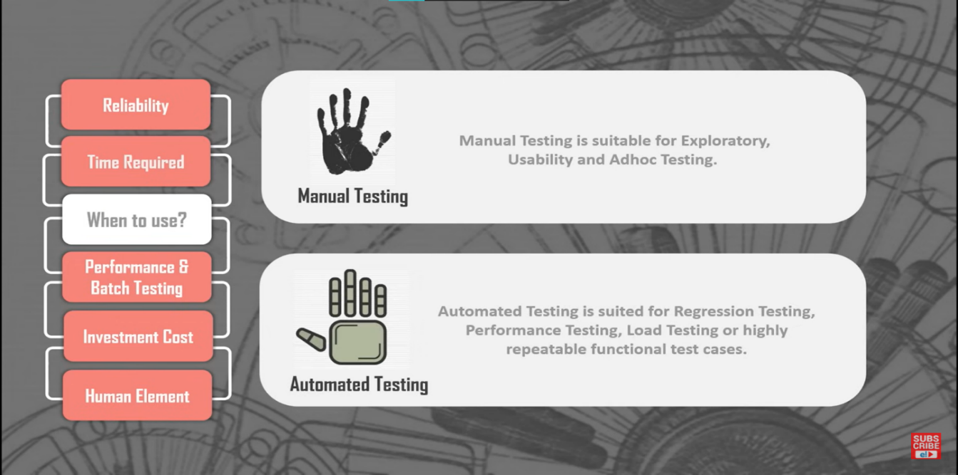

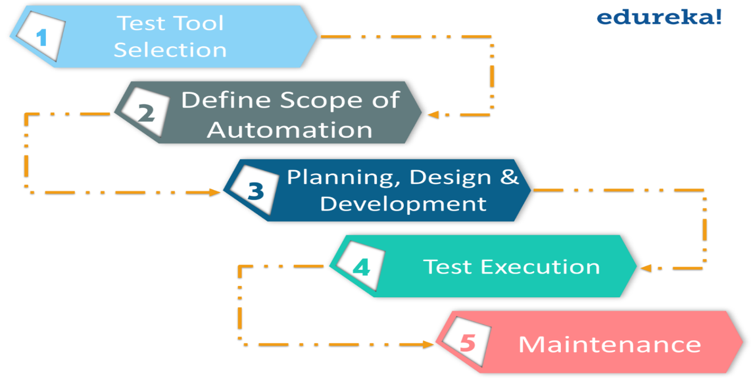

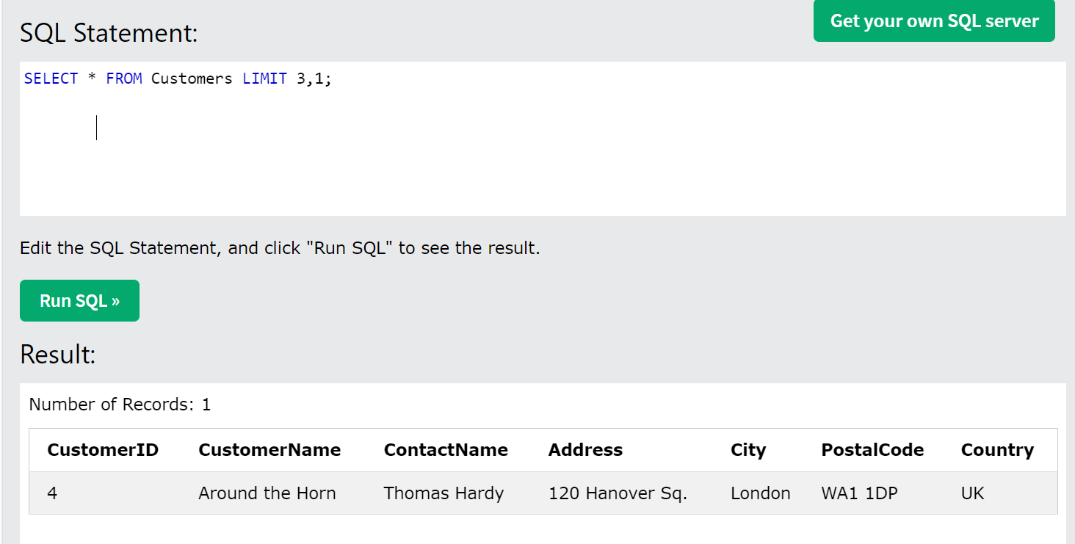

SELECT salary

FROM employee

ORDER BY salary desc limit n-1,1;

GRANT SELECT, INSERT, DELETE, UPDATE ON Users TO 'Amit'@'localhost;

[SQL Commands: DDL, DML, DCL, TCL, DQL - javatpoint](https://www.javatpoint.com/dbms-sql-command)

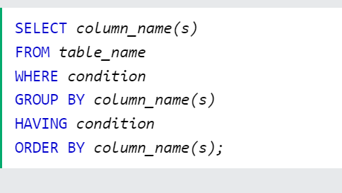

**Layers in Testing:**

1) **TestCaseLayer** 🡺 Feature File

//2) **TestScript Layer 🡺** script for TestCase--->Binding Classes, step definiton

3) **TestFrameWork Layer** 🡺

Config

Source of Data

clients

Localization-->Globalization-->

common Things

utility

4) **TestDataLayer** 🡺

which break an application

data

dynamic data

if we don't clean (Clear,Reset) it 🡪 performanance issue, duplication issue, error

state should be same as before.

5) **Test Reporting Layer 🡺**

log4net

Extent Report

log, Organized way.

Projects:

* Webpages,
* browser(Config)
* data
* reporting
* tests

**MSBuild**, which stands for Microsoft Build Engine, is a platform for building applications. This toolset is used by Visual Studio on Windows and by .NET Core across all platforms. It helps automate the process of compiling the source code, packaging, testing, deploying, and creating documentation. MSBuild uses XML-based project files to control the build process, which define the items to build, as well as how and when they should be built.

### Setup

MSBuild comes integrated with Visual Studio. When Visual Studio is installed, MSBuild is also set up as part of the environment. It can also be used independently by installing the .NET SDK which includes MSBuild.

### Build Process

The MSBuild engine processes the project files (.csproj, .vbproj, etc.), which include instructions on how to build the application. The process generally involves:

1. **Parsing Project Files**: It reads the XML project files to understand what needs to be built and in what order.

2. **Loading Properties and Items**: It configures the environment based on properties (variables) and Items (files and data needed).

3. **Executing Tasks**: It carries out tasks like compiling code, copying files, executing tests, etc.

4. **Handling Target Dependencies**: Targets (a group of tasks) are executed in a specific order, respecting dependencies defined between them.

### Build Environment Setup

To set up MSBuild on a new machine, typically the following steps are involved:

1. **Install .NET SDK**: This installs MSBuild along with other necessary tools.

2. **Verify Installation**: Confirm MSBuild is accessible via the command line or terminal.

3. **Optional Editor/IDE Setup**: Install Visual Studio or other preferred editors that integrate with MSBuild.

### Dependencies within Solution

Dependencies within a solution in MSBuild are managed through project references. In a multi-project solution, project files can use `<ProjectReference>` elements to specify other projects in the solution that they depend on. MSBuild resolves these references and builds the projects in the correct order. Nuget package manager

### Dependencies Outside Solution

Dependencies outside a solution, like third-party libraries or packages, are often managed through package managers like NuGet. MSBuild integrates with tools like NuGet to restore and update packages, and it automatically handles the references during the build process.

### Tasks

Tasks in MSBuild are units of executable code used to perform build operations (like compiling code or copying files). Each task is represented by a `<Task>` element in the project file. MSBuild includes various built-in tasks, and custom tasks can also be created to extend functionality.

### Grouping Tasks

Tasks are grouped into **Targets**. Each Target can contain one or more tasks and can specify dependencies on other targets. For instance, a "Compile" target might depend on a "Clean" target. This grouping helps organize the build process logically and manage task dependencies.

### Conflicts between Different Versions of the Same Assembly

Conflicts can arise when different parts of a solution depend on different versions of the same assembly. MSBuild and the .NET environment address this using:

1. **Assembly Binding Redirection** in app.config or web.config files, where you specify which version of the assembly to use when there’s a conflict.

2. **NuGet’s Package Management**, which attempts to resolve version conflicts and ensure that compatible versions are used across all projects.

3. **Binding Redirects** can be automatically generated by MSBuild in some .NET project types to resolve these conflicts dynamically at build time.

Understanding how MSBuild works can significantly enhance your ability to effectively manage and troubleshoot .NET build processes, especially in complex multi-project environments.

dotnet clean -> dotnet restore -> dotnet build -> dotnet test -> dotnet run -> dotnet publish

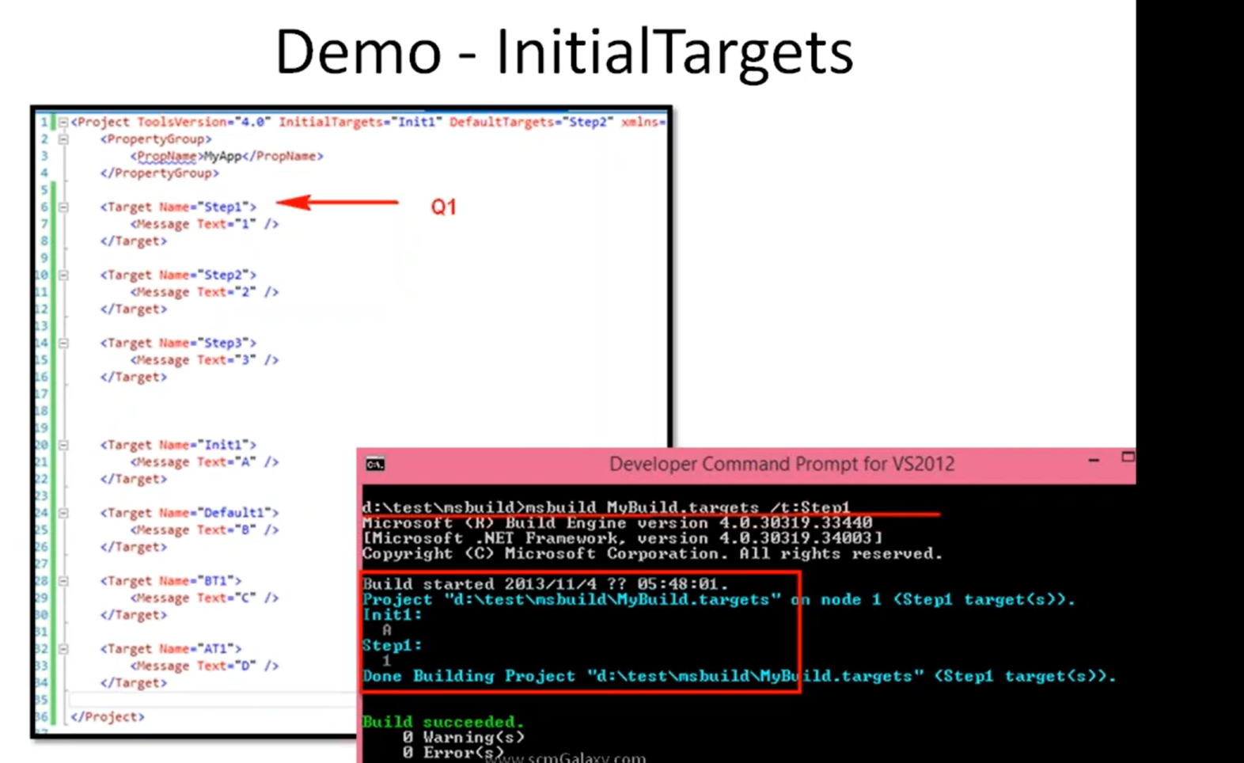

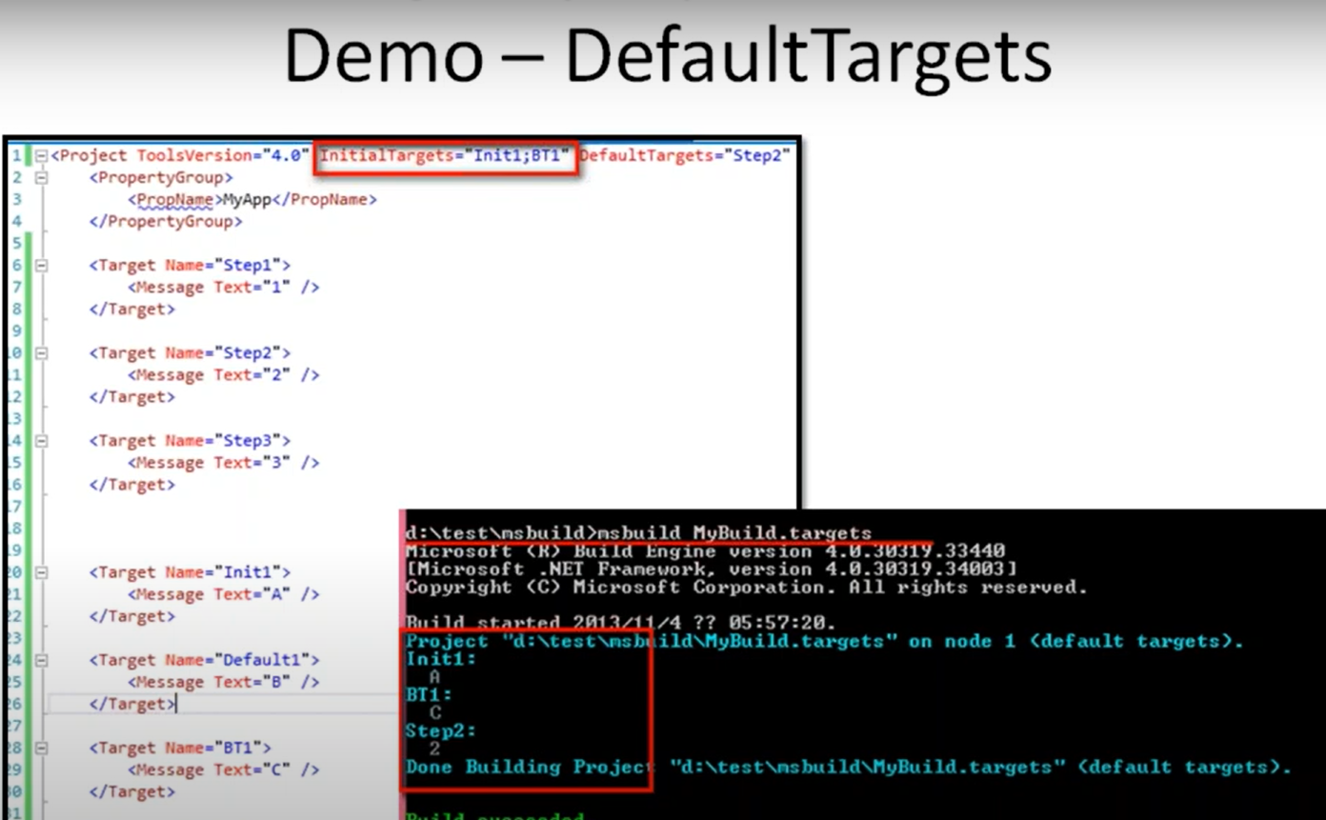

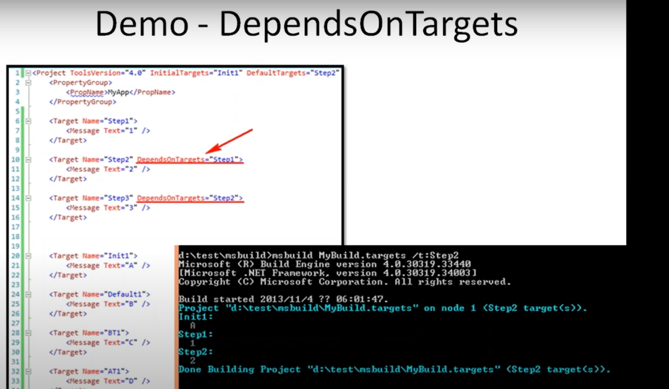

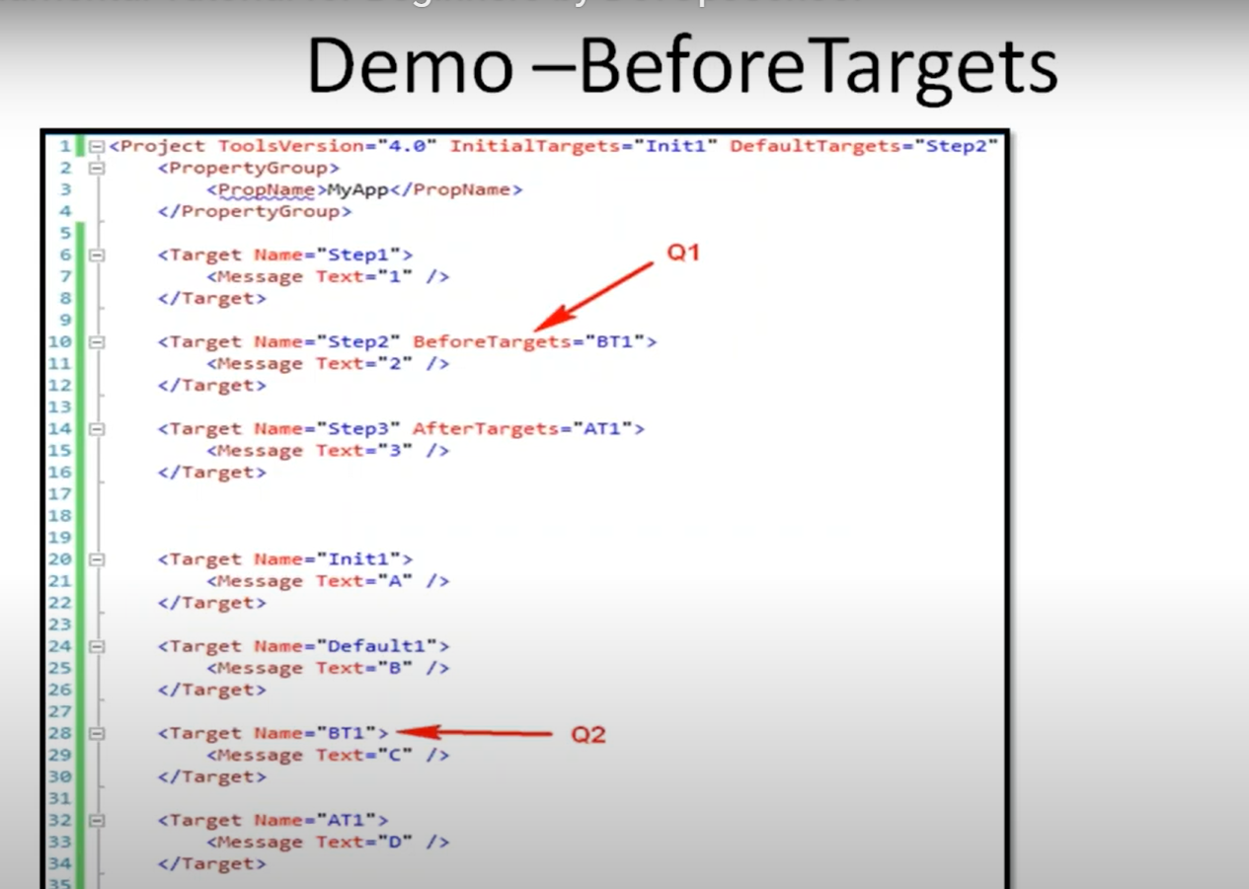

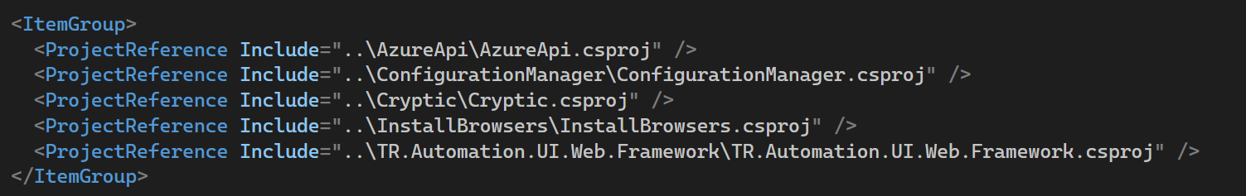

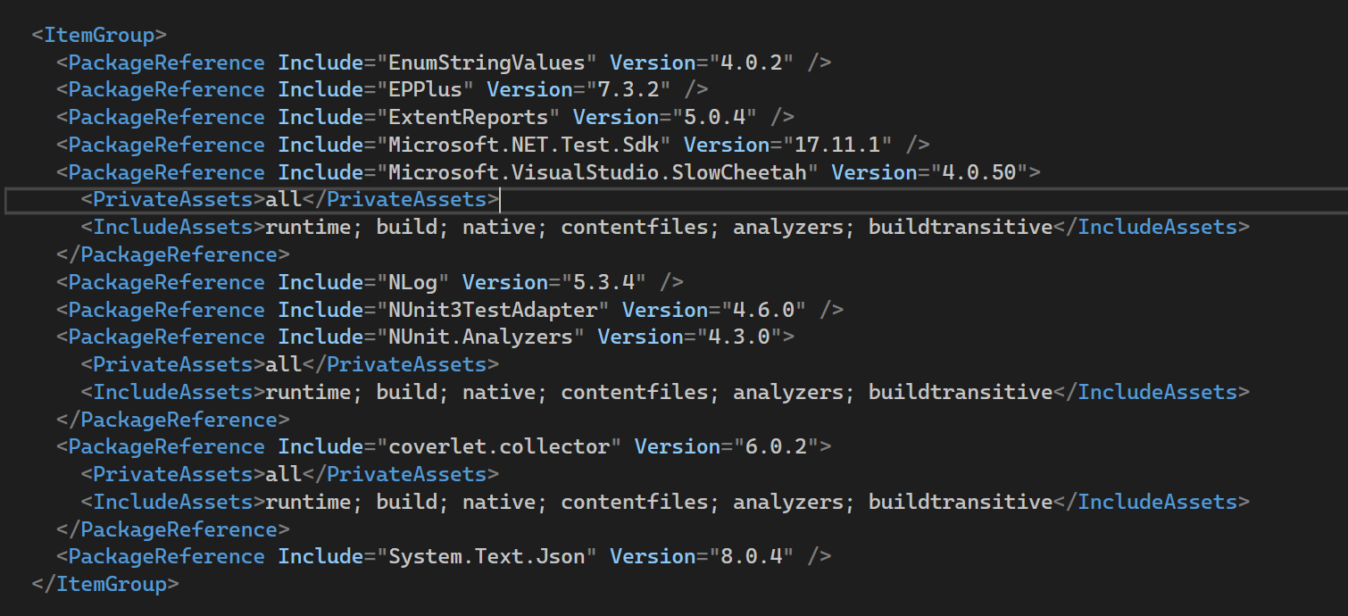

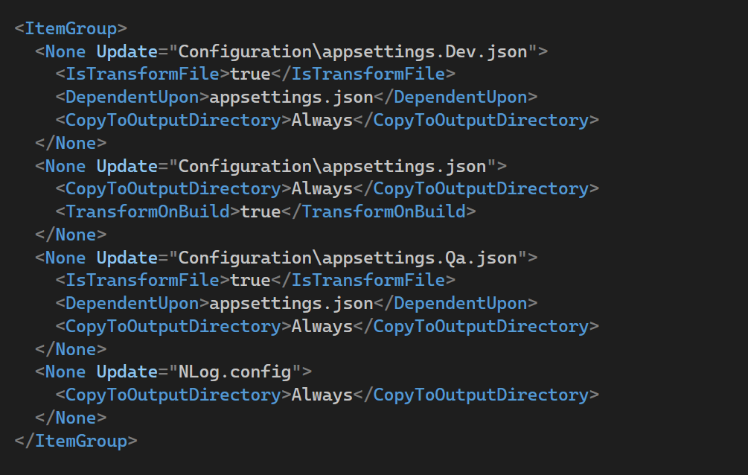

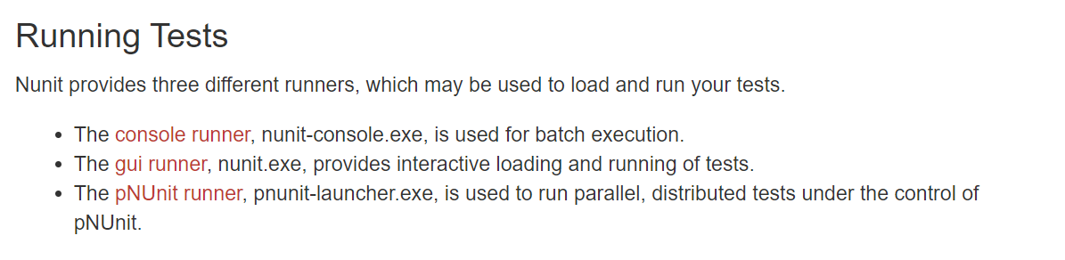

There are many more [Running Tests | NUnit Docs](https://docs.nunit.org/articles/nunit/running-tests/Index.html)

[MSBuild Tutorial: Install and create a project - MSBuild | Microsoft Learn](https://learn.microsoft.com/en-us/visualstudio/msbuild/walkthrough-using-msbuild?view=vs-2022)

<https://youtu.be/zjRmYV5psTg?si=e_hGSPsN_Bgc8O66>

ToLookup() - eager

GroupBy() – lazy

[LINQ Deferred Execution vs Immediate Execution in C# (dotnettutorials.net)](https://dotnettutorials.net/lesson/deferred-execution-vs-immediate-execution-in-linq/)

public class Parent

{

private Parent() { }

}

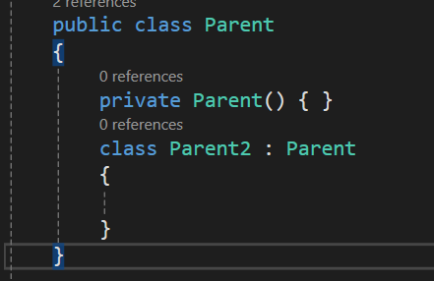

Design Patterns:

[Builder Design Pattern in C# with Examples - Dot Net Tutorials](https://dotnettutorials.net/lesson/builder-design-pattern/)

Nunit :

TestCaseSource

* It may be a field, property or method in the test class.
* It **must** be static.
* It must return an IEnumerable or a type that implements IEnumerable. For fields an array is generally used. For properties and methods, you may return an array or implement your own iterator.

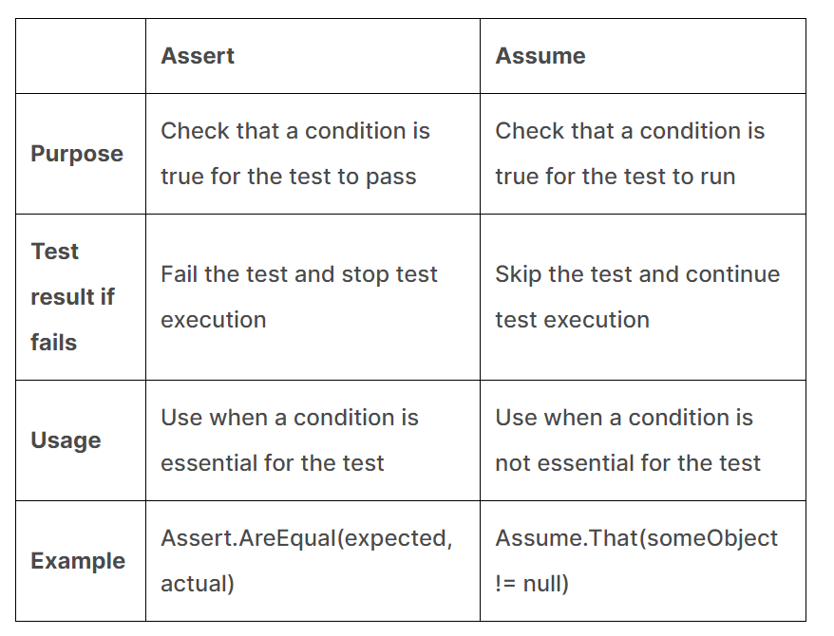

| **Aspect** | **Assume** | **Assert** |
| --- | --- | --- |
| **Purpose** | Used to ensure that prerequisites for a test are met | Used to verify conditions and expected results within the test |
| **Behavior on Failure** | If an assumption fails, the test is skipped, not marked as a failure | If an assertion fails, the test fails and is marked accordingly |

|  |  |  |
| --- | --- | --- |
|  | **TestFixture** | **TestSuite** |
| **Definition** | A class that contains one or more test methods. | A collection of TestFixture instances. |
| **Purpose** | To group related tests together and provide setup/teardown methods. | To organise tests into larger groups or hierarchies. |

**Constraint Model:**

The constraint-based Assert model uses a single method of the Assert class for all assertions.

* Assert.That(myString, Is.EqualTo("Hello"));

Uses:

* 1. Readability, clarity
  2. Flexibility, Extensibility – can create custom constraints
  3. We combine and asserts
     1. Assert.That(value, Is.LessThan(100).And.GreaterThan(50).Or.EqualTo(0));
  4. Improved error messages
  5. Easy to Learn

Special Asserts:

The special assertions do not check any condition.

* [Assert.Pass](https://docs.nunit.org/articles/nunit/writing-tests/assertions/special-assertions/Assert.Pass.html)
* [Assert.Fail](https://docs.nunit.org/articles/nunit/writing-tests/assertions/special-assertions/Assert.Fail.html)
* [Assert.Ignore](https://docs.nunit.org/articles/nunit/writing-tests/assertions/special-assertions/Assert.Ignore.html)
* [Assert.Inconclusive](https://docs.nunit.org/articles/nunit/writing-tests/assertions/special-assertions/Assert.Inconclusive.html)

The **Assert.Inconclusive** method indicates that the test could not be completed with the data available. (Skips the test)

Multiple Assertions:

1. The multiple assert block may contain any code, not just asserts.
2. Multiple assert blocks may be nested. Failure is not reported until the outermost block exits.
3. If the code in the block calls a method, that method may also contain multiple assert blocks.
4. The test will be terminated immediately if any exception is thrown that is not handled. An unexpected exception is often an indication that the test itself is in error, so it must be terminated. If the exception occurs after one or more assertion failures have been recorded, those failures will be reported along with the terminating exception itself.
5. Assert.Fail is handled just as any other assert failure. The message and stack trace are recorded but the test continues to execute until the end of the block.
6. An error is reported if any of the following are used inside a multiple assert block:
   * Assert.Pass
   * Assert.Ignore (test is skipped, no other test steps are executed)
   * Assert.Inconclusive
   * Assume.That
7. Use of Warnings (Assert.Warn, Warn.If, Warn.Unless) is permitted inside a multiple assert block. Warnings are reported normally along with any failures that occur inside the block.

Assert. Throws : pass when expected exception occurs

* Assert.Throws<ArgumentException>( () => throw new ArgumentException()); //pass
* Assert.Throws<Exception>(

() => throw new ArgumentException()); //fail

**Assert.Catch** is similar to **Assert.Throws** but will pass for an exception that is derived from the one specified.

* Assert.Catch<Exception>(

() => throw new ArgumentException()); -pass

* Assert.Catch(

() => throw new ArgumentException()); -pass by default it is exception class

Assert.Catch(

() => Console.WriteLine("print")); -fail should always return exception

Yes, when an assertion fails in NUnit, it throws an exception. Typically, it throws an `**AssertionException**` that indicates that a particular assertion has failed. This exception provides details about the failure, such as the expected and actual values that caused the assertion to fail. This information can be used to debug and rectify the issue in the test.

**Test Context:**

The TestContext class allows tests to access certain information about the execution context.

It is a NUnit.Framework instance.The TestContext class is used to access a variety of information about the test run, such as the test fixture, test case, and environment.

[TestContext | NUnit Docs](https://docs.nunit.org/articles/nunit/writing-tests/TestContext.html)

TestContext.CurrentContext

* Test.FullName: The fully qualified name of the test being run.
* Test.Name: The name of the test being run.
* Test.Properties: A collection of key/value pairs representing properties of the test.
* TestDirectory: The directory containing the test assembly.
* WorkingDirectory: The current working directory for the test run.
* RandomSeed: The random seed used for generating random data in the test run.

Nunit Test Runners:

In NUnit, a test runner is a tool that is used to execute NUnit tests and report the results.

including the console runner, the NUnit GUI runner, and various third-party runners that integrate with popular IDEs like Visual Studio and JetBrains Rider.

nunit3-console.exe C:\JenkinsWorkspace\a\bin\release\net6.0-windows\UltraTaxCSTests.dll --test=UltraTaxCSTests.Tests.DeliveryTests.CheckPrintToMultipleLocationsTest

nunit3-console mytests.dll --where "cat == 'Integration' && cat == 'Fast'"

In addition to these NUnit provides two special runners, the NUnit.Console and the NUnitLite runners, which are described below.

* The [Console Runner](https://docs.nunit.org/articles/nunit/running-tests/Console-Runner.html), nunit-console.exe, is used for batch execution.
* The [NUnitLite runner](https://docs.nunit.org/articles/nunit/running-tests/NUnitLite-Runner.html), nunitlite-runner.exe, is a light weight runner originally used internally in the team, but can be used by anyone who wants to have a simple way of running tests from the command line.

[Console Command Line | NUnit Docs](https://docs.nunit.org/articles/nunit/running-tests/Console-Command-Line.html)

**1. NUnit Console Runner**

* **Description**: The NUnit Console Runner is a command-line tool that allows for running tests from the console (command prompt or terminal). It is handy for integration into Continuous Integration (CI) pipelines.
* **Usage**: You can specify various command-line options to control which tests are run, how results are reported, and more. It can generate reports in various formats that can be used for further analysis or for integration with CI systems.

**2. NUnit GUI Runner**

* **Description**: The NUnit GUI Runner is a graphical user interface that allows for a more visual interaction with your tests. You can see a tree structure of your tests, run them selectively, and view detailed results directly in the GUI.
* **Usage**: This runner is particularly useful during development when you want to run specific tests quickly without needing to use the command line. It also has features like debugging and setting breakpoints.

**3. Test Adapter for Visual Studio**

* **Description**: The NUnit Test Adapter allows you to run NUnit tests from within Visual Studio's Test Explorer. It integrates NUnit with Visual Studio, making it easier to run and debug tests without leaving the IDE.
* **Usage**: After installing the adapter, your NUnit tests appear in Visual Studio’s Test Explorer just like MSTest or xUnit tests would. This allows you to execute tests and even run them as part of Visual Studio's automated build and test cycles.

**4. ReSharper NUnit Integration**

* **Description**: If you use ReSharper, an extension for Visual Studio, it has built-in support for running NUnit tests. ReSharper enhances the test-running capabilities within Visual Studio, offering additional features such as running a subset of tests when code changes.
* **Usage**: ReSharper provides a test runner within Visual Studio that is similar to the Test Explorer but with enhanced functionality. It supports running tests in parallel, rerunning failed tests, and more comprehensive navigation features.

**5. Rider (JetBrains)**

* **Description**: Rider, a cross-platform IDE from JetBrains, supports NUnit natively without requiring additional plugins or adapters. Similar to ReSharper, it offers sophisticated tools for running and debugging NUnit tests.
* **Usage**: Tests can be run directly within the IDE, and it provides tools for analyzing test coverage, profiling tests, and more.

**6. Continuous Integration Servers**

* **Description**: Most CI servers like Jenkins, TeamCity, Travis CI, and others can execute NUnit tests as part of the build process, often using the NUnit Console Runner or through plugins that integrate NUnit.
* **Usage**: Typically, you set up your CI pipeline to invoke the NUnit console runner, possibly using a script, and then use the results (often XML files) to produce reports or make decisions about build success or failure in your pipeline.

Without parallelizable test class execute first and then parallel classes

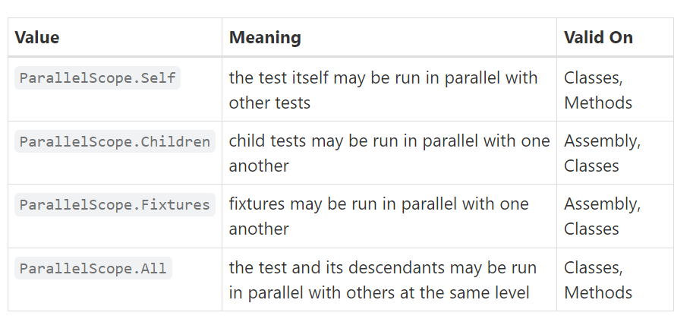

Self: child won’t run in parallel. Class run parallel with other class with all attribute,

Children : only child tests run in parallel but not classes

Fixtures: both classes should have fixtures, only classes run in parallel but tests run sequentially

<https://youtu.be/SijfIlw5sPM?si=JgIyKKxFyhn2znNr>

questions:

one class with All and other with Fixture – both classes execute at same time.

Self Vs Fixtures

Fixtures: child classes -parallel run tests run -sequential

Self: child classes -seq

**SetCulture** is an attribute that allows you to set the culture for the duration of a test. When the test starts, NUnit changes the **CurrentCulture** to the specified culture, and once the test is finished, it reverts it back to the original culture.

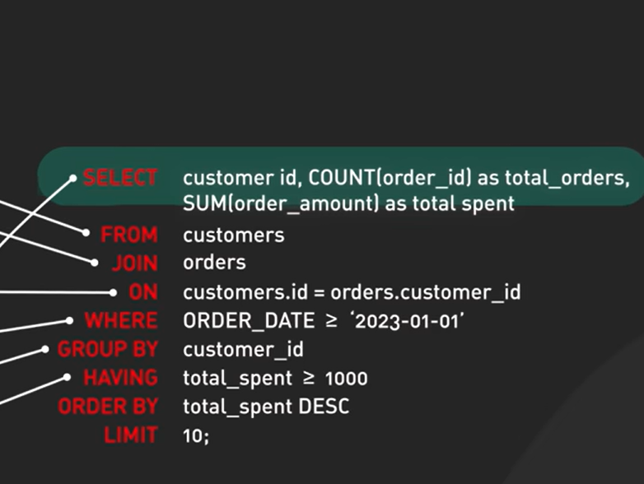

.runsettings:

* used to configure running unit tests
* has more features than .testsettings
* are configuration files used by the Visual Studio Test Platform (VSTest) to customize various aspects of running unit tests, such as the framework version, data collection, and more.

In VS: Test-> Configure run settings

dotnet test --settings:.\test.runsettings

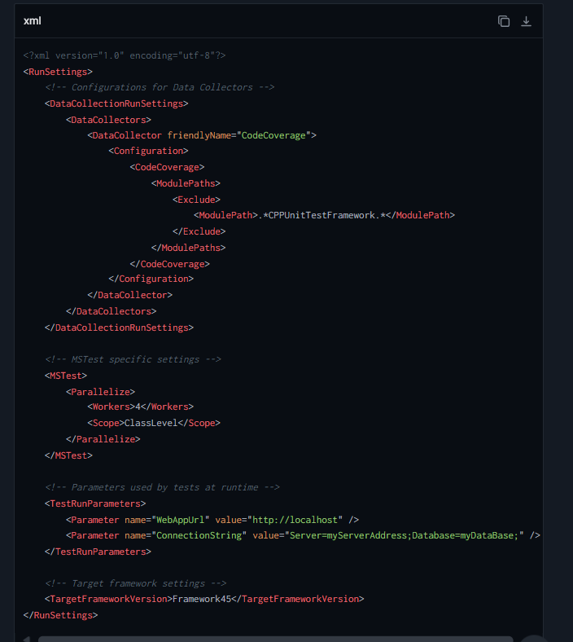

App.config:

.NetFramework only use App.config. .NetCore and .Net 5+ can’t use this file they use json files

Uses:

Security, configure easily

the **App.config** file serves as a central place for hosting application-level settings and configuration data.

* **<appSettings>**: Contains simple key-value pairs.
* **<connectionStrings>**: Defines connection strings for databases.
* **<system.web>**: Contains settings specific to web applications (more commonly seen in **Web.config** files).
* **<configurationSections>**: Allows defining custom configuration sections.

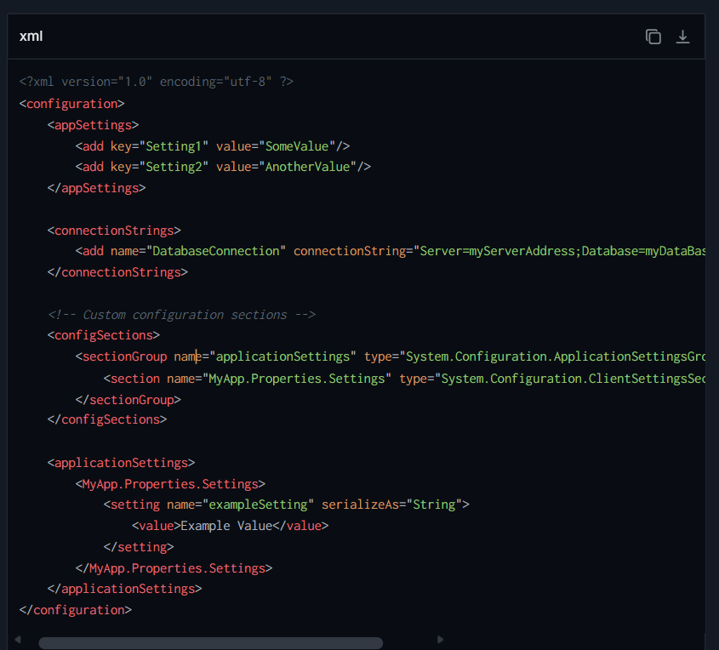

Configuration Manager is System.Configuration add from reference

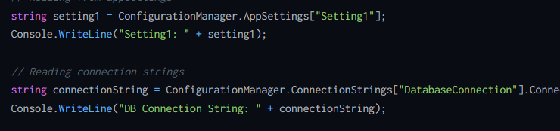

Task vs thread

Task is used for – asynchronous programming, parallel execution

* Return result
* Tasks can be cancelled using cancellation tokens
* A Task is a higher level concept than Thread
* Part of Task parallel library(TPL)
* Internally it uses thread pool to reuse and run tasks

Thread – execute small tasks, represent Os thread

* Don’t return result
* Can’t cancel

 the verification of artifacts typically occurs during the build process, which is defined in the Jenkins job configuration. (while creating pipeline)

This process involves configuring specific build steps or post-build actions that handle the testing, analysis, and

[Types of Keys in Relational Model (Candidate, Super, Primary, Alternate and Foreign) - GeeksforGeeks](https://www.geeksforgeeks.org/types-of-keys-in-relational-model-candidate-super-primary-alternate-and-foreign/)

A composite key is a type of candidate key that consists of two or more attributes (columns) combined to uniquely identify a record in a table.

**SonarQube**

SonarQube is a static code analysis tool used to detect bugs, vulnerabilities, and code smells in your code. It supports multiple programming languages and integrates with continuous integration tools to provide insights into code quality and maintainability.

**Snyk**

Snyk is a developer-first security tool that helps to identify and fix vulnerabilities in your dependencies, containers, and code. It provides continuous monitoring and prioritized fixes to ensure software security throughout the development lifecycle.

Here is a comparison table highlighting key differences between SonarQube and Snyk:

| **Feature** | **SonarQube** | **Snyk** |
| --- | --- | --- |
| **Primary Focus** | Code quality analysis including bugs, code smells, and vulnerabilities. | Security analysis focusing on dependencies and code vulnerabilities. |
| **Supported Languages** | Supports a wide range of programming languages including Java, C#, JavaScript, Python, and more. | Focuses on a variety of languages but is highly recognized for JavaScript, Java, Python, and Ruby. |
| **Integration** | Integrates with CI/CD pipelines and version control systems like Jenkins, Azure DevOps, and GitHub. | Integrates with CI/CD tools, SCM tools, and also provides a CLI tool for deeper integration. |
| **Usage** | Used primarily by developers and QA teams to improve code quality and maintainability. | Used by developers and security teams to identify and fix security vulnerabilities early in the development process. |
| **Output** | Provides detailed reports on code quality metrics, technical debt, and potential bugs. | Provides detailed vulnerability reports with severity ratings and remediation advice. |
| **Community and Support** | Strong community support with a free community version and enterprise editions for additional features. | Strong community engagement with free and paid plans offering different levels of security analysis and support. |

**Static Code Analysis**

Static code analysis involves analyzing the source code without actually executing the program. It is used to detect bugs, security vulnerabilities, and code quality issues early in the development cycle. Tools for static analysis scan the codebase for patterns and logical errors based on predefined rules.

**Dynamic Code Analysis**

Dynamic code analysis involves analyzing the behavior of a program during its execution, often using tools that monitor system memory, functional behavior, and performance issues in real-time. This type of analysis helps identify issues that are only visible when the application is running, such as memory leaks and concurrency problems. Dynamic analysis is crucial for understanding the application's behavior under different runtime conditions.

Ex: SmartBear, Enlightn, CodePulse

**Quality Gates in Testing Process**

Quality gates are predefined checkpoints in the software development lifecycle used to evaluate the software meets the necessary quality standards and requirements, reducing the risk of defects and issues in later stages.

1. Code Review
2. Test coverage
3. Passing automated tests
4. Performance benchmark
5. Security testing
6. Manual testing sign off
7. UAT
8. Document review
9. Bugs threashold
10. Compliance and regulatory checks

Quality Metrics:

**1. Code Coverage**

Code coverage measures the percentage of code that is executed during testing. It helps identify untested parts of the codebase, ensuring that most of the code is tested, which can reduce the likelihood of bugs in production.

**2. Defect Density**

Defect density is calculated as the number of confirmed defects divided by the size of the software entity (e.g., lines of code, function points). This metric helps in understanding the quality of the code; a lower defect density generally indicates higher code quality.

**3. Bug Rate**

Bug rate tracks the number of new defects found over a specific period during the testing phase. It provides insights into the stability of the software and the effectiveness of the current testing strategies.

**4. Mean Time to Detect (MTTD)**

MTTD measures the average time it takes to detect a defect from the time it was introduced into the system. This metric helps in assessing the responsiveness and efficiency of the testing process.

**5. Mean Time to Repair (MTTR)**

MTTR is the average time it takes to fix a defect. It includes the time from when the defect is initially reported to when it is resolved. A lower MTTR indicates a more efficient process for resolving issues.

**6. Escaped Defects**

Escaped defects are the bugs that are found in production, which were not caught during testing. Monitoring escaped defects helps in evaluating the effectiveness of the QA process and in identifying areas for improvement in testing strategies.

**7. Test Case Effectiveness**

This metric assesses the effectiveness of test cases by measuring the proportion of test cases that identified defects versus the total number of test cases. High effectiveness suggests that the test cases are well-designed and are good at catching defects.

**8. Customer Satisfaction**

Customer satisfaction is a qualitative metric that measures how satisfied customers are with the product. It can be assessed through surveys, feedback forms, and direct communication. High customer satisfaction is often correlated with high product quality.

**9. Technical Debt**

Technical debt quantifies the extra development work that arises when code that is easy to implement in the short run is used instead of applying the best overall solution. Technical debt can slow down future development if not managed properly.

**10. Release Burndown**

Release burndown tracks the amount of work remaining until a product release. It helps in understanding whether the project is on track to meet the release deadlines and if the scope needs to be adjusted.

**9. Test Execution Metrics**

These include metrics like the percentage of tests passed, failed, and skipped. These metrics provide a quick overview of the current state of testing and help identify tests that need attention.

**10. Build Success Rate**

The percentage of successful builds out of the total builds attempted. This metric is useful in continuous integration environments to monitor the health of the build process.

Dotnet Commands:

[dotnet command - .NET CLI | Microsoft Learn](https://learn.microsoft.com/en-us/dotnet/core/tools/dotnet)

**1. Creating a Project**

To start a new .NET project, you can use the **dotnet new** command followed by a template. For example, to create a new console application:

bash

dotnet new console -n MyConsoleApp

This command creates a new console application in a folder named **MyConsoleApp**.

**2. Adding Dependencies**

To add a package dependency to your project, use the **dotnet add package** command. For example, to add the **Newtonsoft.Json** package:

bash

cd MyConsoleApp

dotnet add package Newtonsoft.Json

**3. Restoring Dependencies**

Before building or running the application, you need to restore the NuGet packages:

bash

dotnet restore

This command restores all the dependencies specified in the project file.

**4. Building the Project**

To compile the project, use the **dotnet build** command:

bash

dotnet build

This compiles the project and outputs the binaries to the default output directory (or a specified one).

**5. Running the Application**

To run the application, use the **dotnet run** command:

bash

dotnet run

This command builds the project (if necessary) and runs the output executable.

**6. Running Tests**

If you have a test project, you can run tests using the **dotnet test** command. Assuming you have a test project in the same solution:

bash

cd ../MyConsoleApp.Tests

dotnet test

This command runs all the tests in the test project.

**7. Publishing the Application**

To publish the application for deployment, use the **dotnet publish** command:

bash

cd ../MyConsoleApp

dotnet publish -c Release -o ./publish

This command compiles the application in Release mode and outputs the published assets to the **publish** directory.

**8. Cleaning Up**

To clean up the output directories (e.g., **bin** and **obj**), use the **dotnet clean** command:

bash

dotnet clean

This command removes build outputs from the previous compilations.

**9. Managing Solutions**

If you are working with a solution file that contains multiple projects, you can use commands like **dotnet sln** to add, remove, or list projects:

bash

dotnet sln add ./MyConsoleApp/MyConsoleApp.csproj

dotnet sln list

**10. Global Tools**

You can install tools that can be used across projects with the **dotnet tool install** command. For example, to install the Entity Framework CLI:

bash

dotnet tool install --global dotnet-ef

**Parallel tests in test runner Nunit**

ParallelizableScope in the code,   
nunit3-console.exe mytestassembly.dll --workers=4

**Test Reports in Test runner Nunit:**

nunit3-console.exe mytestassembly.dll --result=TestResult.xml;format=nunit3

Install ReportUnit nuget package

reportunit.exe TestResult.xml

- Able to use external assertion libraries Nunit:

1. Install-Package FluentAssertions

int result = 2 + 2;

result.Should().Be(4);

2. Install-Package Shouldly (provides very specific error messages)

int result = 2 * 3;

result.ShouldBe(6);

Is, Has, Does, Throws

**Goals of Test Automation**

1. **Increase Efficiency**: Automation can execute repetitive and time-consuming tests quickly and repeatedly, freeing up human testers to focus on more complex and creative testing tasks.
2. **Enhance Accuracy**: Automated tests perform the same steps precisely every time they are executed, thereby eliminating human errors associated with manual testing.
3. **Improve Consistency**: Test automation ensures that tests are performed consistently across different environments and versions of the software, providing reliable and stable results.
4. **Extend Test Coverage**: Automation makes it feasible to increase the depth and scope of tests, covering more features, more complex scenarios, and more system states than would be possible manually.
5. **Faster Feedback**: Automated tests can be integrated into the continuous integration/continuous deployment (CI/CD) pipeline, providing immediate feedback to developers about the impact of their changes, which accelerates the development process.

**Effectiveness of Test Automation**

* **Cost-Effectiveness**: While the initial setup cost of test automation can be high due to tooling and script development, it becomes cost-effective in the long run, especially for large projects with frequent regression cycles. Automated tests can be run multiple times at no additional cost.
* **Speed**: Automated tests run significantly faster than manual tests, reducing the time required for test cycles. This is particularly beneficial in agile environments where quick product iterations are common.
* **Reliability**: Automated tests are reliable in the sense that they perform the same operations in the same manner every time, reducing the variability introduced by human testers.
* **Scalability**: Test automation can easily scale to handle large volumes of tests, which is essential for testing complex and large-scale systems.
* **Limitations**: Despite its advantages, test automation is not a silver bullet. It can be less effective for user experience or usability testing where human judgment is crucial. Additionally, maintaining test scripts as the application evolves can require significant effort.

**Usage of yield is often used with iterators**

The yield keyword can be used in two forms:

1. **yield return**: This form is used to return each element of the iteration one at a time. The state of the method is preserved, and execution resumes from the point after the yield return statement when the next element is requested.
2. **yield break**: This form is used to terminate the iteration early. It signals that there are no more elements to be returned.

| **Aspect** | **Incident** | **Defect** |
| --- | --- | --- |
| **Definition** | An incident is an event that disrupts normal service operation, leading to an unexpected interruption or reduction in the quality of service. | A defect is a flaw or error in a system or a piece of software that causes it to behave unexpectedly or incorrectly. |
| **Focus** | The focus is on restoring service and minimizing impact on the users. | The focus is on identifying and fixing the underlying cause of the error in the code or system configuration. |

**Example of an Incident:**

* **Scenario**: A company’s email server goes down unexpectedly.
* **Impact**: Employees are unable to send or receive emails, disrupting communication.
* **Resolution**: The IT team reroutes email traffic to a backup server while they diagnose and fix the issue with the primary server.

**Example of a Defect:**

* **Scenario**: A financial software incorrectly calculates tax deductions due to an error in the code.
* **Impact**: Users receive incorrect calculation results when they try to file their taxes.
* **Resolution**: Developers fix the erroneous code and release an update to correct the tax calculation formula.

[Top 50 Manual Testing Interview Questions and Answers (2024 Updated)](https://www.geeksforgeeks.org/manual-testing-interview-questions/)

| **Aspect** | **Concurrency** | **Parallelism** |
| --- | --- | --- |
| **Definition** | The ability of a system to handle multiple tasks at once by utilizing a single processing unit. | The ability of a system to execute multiple tasks simultaneously using multiple processing units |
| **Approach** | Tasks start, run, and complete in overlapping time periods, but not necessarily simultaneously. | Tasks run simultaneously, literally at the same time |

Files in C#:

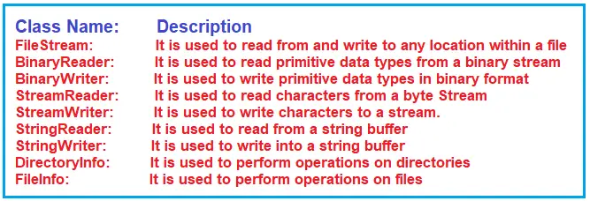

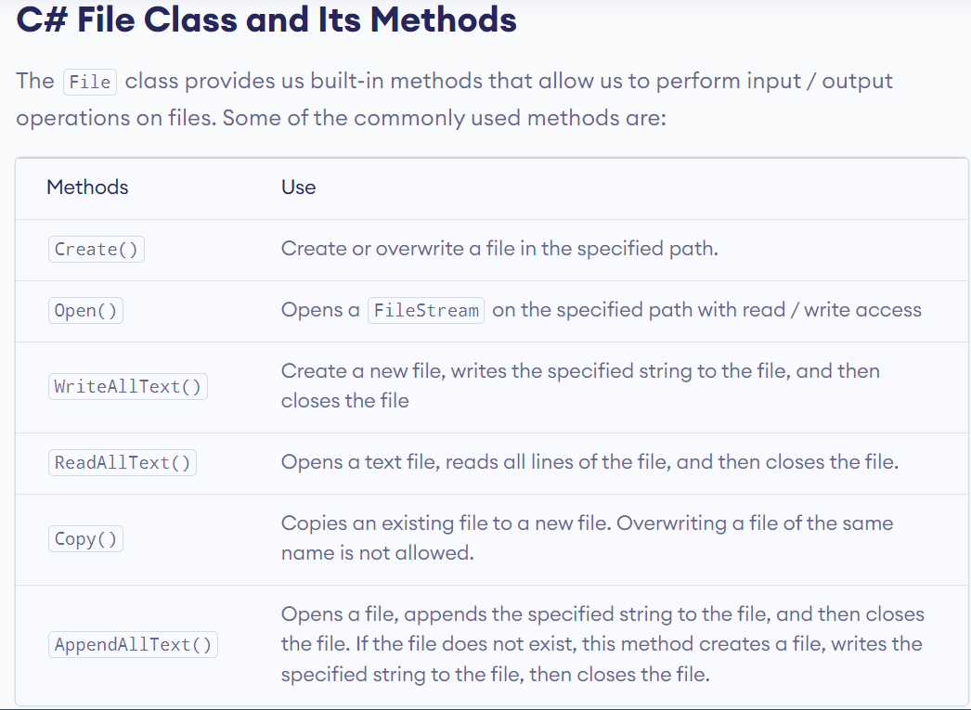

Reflection:

GetType().

1. **GetFields():** It returns all the public fields of the current System.Type.
2. **GetProperties():** It returns all the public properties of the current System.Type.
3. **GetMethods():** It returns all the public methods of the current System.Type.
4. **GetMembers():** It returns all the public members of the current System.Type.
5. **InvokeMember(MethodName, BindingFlags, binder, obj, args)**
6. **Activator.CreateInstance(Type);**

with dynamic in C#, at compile time, we are bypassing the type-checking logic. But at runtime, we preserved the type-checking logic. Dynamic keyword uses Reflection internally

Uses:

Dynamic type, Latebinding, typesafety checks, custom serilization

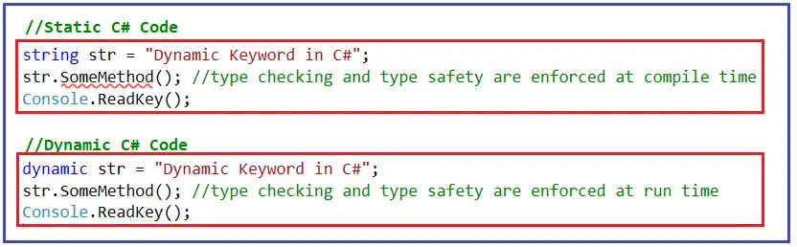

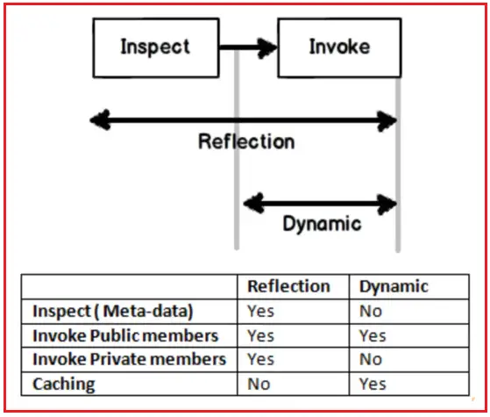

Windows Application Driver (WinAppDriver) is a service to support Selenium-like UI Test Automation on Windows Applications. This service supports testing **Universal Windows Platform (UWP)**, **Windows Forms (WinForms)**, **Windows Presentation Foundation (WPF)**, and **Classic Windows (Win32)** apps on **Windows 10 PCs**.

Appium driver package we need to install

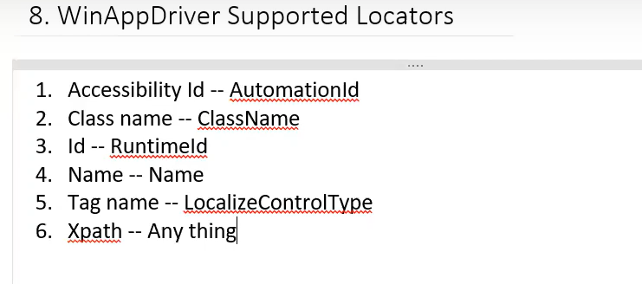

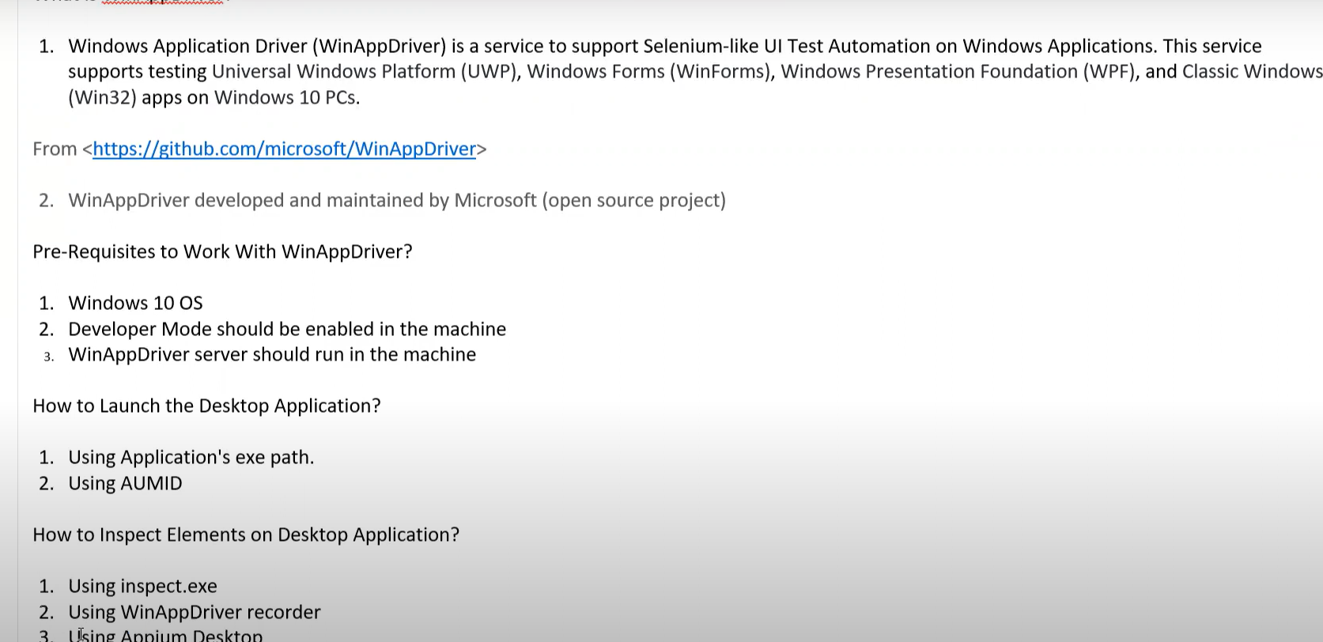

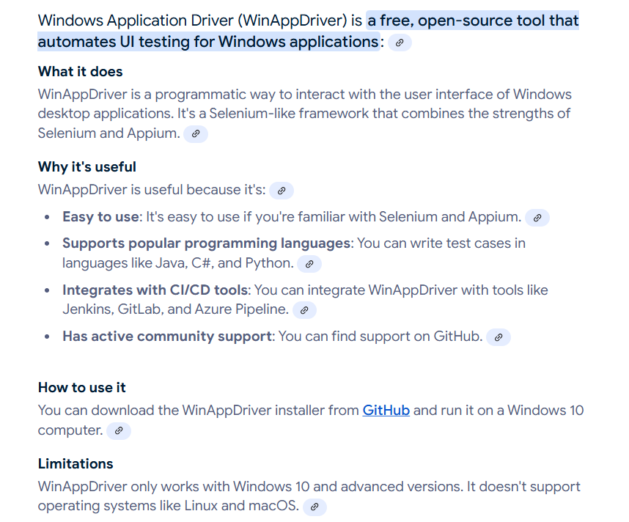

| **Feature** | **WinAppDriver** | **Selenium Drivers** |
| --- | --- | --- |
| Supported platforms | Windows applications (UWP, WinForms, WPF, Win32) | Web browsers (Chrome, Firefox, Safari, HtmlUnitdriver, RemoteWebDriver) |
| Feature | WinAppDriver | Appium |
| Supported platforms | Windows applications (UWP, WinForms, WPF, Win32) | Cross-platform (iOS, Android, Windows) |
|  | Desktop | Desktop and Mobile Applications |
|  | Maintained by microsoft | Maintained by Appium community |

public class Tests

{

WindowsDriver<WindowsElement> driver;

[SetUp]

public void Setup()

{

Process.Start("C:\\Program Files (x86)\\Windows Application Driver\\WinAppDriver.exe");

AppiumOptions Options=new AppiumOptions();

Options.AddAdditionalCapability("app", "Microsoft.WindowsCalculator_8wekyb3d8bbwe!App");

driver = new WindowsDriver<WindowsElement>(new Uri("http://127.0.0.1:4723"), Options);

}

[Test]

public void Test1()

{

driver.FindElementByAccessibilityId("num5Button").Click();

driver.FindElementByXPath("//Button[@Name='Nine'][@AutomationId='num9Button']").Click();

}

[TearDown]

public void TearDown()

{

driver.Close();

}

AUMID --> Application User Model ID.

get-StartApps --> To get Id of Apps (powershell)

